CHURCH SERVICES IN CLIFTON, THE SHELSLEYS AND LOWER SAPEY (HARPLEY)
October 2025
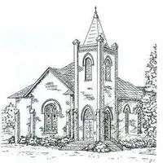

Sunday 5th October
10.30am: Morning Prayer, St Kenelm’s, Clifton
6.30pm: Evensong, St Andrews, Shelsley Walsh

Friday 10th October
5.00pm: Harvest Tea, Clifton Village Hall

Sunday 12th October
11.00am: Harpley Harvest Service followed by Harvest
Lunch, St Bartholomew, Harpley
5.00pm: Harvest Service followed by Harvest Supper,
All Saints, Shelsley Beauchamp

Wednesday 15th October
10.30am: Holy Communion, St Andrews, Shelsley Walsh

Saturday 18th October
4.00pm: Welly Church, Experience Harvest, St Kenelm’s Clifton

Sunday 19th October
10.00am: Praise 4 All, St Kenelm’s, Clifton
6.00pm: Harvest Service followed by Harvest Supper, St Kenelm’s, Clifton

Sunday 26th October
10.30am: Circle Service, St Bartholomew, Harpley

