Advertisement for a vacancy in Potterell’s Cottages

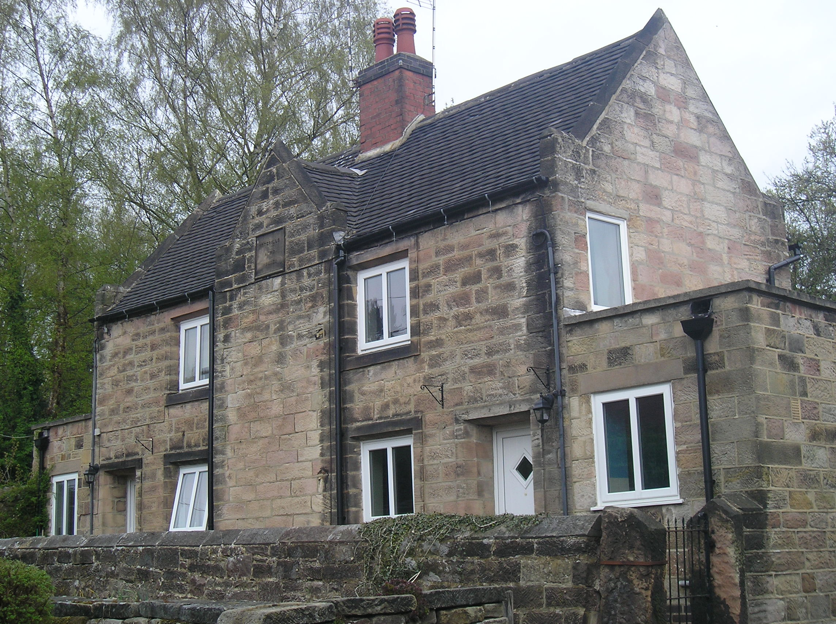
Church Street, Holbrook

To: - Residents of Holbrook & Makeney.

A very attractive one-bedroom stone built cottage in HOLBROOK owned by the Potterell’s Almshouse Charity is available for sole occupancy by one individual in financial or personal need.

The cottage is available for short or long term, depending on personal circumstances.

For further information and details of the Terms for Appointment, and an application form please contact John Maxwell-Jones on 07890 241 673 or edwardpotterellalmshouses@gmail.com on behalf of Edward Potterell’s Almshouses Charity. Applications will be considered on receipt.

Decisions on occupancy will be at the discretion of the Trustees.

