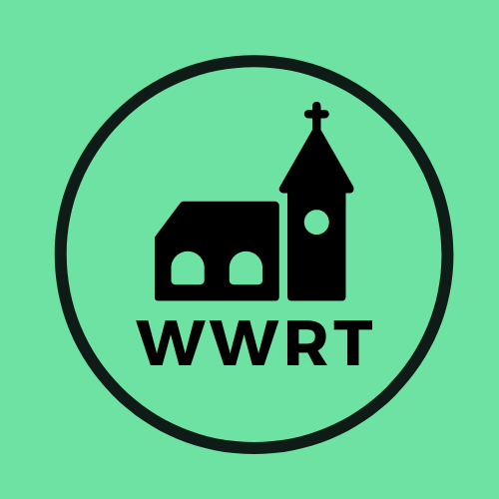

CHURCH SERVICES IN THE LOWER TEME VALLEY OCTOBER 2025

Sunday 5th October
Trinity 16
10.30am Worship for All, St Mary Magdalene, Broadwas
9.00 am BCP Holy Communion, St Leonard, Cotheridge

Sunday 12th October
Trinity 17
3.00pm Harvest, Knightwick Chapel

Sunday 19th October
Trinity 18
10.30am CW Holy Communion, St Mary Magdalene, Broadwas

Sunday 26th October
Trinity 19
10.30am Morning Worship, St Mary Magdalene, Broadwas

In August there will be Holy Communion at Heaton House, Martley on 8th and 22nd Wednesday at 10.15am and on the 1st and 3rd Wednesday via our YouTube channel -wwrtlive1.
All services and timings are subject to review and amendment – please check the website for updates: www.achurchnearyou.com

All services and timings are subject to review and amendment in accordance with Covid lockdown easing – please contact the Rectory or check the website for updates.
01886 888664
www.achurchnearyou.com

