**Higham Scarecrow Festival** – Bank Holiday weekend

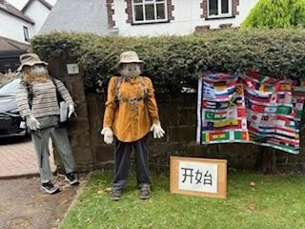

It was another great year for the Scarecrow Festival! The theme was ‘TV and Film’.

**This year the new Fun Dog Show attracted lots of dogs of all shapes, sizes, ages and ability. It was a success and I am sure will be repeated next year.

**Thank you to all who contributed by making Scarecrows, all who attended and participated in the activities and all who worked to plan and make the Festival a success.**

The Winner

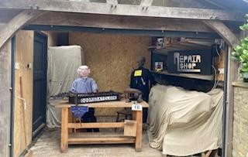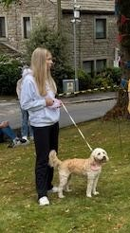

Here are a few Scarecrows – can you work them out?