**PARISH NEWS**

**For the Village of Bracebridge Heath**

**August 2025**



**St John’s Church and Community Garden Bracebridge Heath**

CAN YOU HELP US THIS SUMMER?

We will be working hard at St John’s Church over the summer on the Community Garden of Reflection in the hope that this will become a green space for those of us looking for a chance to pause and reflect. We opened the garden at the rear of the church last year with a service of dedication and cream tea. We also hope to use the space for future outdoor services and events.

Local church congregations, and representatives from the organisations we work with in support of our communities, will gather in the garden to welcome Bishop Nicholas of Lincoln Diocese for conversation and refreshments on the afternoon of the 28 th September this year.

Our funds for the garden project are running low and our hope is that as a community we can work together to ready the garden for the Bishop’s visit. Thank you to the teams from Bracebridge Heath Coop and the Wombles for helping us get this far.

The garden is at present a place of two parts. We would like to get this half:

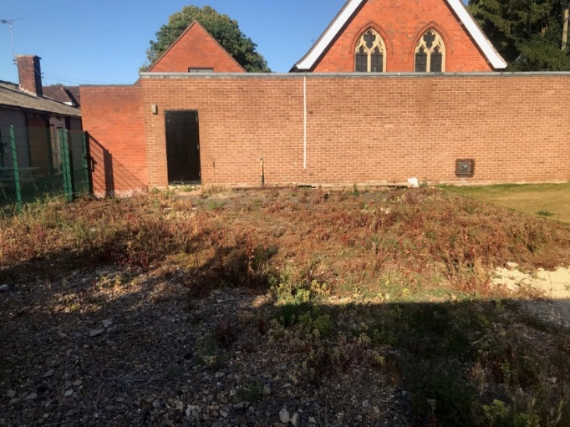

To look like this half during the summer months.

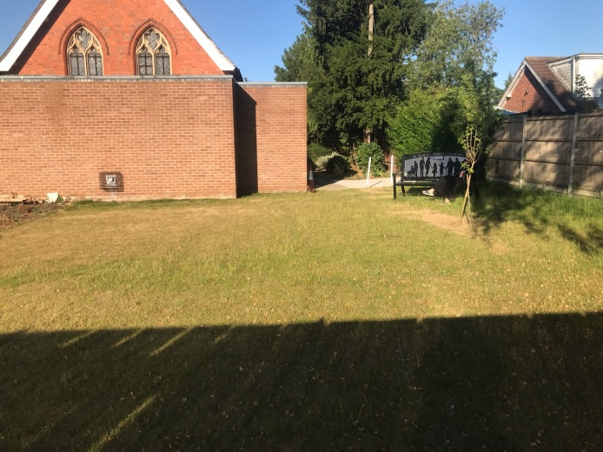

If you can help, or know anyone with the time and machinery to help, please contact myself or our Church Wardens on the information below. We have a small team here ready to work with you.

Our thanks go to the Bracebridge Heath Events group for their offer to donate plants to the garden and to the children of St John’s Academy who would like to be part of this project.

If you would like to find out more about the vision for the garden and church building, pop in to church some time and have a look at the vision board in the foyer.

As well as for services on Sundays and events/services during the week, church is also open every Wednesday and Friday as a quiet prayerful space.

We would love to see you.

Blessings, Revd Jacqueline

**What’s on at St John’s in August.**

Church open every Wednesday and Friday 10am-4pm for space ‘to be’. Community garden at rear of church always open.

Every Wednesday evening Wednesday Night Church 7pm. Please note there will be no service on Wednesday 6th and 13th August.

NIGHT LIGHT CAFÉ EVERY SUNDAY NIGHT 6-9 pm.

Tuesday 29th July Well being Café with Ann’s Crafts. 2-4pm.

Saturday 2nd August– Community Coffee Morning 10-12

Sunday 3rd August 10am Worship with Holy Communion.

Sunday 10th August 10 am Worship with Communion.

There will be no midweek 11 am Communion on Thursday 14th August.

Sunday 17th August 10 am Worship with Communion.

Messy Church Friday 22nd August 10.30 am.

Sunday 24th August 10 am Worship with Communion.

Sunday 31 August 8.30 am Holy Communion BCP

10 am Café Church

Vicar: Revd Jacqueline Bell : 01522 244751

Email: [j.bell313@btinternet.com](mailto:j.bell313@btinternet.com)

Church wardens: Sue Manders TEL. 537350

John Robinson TEL. 827366

Find us on Facebook and Achurchnearyou.com

**READINGS**

AUGUST 3 **THE SEVENTH SUNDAY AFTER TRINITY**

ECCLES. 1.2, 12 – 14; 2. 18 - 23

LUKE 12, 13 - 21

AUGUST 10 **THE EIGHTH SUNDAY AFTER TRINITY**

GENESIS 15, 1 - 6

LUKE 12, 32 - 40

AUGUST 17 **THE NINTH SUNDAY AFTER TRINITY**

JEREMIAH 23, 23 - 29

LUKE 12, 48 - 56

AUGUST 24 **THE TENTH SUNDAY AFTER TRINITY**

ISAIAH 58, 9b – end

HEBREWS 12, 18 - end

LUKE 13, 10 – 17

AUGUST 31 **THE ELEVENTH SUNDAY AFTER TRINITY**

ECCLESIASTES 10, 12 – 18

HEBREWS 13, 1 - 8

LUKE 14, 1, 7 – 14



**PRAYER PAGE**

Please pray for the following:-

Those living in areas mentioned

Areas of special concern

**AUGUST 3** Winchester Close, St. Worcester Close, York Way

John’s Square, Salisbury Drive, Salters Close

Saudi Arabia, Senegal, Serbia and Montenegro

For homes and families, especially those who are struggling financially

**AUGUST 10** Adler Close, Akeman Drive, Alvis Close, Appian Way,

Bath Road, Beech Close, Bentley Drive, Bloxham Lane

Sierra Leone, Singapore, Slovak Republic, Slovenia

For all leaders of churches in this country and the congregations which they serve

**AUGUST 17** Bluebell Court, Bramble Court, Broadway, Caistor Drive

Solomon Islands, South Africa, South Korea, Spain

For all students who have just received ‘A’ level results

**AUGUST 24** Canterbury Road, Canwick Avenue, Cardyke Way

Sri Lanka, Sudan, Swaziland, Sweden, Switzerland

For those who will be contemplating their next move

**AUGUST 31** Cathedral Heights, Chichester Road, Churchill Avenue

Syria, Taiwan, Tajikistan, Thailand, Trinidad & Tobago

For those who have been experiencing first-hand the effects of global warming

*Editor: Here are some insights into the Bible from the Revd Richard Bewes, formerly Rector of All Souls Langham Place, London.*

***How big was the Flood?***

*A Mesopotamian disaster, or a world catastrophe? The Flood continues to fuel speculation worldwide.*

*That is the precise point – we don’t even have to explain which flood we’re talking about; Noah’s Flood is firmly embedded in the human memory on every continent.*

*There is a Hindu tradition about a great flood, and a ship of safety finally landing on a northern mountain. In China, Fa-he, the reputed founder of Chinese civilisation, is represented as escaping from the waters of a deluge – and reappears as the first man in a new world, accompanied by his wife, three sons and three daughters: eight people in all.*

*There is the famous Babylonian Epic of Gilgamesh with its detailed myth-legend of a great flood. The Fiji islanders have accounts of a flood, in which a family of eight was saved. In South America, paintings have been discovered, representing a flood, a man and his wife on a raft, with a mountain featuring in the story, as well as a dove. Even the Cherokee Indians have a similar story. Only Africa seems to be without a traditional flood story.*

*I believe that the book of Genesis gives us the original, inspired and definitive account of this mega event. It could have been Shem, one of Noah’s sons, who later told his children of this great epic of his life, and, as people fanned outwards from Mesopotamia, so the story travelled outwards as well – inevitably becoming garbled in the process, and mixed up with legend and folklore.*

*How big was the Flood, then? The right answer is that it was of all-time, universal dimension and significance. Certainly we can make out a strong case for a literal worldwide flood – with the release of the great waters both from below and above (Genesis 7:11,12) But we may also observe that the phrase of Genesis 7:19 – that ‘all the high mountains under the entire heavens were covered’ can be paralleled by Acts 2:5, where – on the Day of Pentecost – those who were present were ‘from every nation under heaven’. Those nations are then listed out in detail, and they are all from the then known world of Luke the writer – around the Mediterranean basin. So, the Flood itself need not have extended across the entire world.*

*Can we respect the differing views among reverent students of Scripture? If we cannot, we are in deep trouble. Once we get into lengthy and heated debates as to whether the flood covered every dot of land-space on the world, we are in danger of exhausting ourselves and diverting people from hearing the real message of the Flood. And what is that?*

*First, it widens the problem – from a garden to the whole world. The Flood conveys a universal warning. Second, it produces a model – for our entire understanding of judgment and grace, for ultimately the safety of the ark is found in Christ. Third, it sets the stage – for the drama of salvation that is to be unfolded from Genesis 12 onwards.*

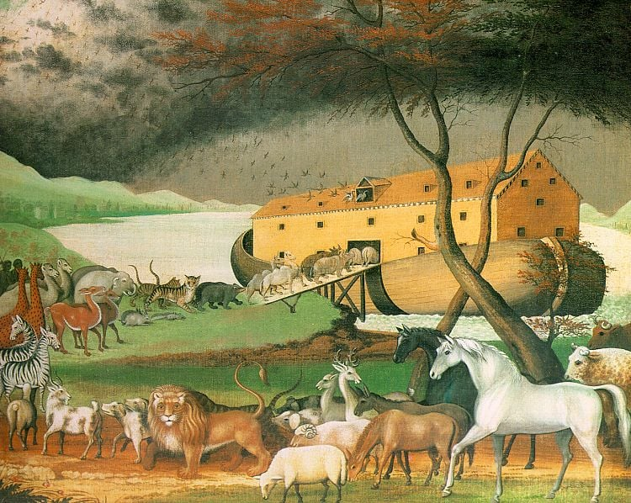

[This Photo](https://fr.vikidia.org/wiki/No%C3%A9) by Unknown Author is licensed under [CC BY-SA](https://creativecommons.org/licenses/by-sa/3.0/)

**What does the modern persecution of Christians look like?**

In the Acts of the Apostles we read, at different times, of disciples being threatened; of disciples being imprisoned. We see disciples, on occasions, fleeing. We read of disciples paying the ultimate price—martyrdom.

To talk of Christians suffering persecution for Christ and the gospel is to realise that this is something that takes different forms in different places. And that means the way we respond—in order to love and care for persecuted Christians—will vary, too.

On-going oppression, for example, may leave the Church bereft of resources and needing help to equip its pastors. By contrast, where Christians have been forced to flee in the face of violence or the threat of violence there may be immediate life-sustaining needs that must be met. Martyrdom or imprisonment throws up the need to care pastorally for widows or for families struggling to cope.

The one constant is all of this is the call to pray for those who suffer because of their faith in Christ—which is always the first thing persecuted Christians ask for. If possible, that prayer ought to be *specific*: for real people in real places, who are really suffering because of their Christian faith.

Release International is a UK-based ministry, called to love and serve those who suffer persecution for Christ and the gospel. Release International works through Christian partners on the ground; partners who understand the needs of those who are suffering, and who have a calling to respond to those needs. We can help those who help the suffering.

And so here in the UK Release International calls Christians to express fellowship with those who suffer—and to do so prayerfully, pastorally and practically. To find out more about how you and your church can be involved in caring for persecuted Christians, go to: [releaseinternational.org](https://releaseinternational.org).

Kenneth Harrod in ‘Parish Pump’

**WHY WAS THE KINGDOM OF GOD THE CHIEF MESSAGE PROCLAIMED BY JESUS?**

In his three-year ministry Jesus said many important things, such as his Sermon on the Mount or the instructions he gave to his disciples concerning the Last Supper. But in teaching both his followers and the crowds who came out to listen to him, where did he place his greatest emphasis? There is, I think, little doubt that what he had to say concerning the Kingdom comes right at the top of the list and permeates everything else that he uttered.

It is well understood that because of their similarity in content, the gospels of Matthew, Mark and Luke are called the synoptic gospels. They have a common ancestry in that they appear to have used a single document for source material. In particular they share a common theme in which they record the Lord’s words about the Coming of the Kingdom. It is a theme that is less obvious in the fourth gospel, that of John.

In the gospel of Matthew the phrase Kingdom of Heaven is mentioned thirty-four times, but nowhere else in the New Testament and not at all in the Old Testament. The Kingdom of God is referred to four times in the same gospel, as well as fourteen times in Mark and thirty-two times in Luke.

Yet when we turn to the gospel of John, we find that the Kingdom of God is mentioned only twice. It is clear that John put his emphasis on what Jesus had to say about Eternal Life (seventeen mentions) achieved through faith in Jesus Christ, rather than the Kingdom.

Do the Kingdom of Heaven and the Kingdom of God mean the same thing? The answer to this is that they do. It has been suggested by scholars that Matthew’s gospel which was aimed at a readership of Christian Jews, followed the practice adopted and used in the Old Testament for Jewish readers. This was for reasons of reverence, to avoid as much as possible referring to God by name. Hence for the same reasons Matthew avoided referring to God by name and substituted the word “heaven” to mean Him.

The phrase Kingdom of God is not mentioned in the Old Testament since as we will see, such a Kingdom did not exist. However its establishment was anticipated. In Psalm 103 King David states, “*The Lord hath prepared his throne in the heavens; and his kingdom ruleth over all”* (verse 19); while Daniel quotes the words of King Nebuchadnezzar, *“His kingdom is an everlasting kingdom, and his dominion is from generation to generation”* (3:3). Note the present tense used by the two OT writers, indicating a recognition that God already ruled a heavenly realm that would survive in some future form, a form admittedly unknown to them.

So what special meaning did Jesus give to the Kingdom? When he spoke of the Kingdom of God (or the Kingdom of Heaven), he was careful to avoid any suggestion that it was an earthly kingdom. That would have immediately alerted the Roman occupiers of Judea and Galilee to what he was saying, with unpleasant consequences to follow. As he later said to Pontius Pilate, *“My kingdom is not of this world*” (John18:36). Moreover he did not claim that the Kingdom was some kind of spiritual territory that God ruled over. Nor did he mean it to be a celestial administrative organisation above the clouds.

For Jesus it signified God’s new reign that was about to start, a reign that would subsume the OT reign. This would be over his people, that is the born again believers who had now achieved salvation. When it was finally brought into existence, the Kingdom will be inhabited by created beings, both angels and saved human beings. All these beings will be in spiritual fellowship with God. And as God is eternal, so the Kingdom and its citizens will last forever.

At the start of his public ministry, Jesus was reported by Mark to say, *“The time is fulfilled and the Kingdom of God is at hand: repent ye and believe the gospel”* (1:15). This tells us that this new Kingdom had not been in existence before the Lord’s announcement. But with his earthly ministry now under way, the Kingdom of God was starting to function, as a replacement for what had gone before

Nevertheless the new Kingdom was not in its final form. It was in a state of provisionality, the reason being that here on earth there was (and still is) sin, disobedience and the last enemy of all, namely death. The Kingdom has survived to the present time in this state of provisionality, and will remain so until Jesus returns in power and majesty as King and Judge. Paul said to the Corinthians that “flesh and blood cannot inherit the Kingdom of God” (1 Cor. 15:50) so we must be patient. When Christ returns at some time in the future, the full realisation of the Kingdom will be achieved.

In the meantime we are told to prepare for the Coming of the Kingdom. Jesus said to Nicodemus, *“Except a man be born again, he cannot see the Kingdom of God”* (John 3:3). We know that to be born again we have to be penitent; we have to be baptised; and we have to believe in the Lord Jesus. Baptism indicates the rejection of the former sinful self and the start of a new life dedicated to the Saviour. Thus by living our lives quietly, and by following in the steps of the Master throughout our earthly existence, our place in God’s Kingdom will be assured and our citizenship confirmed.

When that fateful day comes, we will be changed into beings that are immortal. As we are told in the Book of Revelation of St. John the Divine, we shall become kings and priests serving in the Kingdom of God (1:6 and 5:10). May that happen to all of us!

Roland Morant



**The vicar who won Wimbledon**

Ninety years ago, on 21st August 1935, John Hartley, the British tennis player, died. He was the only clergyman ever to win Wimbledon and was World Number One in both 1879 and 1880 – winning Wimbledon both years.

The Revd John Thorneycroft Hartley was born in 1849 in Wolverhampton and was well connected: his parents were both from Staffordshire industrial business families, and he married Alice Lascelles Murray, daughter of the 4th Earl of Mansfield and a granddaughter of Henry Lascelles, 3rd Earl of Harewood. They had no children.

He won the 1879 Gentlemen's Singles title against Irish champion Vere St Leger Gold in three sets on 15th July, retaining his title the following year. But in attempting the hat-trick in 1881 he lost the shortest ever men’s final, 0-6, 1-6, 1-6, in 37 minutes. He was said to have been ill at the time.

Hartley had become a priest in 1873. He was firstly curate of Christ Church, Southwark, and then became vicar of Burneston, a village in North Yorkshire, from 1874 to 1919. In 1891 he became Rural Dean of East Catterick, and later he was Honorary Canon of Ripon Cathedral.

As an amateur, he received no cash for his Wimbledon wins, and in the course of his first finals win he caught a train to Yorkshire so that he could do his duty and take his services at Burneston on the Sunday. Not only that, but he stayed with a dying parishioner until he passed away on the Monday – the day of the semi-finals. A rain delay helped him to get back to London in time.

At the Golden Jubilee Championships in 1926 he received a silver medal from Queen Mary as one of 34 surviving champions.



*Editor: Tim Lenton looks back on a landmark moment in world history…*

**The atomic bomb that hit Hiroshima**

Eighty years ago, on 6th August 1945, the US Army Air Forces dropped an atomic bomb on the city of Hiroshima in Japan. The centre of the city was totally destroyed, and about 80,000 people were killed immediately. A further 60,000 died by the end of the year, from injury or radiation. Hiroshima was the first city in history to be hit by a nuclear weapon.

Three days later, on 9th August, the USAAF dropped another atomic bomb on Nagasaki, killing 40,000 immediately and more than another 33,000 by the end of the year. It was (so far) the last nuclear bomb ever dropped.

The world's first nuclear explosion – on land – had happened weeks earlier, on 16th July, 1945, in New Mexico. This was known as the Trinity test, part of the Manhattan Project. It was called Trinity by Project scientific leader J Robert Oppenheimer, as a reflection of the Christian reality – death and resurrection – presented in the poetry of John Donne.

The Hiroshima bomb, called Little Boy, was dropped by the bomber Enola Gay and exploded about 1,800 feet above the city. Of those who died, many were vapourised by the explosion: others perished from burns and the effects of radiation. The second bomb, Fat Man, was even more powerful, but caused less destruction because of the terrain. Heavy cloud cover over Kokura, the original target, saved that city from the bomb.

The final Japanese surrender was signed on 2nd September. Because of the terrifying devastation caused by the bombs, there was much criticism of their use. But Lieutenant General Leslie Groves, the military director of the Manhattan Project, argued that they ended the war, and “while they brought death and destruction on a horrifying scale, they averted even greater losses – American, English, and Japanese”.

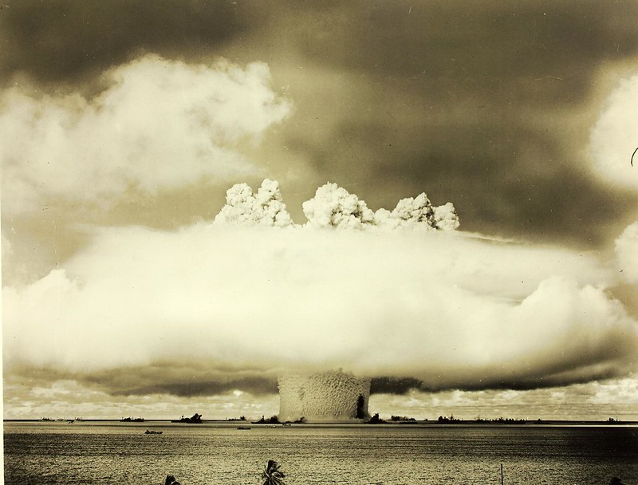

[This Photo](http://code.flickr.net/page/2/) by Unknown Author is licensed under [CC BY](https://creativecommons.org/licenses/by/3.0/)

**Lord’s Prayer tops Shakespeare, Dickens, Churchill and National Anthem in public recognition poll**

People in the UK are more likely to identify correctly a short extract from the Lord’s Prayer – also known as the Our Father – than one from the National Anthem and other sources chosen for their deep cultural resonance, a new poll has found.

The polling, carried out for the Church of England, also found the reference in the prayer to being forgiven and forgiving others was the element people found most meaningful to them.

Pollsters Savanta surveyed more than 2,000 people across the UK. They asked them to match seven famous lines - spanning areas ranging from literature and history to popular culture – with their source, from a list of correct answers.

Overall, the phrase from the Lord’s Prayer was recognised correctly by the largest number of people (80.3 per cent), just ahead of Star Wars (79.9 per cent).

They were followed by Hamlet’s “To be or not to be” (73 per cent) the extract from the National Anthem (63 per cent); the line from Churchill’s ‘The Few’ speech (61 per cent); and You'll Never Walk Alone (58 per cent).

Overall, 89 per cent of those surveyed said that they had previously heard of the Lord's Prayer or the Our Father. This was highest among those who described themselves as Christian (95 per cent), but also by 88 per cent of those who said they had no religion.

The Archbishop of York, Stephen Cottrell**,**is currently leading a ‘Lord’s Prayer Tour’ of events at churches and cathedrals across the north of England attended by thousands of people, as part of his *Faith In The North* initiative.

He said: “In a world of shifting cultures and changing circumstances, the Lord’s Prayer remains a steady guide - perhaps never more so than now.

“Lines like 'Give us this day our daily bread' speak powerfully to today’s challenges, reminding us to seek sufficiency, not excess, and to consider what ‘enough’ truly means.” *‘Parish Pump’*

**The Pilgrim’s Aiding**

God be with thee in every pass,  
Jesus be with thee on every hill,  
Spirit be with thee on every stream,  
Headland and ridge and lawn;

Each sea and land, each moor and meadow,  
Each lying down, each rising up,  
In the trough of the waves, on the crest of the billows,  
Each step of the journey thou goest.

A Celtic prayer collected by Alexander Carmichael

* * * * * * * * * * * * * * * * * * * * * * * * *

**Looking back on JAWS – 50 years on (***from ‘Parish Pump’***)**

The shark that came to Amity Island for dinner – most people aged 60 and over remember him as the scariest fish they ever saw.

As this summer the famous film celebrates its golden anniversary, here are some fun facts about the film which you may not have known…

1. When *Jaws* was released in the summer of 1975, its 28-year-old director Stephen Spielberg was very nervous – making the film had been beset with disasters. He worried that he might never work on films again. But *Jaws* was an instant success – spending 14 consecutive weeks at number one in the USA and eventually grossing $470 million worldwide.

2. *Jaws* was shot on the island of Martha’s Vineyard, and scared people so badly that seaside resorts on the eastern US coastline reported a marked downturn in visitors that summer.

3. *Jaws* is based on the 1974 novel by Peter Benchley, who was inspired by the Jersey Shore shark attacks of 1916. Five attacks, four fatal, had left New Jersey residents terrified of the water.

4. The three 1.2 ton, 25-ft-long pneumatically powered sharks were given a name on the film set – Bruce. They were named after Spielberg’s lawyer, Bruce Ramer.

5. These mechanical sharks were so prone to misfunction that the script was rewritten, so as not even to show the shark until one hour and 21 minutes into the film. But this served as a stroke of genius – for it allowed the tension to build and build.

6. There were endless problems on the set: bad weather, water-logged equipment and even the main boat sinking. The actors were often seasick, and sometimes feuding. The 55-day schedule overran to 159 days, raising the budget from £3.5m to $9m.

7. George Lucas, who visited his pal Spielberg on the set, got his head stuck in the shark’s mouth. They nearly broke the mechanical shark in their frantic efforts to free him.

8. The film’s most famous line, ‘You’re gonna need a bigger boat’, uttered by Chief Brody (Roy Scheider) when he first saw the shark, was not in the script, but improvised. The film crew had been constantly saying it in their complaints about the support vessel on set.

9. When Spielberg first heard composer John Williams’ score for the film, the famous ‘dun-dun’, played on a tuba, he thought it was a joke. Later he said it was 50% responsible for making the film a smash hit.

10. *Jaws* has not been good for the conservation of sharks. It reportedly led to an increase in killings, much to Spielberg’s regret.



[This Photo](https://es.wikipedia.org/wiki/Chondrichthyes) by Unknown Author is licensed under [CC BY-SA](https://creativecommons.org/licenses/by-sa/3.0/)

[*This Photo*](https://es.wikipedia.org/wiki/Chondrichthyes) *by Unknown Author is licensed under* [*CC BY-SA*](https://creativecommons.org/licenses/by-sa/3.0/)



**LINCOLN BRANCH**

Would like to invite you to our next Branch Meeting at

QUEEN’S PARK COMMUNITY HUB

South Park, Lincoln. LN5 8EW

SATURDAY 9th  AUGUST 2025 AT 2 PM

**Presentation by : Nicola**  **Hallam**

**“Let’s Talk of Graves, Worms & Epitaphs”-**

**An exploration of records available relating to**

**death and burial during family history research**

Come and join us at in person or via Microsoft Teams

Email your Teams request and your Membership Number if applicable to: [lincolnbranch@lincolnshirefhs.org.uk](mailto:lincolnbranch@lincolnshirefhs.org.uk)

The Link will be sent to your email address.

We look forward to seeing you!

A £1 Donations would be most welcome towards Speaker and Refreshment Costs.

Teams Attendees can also donate please by using Bank Transfer.

Call for information:

Tracey Fairhurst 07941 245322

**St. John the Evangelist Church**

**Vicar:** The Revd Jacqueline Bell,

11 Salisbury Drive,

Bracebridge Heath,

Lincoln LN4 2SW

Tel: 01522 244751

Email: [j.bell313@btinternet.com](mailto:j.bell313@btinternet.com)

Find us @ [www.achurchnearyou.com](http://www.achurchnearyou.com)

and on Facebook: St John the Evangelist Bracebridge Heath

**Churchwardens:**

Mrs Sue Manders Mr John Robinson

Tel: 01522 537350 Tel: 01522 827366

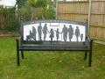

**Magazine Editor:**

Mrs Carolyn Morant

3, Manor House Gardens,

Ancaster Avenue, Lincoln.

LN2 4AY Tel. 01522 537651

Articles for publication to be sent by 10th of preceding month,

please, unless an earlier date has been notified in advance.