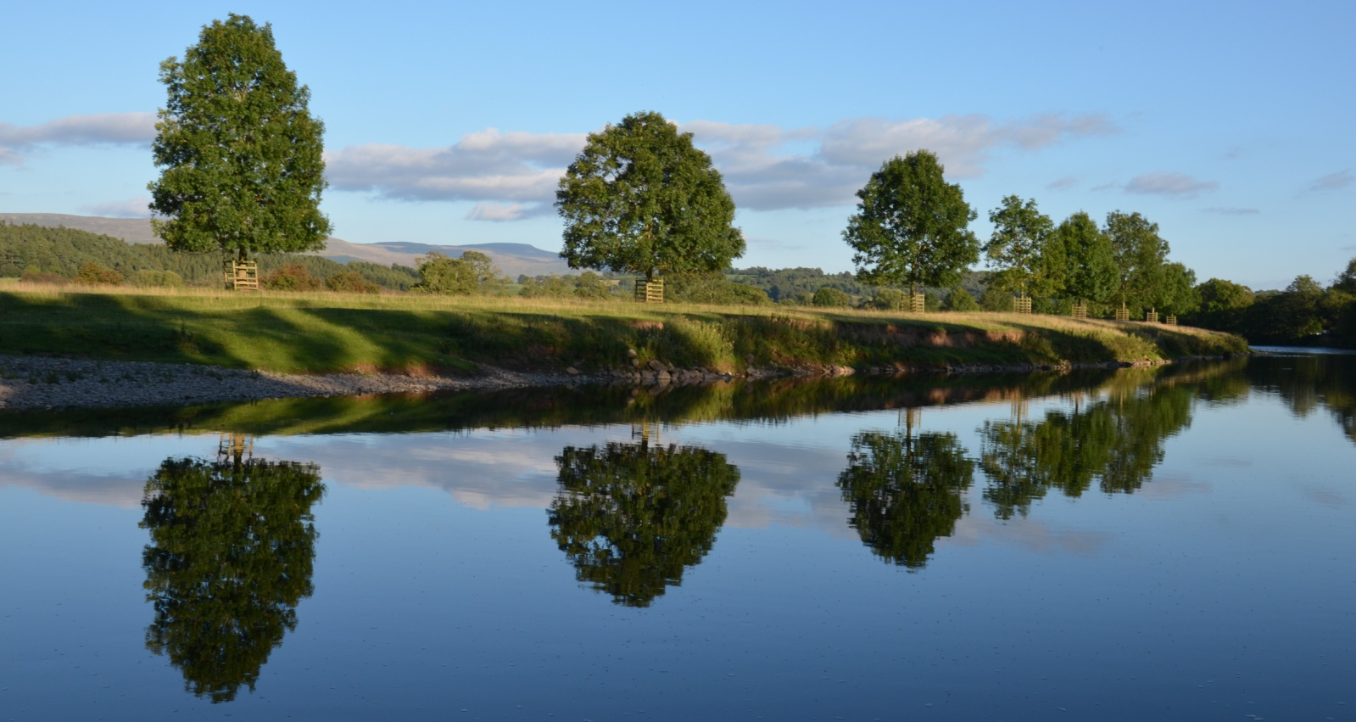

WALKS FOR ALL

Saturday September 20th 2025

Meet in the Square, Kirkoswald, 11am. A pleasant walk across fields to Glassonby and back along the Eden. Several stiles. Approx 4.5miles. Recommended strong footwear, food and drinks. Dogs welcome on leads

Could be changes if weather doubtful!

Any enquiries: Ruth Lee. Tel 01768 898604.