**We are having**

**a B-B-Q**

**Sunday**

**24 August**

**11.30am**

**To build community & raise funds for church & charity**



**Come along & join us at**

**St Peter’s Church**

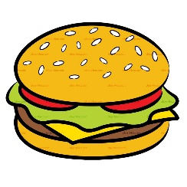**St Peter’s Road N9**