**Royston Parish Church**

**where all are welcome and God’s love is shared**

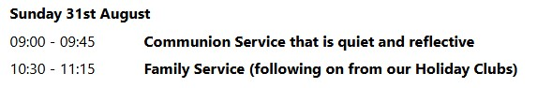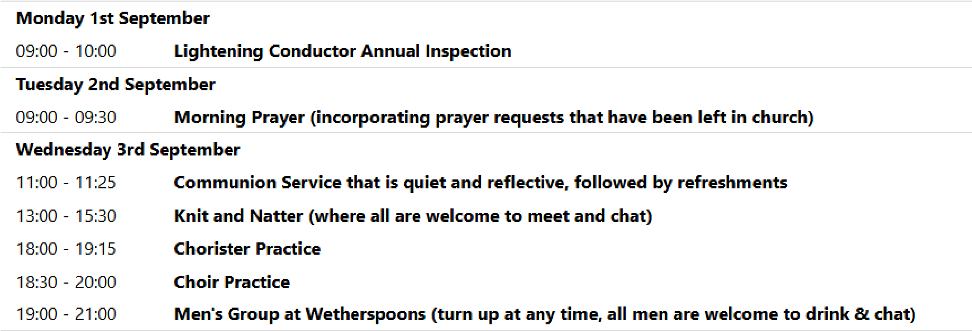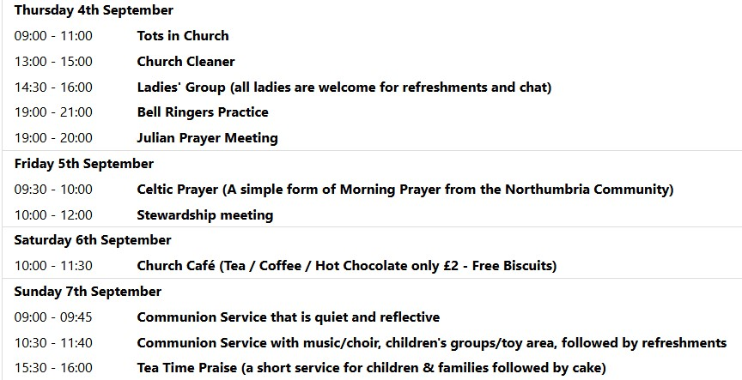

**Sunday 31st August 2025 - 11th Sunday after Trinity**

**If you would like regular copies of the Notice Sheet emailed to you please email the parish office at admin@roystonparishchurch.org.uk.**

**We pray for all Christians worldwide:**

For all Christians The Verda, Gambia and Guinea

For all who are worship at Royston Methodist Church: Revd. Charity Nzegwu

For the work of our mission partners: Mercy Ships **We pray for the community of Royston**: For our local health centres

For all those employed at our local Royston Foodbank **We pray for our world and ECO projects:**

The first week in September is "Zero Waste Week" (see zerowasteweek.co.uk) in which we are encourage to reduce our waste and set goals to reuse, recycle and repurpose.

**We pray for the sick and suffering:**

|  |  |
| --- | --- |
| **3rd August** **10th August** **17th August**  Lee Cockerill Chris Christou Val Brown  Carey & Pat Pritchard Paul & Pat Tidey Angi and Ken Rushall  David Gower Mike Brown Paula Walker    **We pray for those who have died in the faith of Christ:**  **Deceased** **Bereaved**  Susan Titmuss Family and friends  We pray for those whose anniversaries fall at this time:  Desmond McElney Daphne Charter John Salmon | **24th / 31st August**  Peter Coates  Emma and Phil Heath  Peter Foster |

**NOTICES**

**CHURCH TELEPHONE NUMBERS:** Please be aware that we are now operating using a new telephone system. Here are the numbers that are now affected:

General Church Number 01763 243145

Steven (Vicar) 01763 580242

Jaime (Curate) 01763 580241

Joanne (Administrator) 01763 580218

Please note that, if you use the general church number, you will then be presented with options to get in touch with Steven, Jaime or Joanne. All other numbers associated with the church will no longer be operational, but personal numbers such as other people who minister in the church (such as John, Reg or Emma) remain unchanged.

**CELTIC PRAYER CHANGE:** From September the Celtic Morning Prayer will be moving from the first Wednesday of the month to its new slot on the first Friday of the month (from 5th September). It will still be in the side chapel at 9.30 as before.

**HARVEST SUPPER** SATURDAY 4th OCTOBER, 6:30PM in ROYSTON PARISH CHURCH. Tickets £10 individual / £25 family, Supper includes shepherds pie or vegetarian alternative, with fruit crumble for dessert. Drinks available to buy. **Please bring own plate and bowl.**

To enable us to cater for the right numbers please book by going to <https://bit.ly/4me70Y9>or scan the QR code or see Joanne in Church for help

**JULIAN PRAYER MEETING:** Thursday 4th September at 11 Middle Drift. All welcome.

# CHILDREN'S CHURCH IS TAKING A BREAK DURING THE SCHOOL SUMMER HOLIDAYS

However, 10.30am each Sunday, on the red tables in the side aisle near the creche, there will be activity sheets, materials etc which parents/ carers are welcome to use with their children.

31st August will be an all-age celebration at the close of our Summer Holiday Club. 7 September - Children's Church restarts - all school-age children most welcome.

**BEDS & HERTS HISTORIC CHURCHES TRUST - SPONSORED BIKE ‘N HIKE - SATURDAY 13TH SEPTEMBER 2025** Last year we in Royston raised over £ 1,700 which was divided equally between BHHCT and our own parish funds. We hope to do just as well or better this year and the numbers asking for Sponsor Forms is encouraging. Select your own route for cycling or hiking between the churches – there are over 600 churches to choose from so make it as

long or as short as you wish. Most churches will be open on the day. The Sponsorship Packs are now available and if you would like a pack, please contact Mike Maze (245606 or mikefmaze@aol.com). There is always the easier option which is to sponsor one of the participants using their Sponsor form or if online giving suits you best, please visit:- [Michael's fundraising page](https://www.justgiving.com/page/michael-maze-7?newPage=true) or [Rodney's fundraising page](https://www.justgiving.com/page/rodney-dyer-9)

**UPCOMING EVENTS :**There are a number of events coming up over the next few months to look forward to.

26th September - Organ recital—tickets now available at https://bit.ly/45jr7xM

8th November - Remembrance themed lunch time concert. Ruth Savage **CARBON LITERACY PROJECT** There will be a total of six sessions on consecutive Monday evenings at Royston Parish Church from September 22nd. To see more information please either visit the Website roystonparishchurch.org.uk or see the poster at the back of Church

## SUNDAY READING SHEET 31st August 2025 11th Sunday after Trinity A Reading from the Letter to the Hebrews

Let mutual love continue. Do not neglect to show hospitality to strangers, for by doing that some have entertained angels without knowing it. Remember those who are in prison, as though you were in prison with them; those who are being tortured, as though you yourselves were being tortured. Let marriage be held in honour by all, and let the marriage bed be kept undefiled; for God will judge fornicators and adulterers. Keep your lives free from the love of money, and be content with what you have; for he has said, ‘I will never leave you or forsake you.’ So we can say with confidence,

‘The Lord is my helper; I will not be afraid.

What can anyone do to me?’

Remember your leaders, those who spoke the word of God to you; consider the outcome of their way of life, and imitate their faith. Jesus Christ is the same yesterday and today and for ever.

Through him, then, let us continually offer a sacrifice of praise to God, that is, the fruit of lips that confess his name. Do not neglect to do good and to share what you have, for such sacrifices are pleasing to God.

*Hebrews 13:1-8, 15 - 16*

## GOSPEL

When Jesus noticed how the guests chose the places of honour, he told them a parable. ‘When you are invited by someone to a wedding banquet, do not sit down at the place of honour, in case someone more distinguished than you has been invited by your host; and the host who invited both of you may come and say to you, “Give this person your place”, and then in disgrace you would start to take the lowest place. But when you are invited, go and sit down at the lowest place, so that when your host comes, he may say to you, “Friend, move up higher”; then you will be honoured in the presence of all who sit at the table with you. For all who exalt themselves will be humbled, and those who humble themselves will be exalted.’

He said also to the one who had invited him, ‘When you give a luncheon or a dinner, do not invite your friends or your brothers or your relatives or rich neighbours, in case they may invite you in return, and you would be repaid. But when you give a banquet, invite the poor, the crippled, the lame, and the blind. And you will be blessed, because they cannot repay you, for you will be repaid at the resurrection of the righteous.’ *Luke 14:7-14*

If you wish to make a donation to the church, then please hold your phone’s camera over this image then touch the link that appears: