Sunday 17th August 2025 St Paul’s, Woodhouse Eaves
WE WELCOME YOU, for we are all one in Christ Jesus

SAFEGUARDING  The parishes of St Paul’s, Woodhouse Eaves & St Mary’s, Woodhouse, are committed to the safeguarding of children, young people and adults. We follow the House of Bishops’ guidance and policies, and have our own Parish Safeguarding Officers. If you are concerned that a child or adult has been harmed or may be at risk of harm please contact –  ST PAUL’S - Safeguarding  Co-ordinator: Tony Lane  07977 924 677  ST MARY’S - Safeguarding Co-ordinator: Andrea Farnsworth 07958 376 963  As a Benefice, we affirm that it is about not just a set of policies and procedures, but about all of us as the body of Christ sharing the responsibility for making God’s Church as safe as we can  If you have been affected by the publication of the Makin Report and would like to talk to your parish priest, Rev’d Lisa, then please do get in contact – 01509 890 972  A prayer for our next Archbishop of Canterbury  Heavenly Father,  shepherd of your Church,  send us a faithful pastor  to lead with wisdom, courage, and love,  proclaiming your Gospel,  celebrating the sacraments,  and guiding your people in unity and truth.  Strengthen your Church, we pray,  and direct us in your ways;  through Jesus Christ our Lord.  Amen |  | Our Mission Statement  Our Mission is to make known the Gospel and love of Jesus Christ. We hope that you experience us as a safe, sacramental, welcoming, loving and inclusive Kingdom people who seek to make Christ present in the hearts of all.  Let us use our time  before the service  to talk to God,  during the service may  God talk to us, and  after the service let us talk to one another  If you would like someone to listen or to pray with you, please contact the Parish Priest:  Rev’d Lisa Temperley-Barnes - 01509 890 972  If you would like us to pray for someone by name in our Sunday services and through the week, please email Rev’d Lisa or Stephen. Any Notices should be sent to Stephen by Tuesday evening at the latest please:  stephen.burnham@yahoo.co.uk or 07835 461 668  Generous God, you give us gifts and make them grow:  though our faith is small, as a mustard seed, make it grow to your glory and the flourishing of your kingdom; through Jesus Christ our Lord. Amen  A prayer for peace  O God of all hope and peace, we bring to you the needs of our broken and hurting world.  We pray for an end to violence and warfare. Help us, O Lord, to affirm our common humanity so that in our differences we may work together for justice and peace. In Jesus Christ, our Lord. Amen |  | We pray for all who are ill,  for Dennis, Amelia,  Robert Martin, Di Alsop,  Sue and John Thorne,  June Taylor, Jean Sury,  June Shilton, Joseph Breed  We remember before God  the faithful departed  Helen Simpson,  Les Pole  and from St Mary’s  Book of Remembrance  Jack Newton Fowkes  and from St Paul’s  Book of Remembrance  Mary Jane Pitteway,  Irene Edith Cramp,  Nigel Garth Ian Dykes,  Klaus Roderick Kaiser,  Susan Partner,  Andrew Simpson Bagley  Rest eternal grant unto them,  O Lord, and let light perpetual shine upon them.  May the souls of the faithful departed through the mercy of God, rest in peace and rise in glory. Amen  Please take this pew sheet  home and recycle it when you’ve read it. Thank you
Trinity 9 Sung Eucharist
COLLECT  Almighty God,  who sent your Holy Spirit  to be the life and light of your Church:  open our hearts to the riches of your grace,  that we may bring forth the fruit of the Spirit  in love and joy and peace;  through Jesus Christ your Son our Lord,  who is alive and reigns with you,  in the unity of the Holy Spirit,  one God, now and for ever. Amen  FIRST READING  A reading from the prophet  Jeremiah  ²³ “I am a God who is everywhere and not in one place only. ²⁴ No one can hide where I cannot see them. Do you not know that I am everywhere in heaven and on earth? ²⁵ I know what those prophets have said who speak lies in my name and claim that I have given them my messages in their dreams. ²⁶ How much longer will those prophets mislead my people with the lies they have invented? ²⁷ They think that the dreams they tell will make my people forget me, just as their ancestors forgot me and turned to Baal. ²⁸ The prophet who has had a dream should say it is only a dream, but the prophet who has heard my message should proclaim that message faithfully. What good is straw compared with wheat? ²⁹ My message is like a fire and like a hammer that breaks rocks in pieces.  Jeremiah 23:23-29  This the word of the Lord  Thanks be to God |  | PSALM 82:1-8  Refrain: Arise, O God, and judge the earth  1 God has taken his stand in the council of heaven; ♦  in the midst of the gods he gives judgement:  2 ‘How long will you judge unjustly ♦  and show such favour to the wicked? R  3 ‘You were to judge the weak and the orphan; ♦  defend the right of the humble and needy;  4 ‘Rescue the weak and the poor; ♦  deliver them from the hand of the wicked.  5 ‘They have no knowledge or wisdom;  they walk on still in darkness: ♦  all the foundations of the earth are shaken. R  6 ‘Therefore I say that though you are gods ♦  and all of you children of the Most High,  7 ‘Nevertheless, you shall die like mortals ♦  and fall like one of their princes.’  8 Arise, O God and judge the earth, ♦  for it is you that shall take all nations for your possession. R  Glory be to the Father, and to the Son, and to the Holy Spirit; as it was in the beginning, is now, and ever shall be, world without end. Amen  GOSPEL  Alleluia, alleluia  “Speak, Lord, your servant is listening. You have the words to eternal life.”  Alleluia  Hear the holy Gospel of our Lord Jesus Christ according to St Luke  -  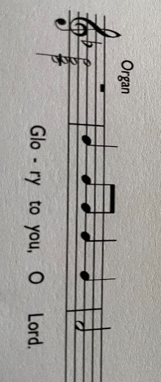 |  | Jesus said, ‘I came to bring fire to the earth, and how I wish it were already kindled! ⁵⁰ I have a baptism with which to be baptized, and what stress I am under until it is completed!  ⁵¹ Do you think that I have come to bring peace to the earth? No, I tell you, but rather division! ⁵² From now on, five in one household will be divided, three against two and two against three; ⁵³ they will be divided:  father against son  and son against father,  mother against daughter  and daughter against mother,  mother-in-law against her daughter-in-law  and daughter-in-law against mother-in-law.’  ⁵⁴ He also said to the crowds, ‘When you see a cloud rising in the west, you immediately say, “It is going to rain”; and so it happens.  ⁵⁵ And when you see the south wind blowing, you say, “There will be scorching heat”; and it happens.  ⁵⁶ You hypocrites! You know how to interpret the appearance of earth and sky, but why do you not know how to interpret the present time?  Luke 12:49-56  This is the Gospel of the Lord  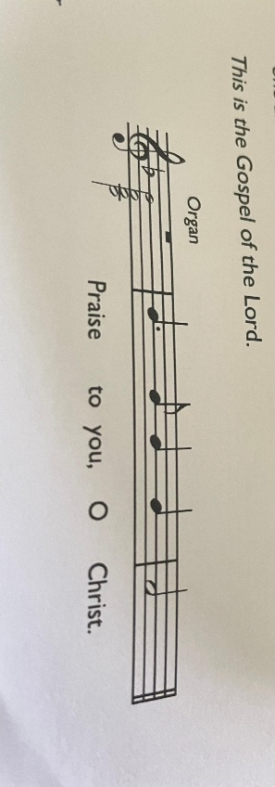  POST COMMUNION PRAYER  Holy Father,  who gathered us here around the table of your Son  to share this meal with the whole household of God:  in that new world where you reveal the fullness of your peace,  gather people of every race and language  to share in the eternal banquet of Jesus Christ our Lord. Amen

