CHURCH SERVICES IN CLIFTON, THE SHELSLEYS AND LOWER SAPEY (HARPLEY)
August 2025
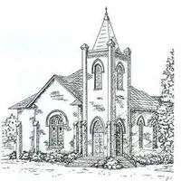

Sunday 3rd August
10.30am: Morning Prayer, St Kenelm’s, Clifton
10.30am: Morning Service, St Bartholomew, Harpley

Sunday 10th August
8.00am: Morning Prayer Service, (Midland Automobile Club) MAC Service, St Andrew’s, Shelsley Walsh
10.30am: Family Communion, All Saints, Shelsley Beauchamp
4.00pm: Iona, Celebration of Lammas, Hanley Village Hall

Sunday 17th August
6.30pm: Evensong, St Kenelm’s, Clifton

Wednesday 20th August
10.30am: Holy Communion, St Andrews, Shelsley Walsh

Saturday 23rd August
4.00pm: Welly Church, St Kenelm’s Clifton

Sunday 24th August
3.00pm: Annual Service, Old St Bartholomew’s,
Lower Sapey WR6 6HE Bring a picnic and a chair.

Thursday 28th August
12.45am: Soul Space, Clifton Village Hall, Rowberry Room

Sunday 31st August
9.30am: Café Church, Hanley Village Hall

