**Royston Parish Church**

**where all are welcome and God’s love is shared**

**Sunday 17th August 2025 - 9th Sunday after Trinity**

**If you would like regular copies of the Notice Sheet emailed to you please email the parish office at admin@roystonparishchurch.org.uk.**

**Steven and Emma are away and back to work on 3rd September**

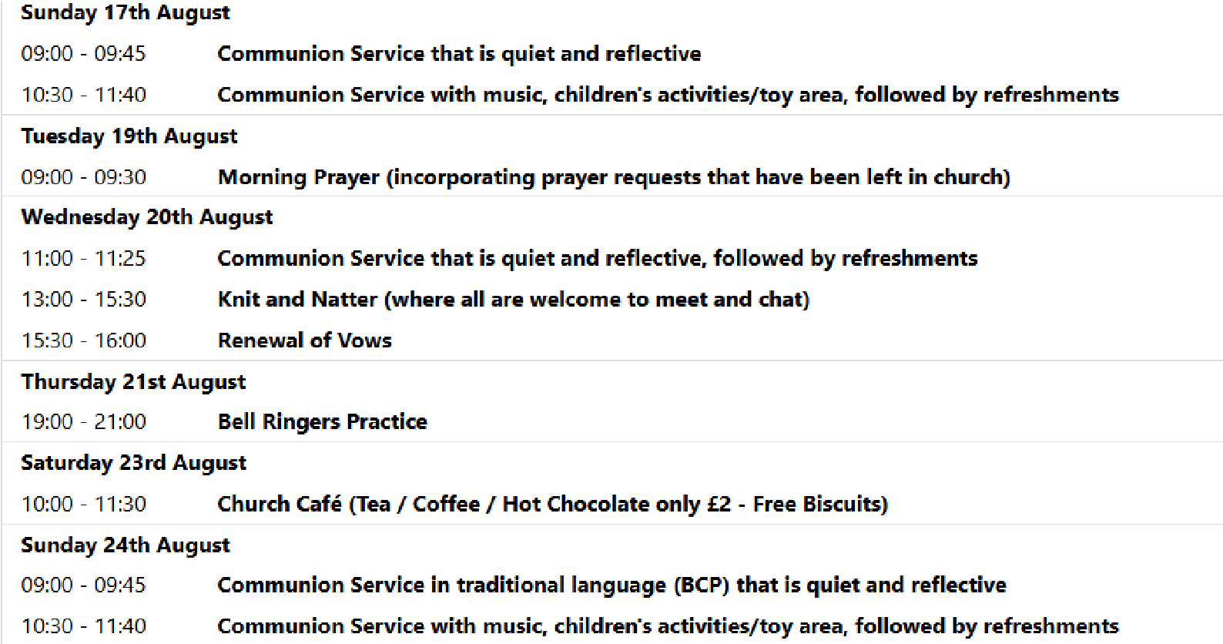

# SUNDAY 31ST AUGUST 10.30 am—SERVICE OF THE WORD

On Sunday August 31st there will be a blessing of school bags at the 10.30 service in anticipation for the start of the new school year the following week. All are invited to bring along a bookbag or backpack to be blessed within the service.

**We pray for all Christians worldwide:**

For all Christians in Nigerauritania, Niger

For all who are worship at Bassingbourn Parish Church: Revd. Helen Orr For the work of our mission partners: GenR8

**We pray for the community of Royston**:

For our local health centres

For all those employed at our local Famers and Land workers

**We pray for our world and ECO projects:**

19th August is International Orang Utan Day **We pray for the sick and suffering:**

|  |  |
| --- | --- |
| **3rd August** **10th August** **17th August**  Lee Cockerill Chris Christou Val Brown  Carey & Pat Pritchard Paul & Pat Tidey Angi and Ken Rushall  David Gower Mike Brown Paula Walker    **We pray for those who have died in the faith of Christ:**  **Deceased** **Bereaved**  John Holmes Family and friends  We pray for those whose anniversaries fall at this time: | **24th / 31st August**  Peter Coates  Emma and Phil Heath  Peter Foster |

**NOTICES**

**CHURCH TELEPHONE NUMBERS:** Please be aware that we are now operating using a new telephone system. Here are the numbers that are now affected:

General Church Number 01763 243145

Steven (Vicar) 01763 580242

Jaime (Curate) 01763 580241

Joanne (Administrator) 01763 580218

Please note that, if you use the general church number, you will then be presented with options to get in touch with Steven, Jaime or Joanne. All other numbers associated with the church will no longer be operational, but personal numbers such as other people who minister in the church (such as John, Reg or Emma) remain unchanged.

## ST JOHN the BAPTIST CHURCH ROYSTON, HOLIDAY CLUB 'SEASIDE ADVENTURES

**TRUSTING IN GOD'**. This is for children 0 to 11 years with their parent/carer with sessions on August 28th from 10am to 12 am. It is £2.50 per child. Booking link on the website under Youth and Children or call 01763 448063

**THE BISHOP OF ST ALBANS GARDEN** will be open over the last two weekends in August (23 and 24 August and 30 and 31 August) between 2pm and 4pm for people to come and look at the beautiful gardens and the summer display. Those who saw the snowdrops earlier in the year will have seen the potential that the garden had for the summer and will be delighted at the change a different season brings. The garden will be open regardless of the weather. The two acres of garden is an oasis in central St Albans and visitors frequently comment on the fact that they did not know the garden was here or how extensive it is. Entrance is £5 per person (children free) and dogs on leads are welcome. All money raised is donated to the Beds and Herts Historic Churches Trust, Abbey Gate House, Abbey Mill Lane, St Albans AL3 4HD.

**CHURCHES TOGETHER – LIGHT PARTY – CAN YOU HELP? -** We would love someone to join the Light Party core team to take on the administrative tasks. You would need to attend 2 or 3 organising meetings in the run-up to the event and if possible be available on 31st October to help set up and welcome people. Other tasks include emailing volunteers, contacting schools, churches, and local press with publicity (using existing contact lists) plus updating the risk assessment and safeguarding information. If you think you may be able to help, please contact Helen on lightparty@ct-royston.org.uk

## CHILDREN'S CHURCH IS TAKING A BREAK DURING THE SCHOOL SUMMER HOLIDAYS

However, 10.30am each Sunday, on the red tables in the side aisle near the creche, there will be activity sheets, materials etc which parents/ carers are welcome to use with their children.

31st August will be an all-age celebration at the close of our Summer Holiday Club. 7 September - Children's Church restarts - all school-age children most welcome.

**BEDS & HERTS HISTORIC CHURCHES TRUST - SPONSORED BIKE ‘N HIKE - SATURDAY 13TH SEPTEMBER 2025** Last year we in Royston raised over £ 1,700 which was divided equally between BHHCT and our own parish funds. We hope to do just as well or better this year and the numbers asking for Sponsor Forms is encouraging. Select your own route for cycling or hiking between the churches – there are over 600 churches to choose from so make it as long or as short as you wish. Most churches will be open on the day. The Sponsorship Packs are now available and if you would like a pack, please contact Mike Maze (245606 or mikefmaze@aol.com). There is always the easier option which is to sponsor one of the participants using their Sponsor form or if online giving suits you best, please visit:- [Michael's fundraising page](https://www.justgiving.com/page/michael-maze-7?newPage=true) or [Rodney's fundraising page](https://www.justgiving.com/page/rodney-dyer-9)

**UPCOMING EVENTS :**There are a number of events coming up over the next few months to look forward to.

26th September - Organ recital—tickets now available at https://bit.ly/45jr7xM

4th October - Harvest Supper

8th November - Remembrance themed lunch time concert. Ruth Savage **CARBON LITERACY PROJECT** There will be a total of six sessions on consecutive Monday evenings at Royston Parish Church from September 22nd. To see more information please either visit the Website roystonparishchurch.org.uk or see the poster at the back of Church

**SUNDAY READING SHEET 17th August 2025 9th Sunday after Trinity**

**A Reading from the Prophecy of Jeremiah**

Am I a God near by, says the Lord, and not a God far off? Who can hide in secret places so that I cannot see them? says the Lord. Do I not fill heaven and earth? says the Lord. I have heard what the prophets have said who prophesy lies in my name, saying, ‘I have dreamed, I have dreamed!’ How long? Will the hearts of the prophets ever turn back—those who prophesy lies, and who prophesy the deceit of their own heart? They plan to make my people forget my name by their dreams that they tell one another, just as their ancestors forgot my name for Baal. Let the prophet who has a dream tell the dream, but let the one who has my word speak my word faithfully. What has straw in common with wheat? says the Lord. Is not my word like fire, says the Lord, and like a hammer that breaks a rock in pieces? *Jeremiah 23:23-29*

# GOSPEL

Jesus said:

‘I came to bring fire to the earth, and how I wish it were already kindled! I have a baptism with which to be baptized, and what stress I am under until it is completed! Do you think that I have come to bring peace to the earth? No, I tell you, but rather division! From now on, five in one household will be divided, three against two and two against three; they will be divided: father against son and son against father, mother against daughter and daughter against mother, mother-in-law against her daughter-in-law

and daughter-in-law against mother-in-law.’ He also said to the crowds, ‘When you see a cloud rising in the west, you immediately say,

“It is going to rain”; and so it happens. And when you see the south wind blowing, you say, “There will be scorching heat”; and it happens. You hypocrites! You know how to interpret the appearance of earth and sky, but why do you not know how to interpret the present time? *Luke 12:49-56*

If you wish to make a donation to the church, then please hold your phone’s camera over this image then touch the link that appears: