We bade a fond farewell to Geoff and Pat Wormwell at our 11am service last Sunday. Geoff and Pat are re locating down south, to be nearer their family. It was an emotional service, as Geoff acted as crucifer at St Anne’s for the last time. We were joined by choir members from St John’s and Geoff had chosen many of the hymns.

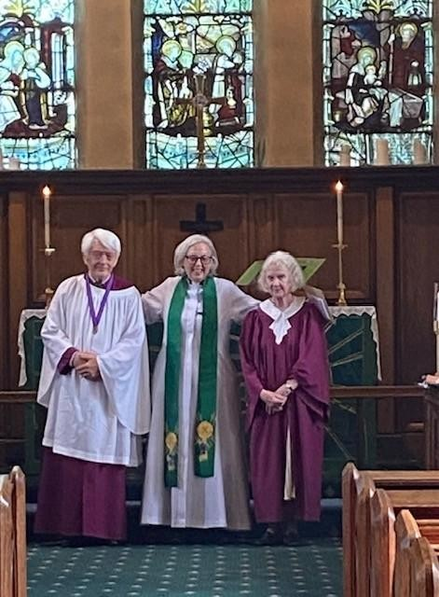
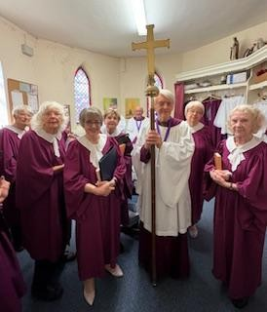

Geoff and Pat were presented with a Gift Voucher from the church family.

Tea, coffee and cakes were served in The Refectory after our service. We will miss Geoff and Pat. They leave with our love and blessings.
