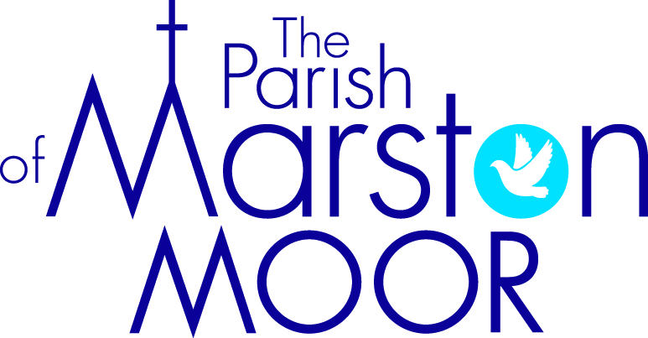 | Askham Richard | Bilbrough | Long  Marston | Rufforth | Tockwith
7th  12th Sunday after Trinity |  | 9.00am  Holy Communion | 8.30am  Breakfast Praise | 11.00am  Holy Communion | 11.00am  Refresh Service
14th  13th Sunday after Trinity | 9.00am  Holy Communion | 10.00am  Parish Praise | 5.00pm Holy Communion | 11.00am  Worship and Wonder | 11.00am  Creative Communion
21st  14th Sunday after Trinity | 10.00am  All Age Worship | 9.00am  Holy communion | 11.00am  Creative Church | 11.00am  All Age Worship | 6.00pm  BCP Evensong
28th  15th Sunday after Trinity | 9.00am  Holy Communion | 10.00am  Family HARVEST Service | 11.00am  All Age Worship | 11.00am  Holy Communion | 11.00am  Informal Parish Praise

