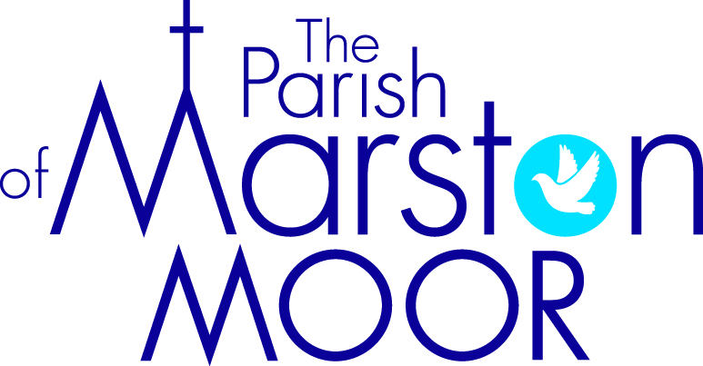 | Askham Richard | Bilbrough | Long  Marston | Rufforth | Tockwith
3rd  Trinity 7 | 10.30am Service at Tockwith Showground
 |  | 9.00am  Holy Communion |  | 11.00am  Holy Communion | 11.00am  Refresh Service
10th  ^{Trinity 8} | 9.00am  Holy Communion | 10.00am  Parish Praise | 5pm Informal Communion | 11.00am Worship and Wonder | 11.00am  Holy Communion
17th  ^{Trinity 9} | 10.00am  All Age Worship | 9.00am  Holy Communion | 11.00am Creative Church | 11.00am  All Age Worship | 6pm  BCP Communion
24th  ^{Trinity 10} | 9.00am  Holy Communion | 10.00am  Family Praise | 11.00am  All Age Worship | 11.00am  Holy Communion | 11.00am Informal Parish Praise
31st  Trinity 11 | 10.00am Bilbrough  Parish Holy Communion

