
St Anne’s and St John’s
Friday Faith and Fun were joined by Pizza and Praise on a very hot evening last Friday! We met at The Refectory for the summer party. We heard the story of The Prodigal
Son, and the party given for him on his return to his father’s house.

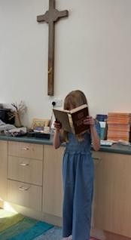
We played party games and ate a party tea! Thank you to all who help with these worship times for our youngsters.

Isla volunteered to do our reading, and made an excellent job of it, although we couldn’t see her face!!

