Sunday 20th July 2025 St Paul’s, Woodhouse Eaves
WE WELCOME YOU, for we are all one in Christ Jesus

SAFEGUARDING  In light of the resignation of the Archbishop of Canterbury and the publication of the Makin Report, if you have been affected and would like to talk to your parish priest, Rev’d Lisa, then please do get in contact – 01509 890 972  The parishes of St Paul’s, Woodhouse Eaves & St Mary’s, Woodhouse, are committed to the safeguarding of children, young people and adults. We follow the House of Bishops guidance and policies, and have our own Parish Safeguarding Officers. If you are concerned that a child or adult has been harmed or may be at risk of harm please contact –  ST PAUL’S - Safeguarding  Co-ordinator: Tony Lane  07977 924 677  ST MARY’S - Safeguarding Co-ordinator: Andrea Farnsworth 07958 376 963  As a Benefice, we affirm that it is about not just a set of policies and procedures, but about all of us as the body of Christ sharing the responsibility for making God’s Church as safe as we can |  | Our Mission Statement  Our Mission is to make known the Gospel and love of Jesus Christ. We hope that you experience us as a safe, sacramental, welcoming, loving and inclusive Kingdom people who seek to make Christ present in the hearts of all.  Let us use our time  before the service  to talk to God,  during the service may  God talk to us, and  after the service let us talk to one another  If you would like someone to listen or to pray with you, please contact the Parish Priest:  Rev’d Lisa Temperley-Barnes - 01509 890 972  If you would like us to pray for someone by name in our Sunday services and through the week, please email Rev’d Lisa or Stephen. Any Notices should be sent to Stephen by Tuesday evening at the latest please:  stephen.burnham@yahoo.co.uk or 07835 461 668  Holy God,  faithful and unchanging:  enlarge our minds with the knowledge of your truth,  and draw us more deeply into the mystery of your love,  that we may truly worship you,  Father, Son and Holy Spirit,  one God, now and for ever.  Amen |  | We pray for all who are ill, especially for Dennis, Amelia,  Di Alsop, Sue and John Thorne, June Taylor, Jean Sury,  June Shilton, Joseph Breed  We remember before God  the faithful departed  especially Bill Clark  and from St Mary’s  Book of Remembrance  Horace Albert Wood,  Bernard Charles Bryan,  John Smith Hamilton  and from St Paul’s  Book of Remembrance  Aran Chada, Joan Carter,  Simon Harvey Cook,  Thomas Arthur Ralphs,  Thomas Charles Constable,  Rosemary Siennicki,  Susan Elizabeth Rosemary Tebbutt  Rest eternal grant unto them,  O Lord, and let light perpetual shine upon them.  May the souls of the faithful departed through the mercy of God, rest in peace and rise in glory. Amen  Please take this pew sheet  home and recycle it when you’ve read it. Thank you
Trinity 5 Sung Eucharist
COLLECT  Almighty and everlasting God,  by whose Spirit the whole body of the Church is governed and sanctified: hear our prayer which we offer for all your faithful people, that in their vocation and ministry they may serve you in holiness and truth to the glory of your name; through our Lord and Saviour Jesus Christ, who is alive and reigns with you, in the unity of the Holy Spirit, one God, now and for ever. Amen  FIRST READING  A reading from the book of Genesis  The Lord appeared to Abraham at the sacred trees of Mamre. As Abraham was sitting at the entrance of his tent during the hottest part of the day, he looked up and saw three men standing there. As soon as he saw them, he ran out to meet them. Bowing down with his face touching the ground, he said, “Sirs, please do not pass by my home without stopping; I am here to serve you. Let me bring some water for you to wash your feet; you can rest here beneath this tree. I will also bring a bit of food; it will give you strength to continue your journey. You have honoured me by coming to my home, so let me serve you.” They replied, “Thank you; we accept.” Abraham hurried into the tent and said to Sarah, “Quick, take a sack of your best flour, and bake some bread.” Then he ran to the herd and picked out a calf that was tender and fat, and gave it to a servant, who hurried to get it ready. He took some cream, some milk, and the meat, and set the food before the men. There under the tree he served them himself, and they ate. Then they asked him, “Where |  | is your wife Sarah?” “She is there in the tent,” he answered. One of them said, “Nine months from now I will come back, and your wife Sarah will have a son.”  Genesis 18:1-10a  This the word of the Lord  Thanks be to God  PSALM 15  Refrain: Through the greatness of your mercy O Lord, I will come into your house  - Lord, who may dwell in your tabernacle? ♦  Who may rest upon your holy hill?  - Whoever leads an uncorrupt life ♦  and does the thing that is right;  - Who speaks the truth from the heart ♦  and bears no deceit on the tongue R  - Who does no evil to a friend ♦  and pours no scorn on a neighbour;  - In whose sight the wicked are not esteemed, ♦  but who honours those who fear the Lord.  - Whoever has sworn to a neighbour ♦  and never goes back on that word R  - Who does not lend money in hope of gain, ♦  nor takes a bribe against the innocent;  - Whoever does these things ♦  shall never fall R  Glory be to the Father, and to the Son, and to the Holy Spirit; as it was in the beginning, is now, and ever shall be, world without end. Amen |  | GOSPEL Alleluia, alleluia  Jesus said, ‘All who see the Son and believe in him may  have eternal life; and I will raise them up on the last day.’  Alleluia  Hear the holy Gospel of our Lord Jesus Christ according to St Luke  -  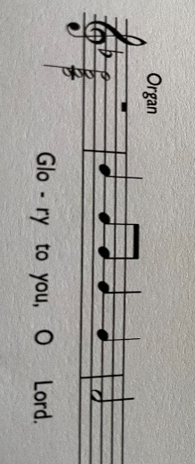  Now as they went on their way, Jesus entered a certain village, where a woman named Martha welcomed him into her home. She had a sister named Mary, who sat at the Lord’s feet and listened to what he was saying. But Martha was distracted by her many tasks; so she came to him and asked, ‘Lord, do you not care that my sister has left me to do all the work by myself? Tell her then to help me.’ But the Lord answered her, ‘Martha, Martha, you are worried and distracted by many things; there is need of only one thing. Mary has chosen the better part, which will not be taken away from her.’  Luke 10:38-end  This is the Gospel of the Lord  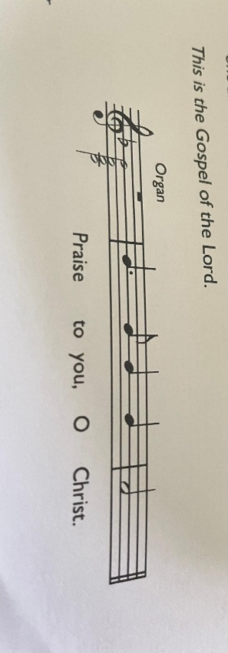  POST COMMUNION PRAYER  Grant, O Lord, we beseech you,  that the course of this world may be so peaceably ordered  by your governance,  that your Church may joyfully serve you in all godly quietness;  through Jesus Christ our Lord. Amen

