Next Sunday

27th July 2025

Sixth Sunday after Trinity
Proper 12
11.00am
Sung Eucharist
With
Revd Chris McQuillen-Wright

1st reading Paul
2nd reading Sandy
Intercessions Shelley
Priest’s assistant Jim

Dates for your diary;

Cream Teas at Ivy Cottage 26th July.
Thanks to Liz Edwards. Helpers needed, please see Shelley.

27th July Cream Teas commence in church, 3.00 till 5.00pm. The church will run these on Sundays this year. Please enter your name on the list at the back of church if you are able to help.

Thank you to those who helped with the Cream Teas, and to the School Choir who delighted us with their singing.
£95 was donated to Church Funds.

Please pray for;-
Holly Pat Weston
Elizabeth Cleare Magi & Vern
Gill Moore Emma Slater
Jenny Filer Toni Olsson
Sandra George Robin Burley
Vanessa Jeffries Helen Peacock
Sadie Rawlings

RIP; Peter Cleare who died on 4th July, and Kevin Green who died on 13th July.

Years mind; Stephen Carthew (2017)

Food Bank; Thank you for your continued support.
This week’s wish list;-

UHT milk
Long life fruit juice
Tinned meat
Tinned fruit
and Cereal

We shall be hosting the Pop-up Café presented by The Village Shop & Post Office on Mondays to Saturdays in August & September starting on 1st August
10.00am till 3.00pm

If you have items suitable for inclusion in next Sunday’s leaflet please ring Jim on 01726 850553 or email jim.cleare@btinternet.com
by 9.00pm on Saturday

Welcome to

Luxulyan Church

SS Cyriacus & Julitta
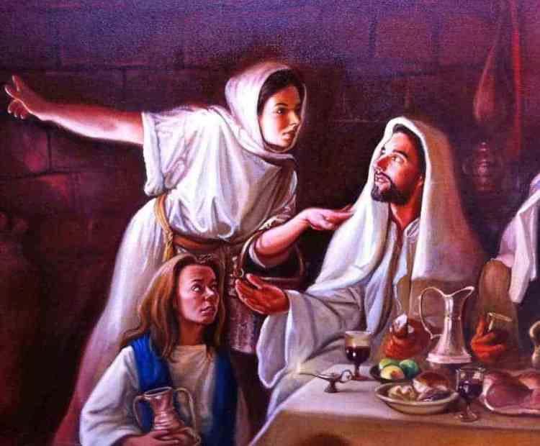
20th July 2025

Fifth Sunday after Trinity
Proper 11
11.00am
Sung Eucharist
With
Revd Chris McQuillen-Wright

1st reading Paul
2nd reading Jim
Intercessions Ros
Priest’s assistant Jim

Please take this leaflet home

The Fifth Sunday after Trinity Green
Collect
Almighty and everlasting God,
by whose Spirit the whole body of the Church
is governed and sanctified:
hear our prayer which we offer for all your faithful people,
that in their vocation and ministry
they may serve you in holiness and truth
to the glory of your name;
through our Lord and Saviour Jesus Christ,
who is alive and reigns with you,
in the unity of the Holy Spirit,
one God, now and for ever.

FIRST READING Genesis 18.1–10a
A reading from the book of Genesis.
1 The LORD appeared to Abraham by the oaks of Mamre, as he sat at the entrance of his tent in the heat of the day.
2 He looked up and saw three men standing near him. When he saw them, he ran from the tent entrance to meet them, and bowed down to the ground.
3 He said, ‘My lord, if I find favour with you, do not pass by your servant.
4 Let a little water be brought, and wash your feet, and rest yourselves under the tree.
5 Let me bring a little bread, that you may refresh yourselves, and after that you may pass on – since you have come to your servant.’ So they said, ‘Do as you have said.’
6 And Abraham hastened into the tent to Sarah, and said, ‘Make ready quickly three measures of choice flour, knead it, and make cakes.’
7 Abraham ran to the herd, and took a calf, tender and good, and gave it to the servant, who hastened to prepare it.
8 Then he took curds and milk and the calf that he had prepared, and set it before them; and he stood by them under the tree while they ate.
9 They said to him, ‘Where is your wife Sarah?’ And he said, ‘There, in the tent.’
10 Then one said, ‘I will surely return to you in due season, and your wife Sarah shall have a son.’

SECOND READING Colossians 1.15–28
A reading from the letter of Paul to the Colossians.
15 Christ is the image of the invisible God,
the firstborn of all creation;
16 for in him all things in heaven and on earth were created, things visible and invisible,
whether thrones or dominions or rulers or powers
all things have been created through him and for him.
17 He himself is before all things,
and in him all things hold together.
18 He is the head of the body, the church;
he is the beginning, the firstborn from the dead,
so that he might come to have first place in everything.
19 For in him all the fullness of God was pleased to dwell,
20 and through him God was pleased to reconcile to himself all things, whether on earth or in heaven,
by making peace through the blood of his cross.
21 And you who were once estranged and hostile in mind, doing evil deeds,
22 he has now reconciled in his fleshly body through death, so as to present you holy and blameless and irreproachable before him –
23 provided that you continue securely established and steadfast in the faith, without shifting from the hope promised by the gospel that you heard, which has been proclaimed to every creature under heaven.
I, Paul, became a servant of this gospel.
24 I am now rejoicing in my sufferings for your sake, and in my flesh
I am completing what is lacking in Christ’s afflictions
for the sake of his body, that is, the church.
25 I became its servant
according to God’s commission that was given to me for you, to make the word of God fully known,
26 the mystery that has been hidden throughout the ages and generations but has now been revealed to his saints.
27 To them God chose to make known how great among the Gentiles are the riches of the glory of this mystery, which is Christ in you, the hope of glory.
28 It is he whom we proclaim,
warning everyone and teaching everyone in all wisdom, so that we may present everyone mature in Christ.

GOSPEL Luke 10.38–42
Hear the gospel of our Lord Jesus Christ according to Luke.
38 Now as Jesus and his disciples went on their way, he entered a certain village, where a woman named Martha welcomed him into her home.
39 She had a sister named Mary, who sat at the Lord’s feet and listened to what he was saying.
40 But Martha was distracted by her many tasks;
so she came to Jesus and asked,
‘Lord, do you not care that my sister has left me to do all the work by myself? Tell her then to help me.’
41 But the Lord answered her, ‘Martha, Martha, you are worried and distracted by many things;
42 there is need of only one thing.
Mary has chosen the better part,
which will not be taken away from her.

Post Communion
Grant, O Lord, we beseech you,
that the course of this world may be so peaceably ordered by your governance,
that your Church may joyfully serve you
in all godly quietness;
through Jesus Christ our Lord.

Copyright acknowledgement (where not already indicated above):
Scripture quotations are from New Revised Standard Version Bible: Anglicized Edition, copyright © 1989, 1995 National Council of the Churches of Christ in the United States of America. Used by permission. All rights reserved. Collect and Post-Communion Prayer from Common Worship: Services and Prayers for the Church of England, copyright © The

