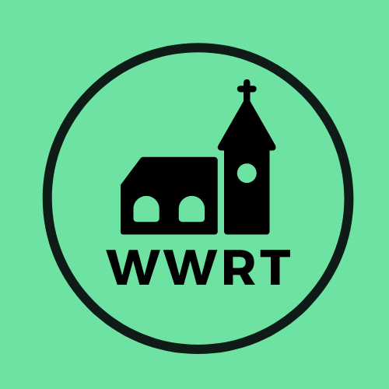

CHURCH SERVICES IN THE LOWER TEME VALLEY AUGUST 2025

Sunday 3rd August
Trinity 7
10.30am All Age, St Mary Magdalene, Broadwas*
9.00 am BCP Holy Communion, St Leonard, Cotheridge
*weather dependent picnic to follow service
Sunday 10th August
Trinity 8
3.00pm Evening Worship, Knightwick Chapel

Sunday 17th August
Trinity 9
10.30am CW Holy Communion, St Mary Magdalene, Broadwas

Sunday 24th August
Trinity 10
10.30am Morning Worship, St Mary Magdalene, Broadwas

Sunday 31st August
Trinity 11
10.30 am Songs of Praise, St Leonard, Cotheridge

In August there will be Holy Communion at Heaton House, Martley on 13th and 27th Wednesday at 10.15am and on the 1st and 3rd Wednesday via our YouTube channel -wwrtlive1.
All services and timings are subject to review and amendment – please check the website for updates: www.achurchnearyou.com

All services and timings are subject to review and amendment in accordance with Covid lockdown easing – please contact the Rectory or check the website for updates.
01886 888664
www.achurchnearyou.com

