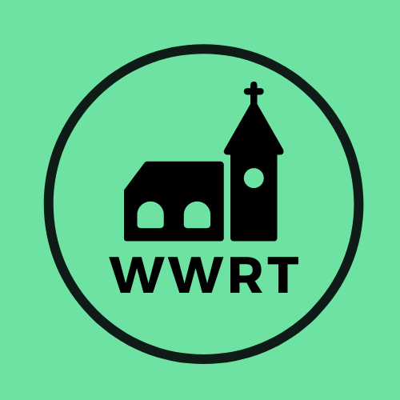
CHURCH SERVICES IN MARTLEY AND WICHENFORD
AUGUST 2025

Sunday 3rd August
Trinity 7
10.30am All Age, St Mary Magdalene, Broadwas *
10.30am CW Holy Communion, St Peter, Martley
*weather dependent picnic to follow service
Sunday 10th August
Trinity 8
10.30am CW Holy Communion, St Laurence, Wichenford

Sunday 17th August
Trinity 9
10.30am Café Church, St Peter, Martley

Sunday 24th August
Trinity 10
10.30am CW Holy Communion, St Peter, Martley

In August there will be Holy Communion at Heaton House, Martley on the 13th and 27th Wednesday at 10.15am and on the 1st and 3rd Wednesday via our YouTube channel -wwrtlive1.
All services and timings are subject to review and amendment – please check the website for updates: www.achurchnearyou.com

