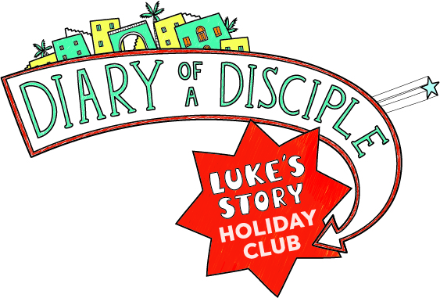

PLEASE RETURN TO Rev’d David Munchin, The Rectory, Ottway Walk, Welwyn, AL6 9AS, davidmunchin@outlook.com
Holiday club 2025 – calling all primary school children !
We are pleased to announce the next edition of our popular Holiday Club

Join our team of divers this Summer in our holiday club
‘Diary of a disciple’ at
St Mary’s Church in Welwyn

We meet at 10-12 every morning from
Monday 28th July to Friday 1st August for lots of games, crafts, activities and songs

The club is for primary school aged children and we ask you pay £5 towards our expenses per family

This event has 40 places, so it’s vital to book your place by returning the form overleaf

We hope to see you then! Do tell your friends and get them to book too.

Child’s Name……………………………………………………………………Age………………………….

Address (inc postcode): ………………………………………………………………………………………………………………………

Telephone……………………………………………………… 2nd Contact number …………….

E-mail……………………………….

Any known medical conditions ……………………….

Food allergies or special dietary requirements ………………………………..

Anything else useful for us to know …………………………………………….

Family doctor …………………………………………… Tel …………………………..

Parent(s)/ guardian name(s)……………………………………………………………………………….

And signature:……………………………………….. Date …………………………….

School……………………………………………………….

If you wish to pay in advance. Put a tick here…………… and enclose £5 –
or by BACS Acc no. 70939749 Sort Code: 20-92-54 Welwyn St Mary’s PCC
or use Card Reader in Church sometime during the week.

I give my permission for my child and my details to be entered on the church PC database (this will help us to administer this club) YES / NO

I give permission for my child’s photograph to be taken during the club by a club leader (this will only be used for church purposes, such as the magazine, and will not be distributed)
YES / NO

I give my consent to any necessary medical or dental treatment (including anaesthetic) that may be necessary in event of an emergency and/or if I am not contactable. YES / NO
I give consent for St Mary’s church to use these contact details to inform me of services and events that are relevant for my child. YES / NO
If we are oversubscribed we shall operate on a first come first served system, but assume that there is room, unless you hear otherwise.

