**St Mary Magdalene Parish Church, Medomsley**

**Church Repair Project**

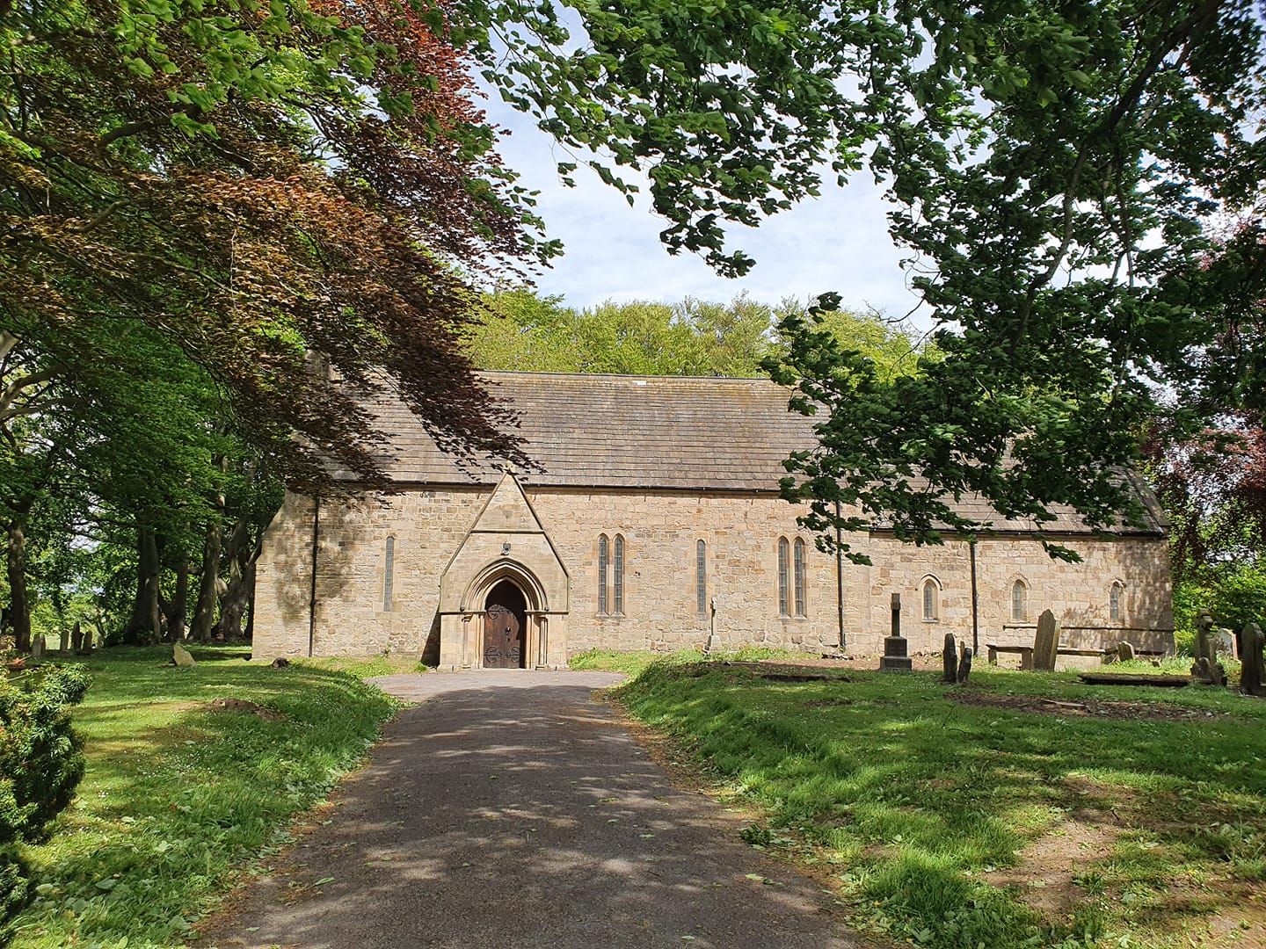

We are fundraising to raise money to pay for major repairs and some re-ordering works to St Mary Magdalene Church. Architect plans have been formally approved for the Grade I Listed Medieval Church, but we need to raise about **£20,000** more to proceed with the project.

**The Church Repair Project:**

* Repair of external drainage to the South Façade, causing internal dampness
* Replacement of the rotten and damaged nave floor
* A new energy efficient main boiler & relocation to the vestry
* Removal of 5 pews from the rear of church to create a more flexible space
* Redecoration of plasterwork

Medomsley Parochial Church Council would be very grateful for any financial donation you may be able to offer. We have already raised a significant amount but need to raise more to reach the target to proceed with the required work.

**How can you help?**

Your financial donation will help us in our aim of preserving our village’s historic and beautiful building for future generations.

**To donate,** please give **cash** or a **cheque** to ‘***Medomsley PCC’***or use the **church** **card machine** in church.

If you are a UK taxpayer, then please complete a gift aid envelope with your donation, as this increases the value of the gift without any extra cost to you.

Your support is greatly appreciated.

Thank you**.**

Medomsley Parochial Church Council Date: 23rd June 2025