If you would like to contribute towards keeping the church tower standing safely please scan the QR code below and it will take you to the Sumup giving page for the church account.

Just point the camera on your phone or tablet at the square and it will offer to open the webpage.

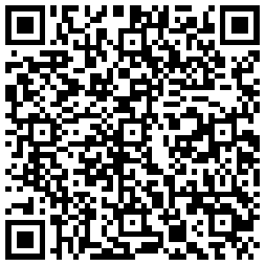

Alternatively, visit
https://pay.sumup.com/b2c/QZMG9XP7?utm_source=qr&utm_medium=digital&utm_campaign=image

by pasting it into your browser

