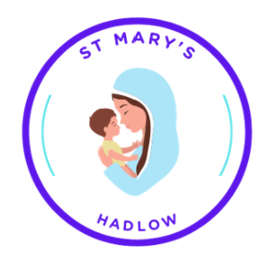
Questionnaire: Your Church
St Mary’s - Hadlow
An Inclusive Vision for 2030 –
Sustainability and Community -
A zero carbon project.
The Parochial Church Council (The PCC) of St Mary’s Hadlow are seeking your views and more ideas on proposed changes to the church and on how the building and church community can work more effectively together. What more could be done at the church to support the community, improve the environment and make for better outcomes for local people? The overall project is proposing to aim for the church to be net zero carbon as set out as a target by the Church of England. There will be funds available from the Church of England and charities supporting the Church of England Mission, however these will need to be supplemented by local fund raising and possibly Heritage Lottery funding and other funds supporting buildings of historical interest.
The PCC are responsible for the management of the church building and the Parish Council are responsible for the management of the churchyard. Changes proposed will need to be supported and agreed with the Diocese (Rochester), the PCC and the Parish Council where these involve the churchyard.

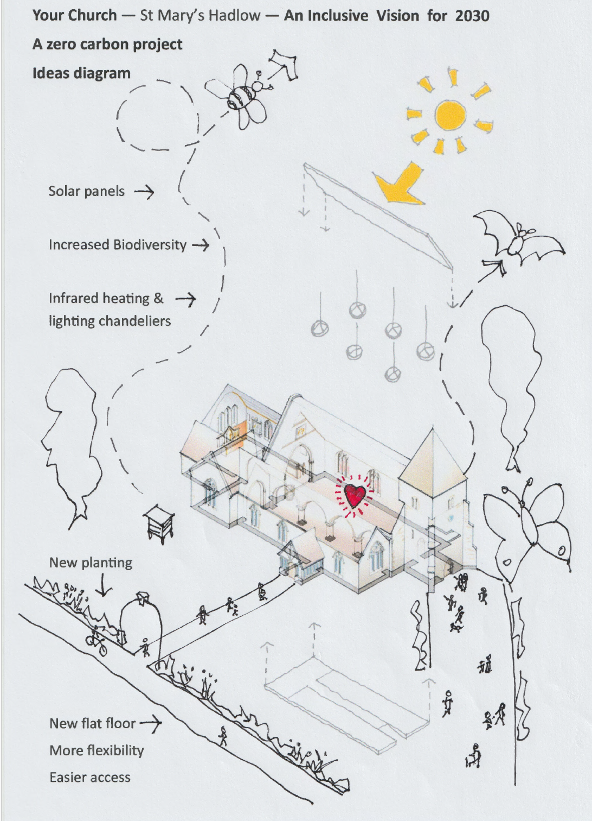

- Are you responding as:
  - An individual from the village
  - A representative of a society or group
  - Other
- If you are responding on behalf of an organisation please give the name and contact details:
Please write in below.

If you answered Other in question 1 please tell us a little bit more why you are interested in the proposal. Please write in below.

- Below is a list of current uses of the church building
Please confirm your views in relation to each by ticking the relevant box:
Yes - this is a good idea
No - this is not a good use of the Building
Activity | Yes | No
Weekly Communion services, Sunday and Wednesday
Morning Prayer Services, Tuesday and Thursday
Coffee morning for seniors
Tiny Tots and Coffee Pots
Monthly quiz and drinks nights
Food Bank (Thursdays)
Bell ringing group
Occasional concerts, assemblies, fayres, recitals etc,
Meetings for:
Historical Society
Yoga
Café Plus
Friends together Bereavement Support
Seniors’ tea
Carers Together Group

Note the Church is open 10.00am to 3.00pm everyday for quiet reflection and open for hire at other times
- Below is a list of current proposed alterations of the church building and its management.
Activity | Yes | No
Remove trip hazards and uneven floor to Nave
Change heating to electric infrared, heating people when they are in the building. Remove old pipes and radiators that are causes of trip hazards, leaks and maintenance issues, and gas boilers, as the new heating is in place.
Create a ground floor kitchenette to enable more easy service and reduce trip risks
Change seating to make easier and more comfortable rearrangement to different formats
Generate electricity on site with solar panels
Improve lighting (note some improvements were made last year by changing to LED sources)
Update wifi and electrics to allow for more flexible usage
Create a warm space available for anyone during hours the church is open.
Increase biodiversity in the church yard with perimeter planting, bat boxes, bug hotels and bird boxes
Manage the trees to increase biodiversity

Target zero carbon with suppliers and activities, and using onsite generation to assist with this.
Recycle materials where possible, ie steel pipes and radiators, redundant chairs etc.

- Please list any ideas you have on how the church can serve the local community better.
These could be ideas for specific activities or things you think the village generally needs that you could see the Church providing.

What would you like to see happen here?
Please write in below, activities or ideas for changes you see as beneficial.

Would you like to join a Friends of St Mary’s WhatsApp group to keep in touch with the project and help with its development?
If so, please provide contact details below, including a phone number, and email us
friends@stmaryshadlow.org.uk.
If you would like to talk about this, please call Richard Hopkinson (PCC Secretary – St Mary’s Hadlow) on 07717 870706.
When completed either return this to the church or to the Old School Hall office, or to any PCC members or by email to:
friends@stmaryshadlow.org.uk
A PCC members list can be found in the church or online @
https://www.achurchnearyou.com/church/16980/page/81081/view/

RH.
PCC Secretary

