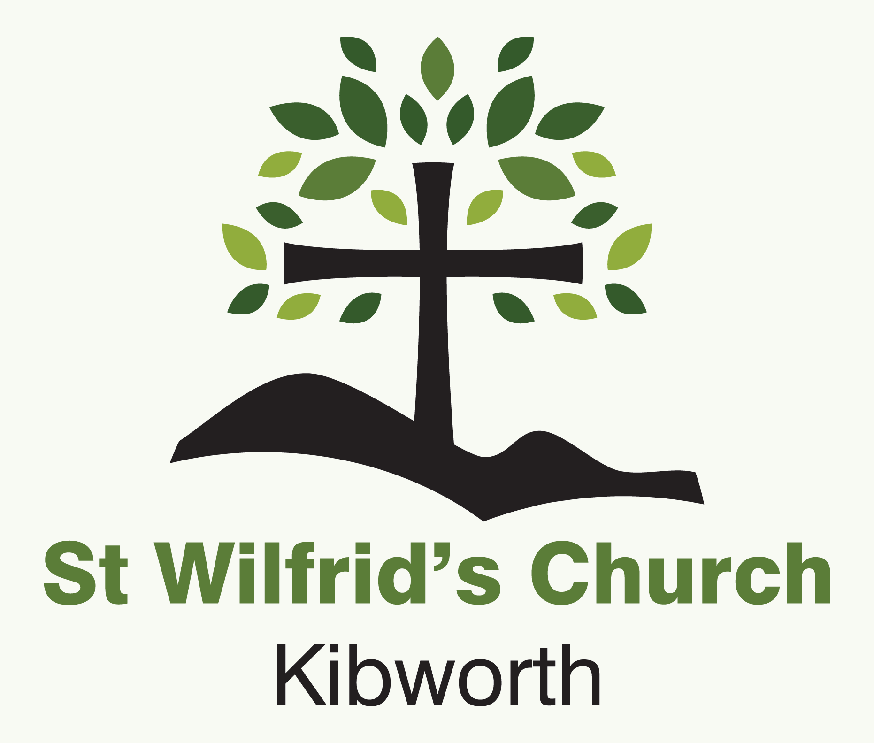

**Parish Giving Scheme**

St Wilfrid’s is pleased to announce that it is joining the *Parish Giving Scheme,* this is a new and innovative way in which parishioners can support the work of their local church.

The past eighteen months have been very challenging for all of us, but they have also been challenging for our church finances, if we are to continue the important work we do, to maintain our beautiful church, to spread the Gospel and to support our charities, then we have to look at new ways in which we can raise money, *The Parish Giving Scheme* does just that.

**How does it work?**

Many people already give by standing order. *The Parish Giving Scheme,* works by direct debit instead. It also allows us to claim gift aid in a much easier way than before and you can arrange to have your donation raised each year in line with inflation, to ensure that the full value of your donation is maintained. You can donate monthly, quarterly or yearly and it is simple to change your donation depending on your circumstances.

**Where does my donation go?**

Rest assured, that through the *Parish Giving Scheme* your money only goes to St Wilfrid’s and no deductions are made.

**What do I have to do?**

Setting up a donation to the *Parish Giving Scheme* is very easy, the best way is to do it online and the Church Wardens will be very happy to help you do this, however you can do it via a written form if that is what you would prefer. Several members of the PCC have already signed up. If you would like to take this further, please see one of the Church Wardens who will be happy to discuss it further and to help you through the process.

Please consider signing up to *The Parish Giving Scheme* and support the valuable work of St Wilfrid’s.

*This Guarantee should be detached and retained by the payer*

**The Direct Debit Guarantee**

* **This Guarantee is offered by all banks and building societies that accept instructions to pay Direct Debits.
* If there are any changes to the amount, date or frequency of your Direct Debit PGS will notify you 10 working days in advance of your account being debited or as otherwise agreed. If you request PGS to collect a payment, confirmation of the amount and date will be given to you at the time of the request
* If an error is made in the payment of your Direct Debit, by PGS or your bank or building society, you are entitled to a full and immediate refund of the amount paid from your bank or building society.
* If you receive a refund you are not entitled to, you must pay it back when PGS asks you to.
* You can cancel a Direct Debit at any time by simply contacting your bank or building society. Written confirmation may be required. Please also notify us. *(Phone- Online- and in person Banking are all included in this)*