Good News from Holnest Church!

Holnest PCC are very pleased to update you with the news that the planned scheme of major repairs and other emerging works has now been satisfactorily completed to a high standard and we look forward to reopening the church daily from 21 June.
We are grateful for the financial support we have received from the Heritage Lottery Fund thanks to lottery players, Dorset Historic Churches Trust, Erskine Muton Trust and the Friends of Holnest Church courtesy of their members and supporters and from the local Whist Drive players.
We also express our sincere thanks to those who have made very generous personal donations towards the repair and conservation costs. Collectively, along with our loyal supporters past and present we have been able to achieve the seemingly impossible.
Holnest Church invites you to join us at 4pm on Sunday 27 June for a ‘Thanksgiving Songs of Praise’ to celebrate the completion of building works and a party to launch a free ‘Summer Programme of Events and Activities’ with something for everyone. More details on page ?????.

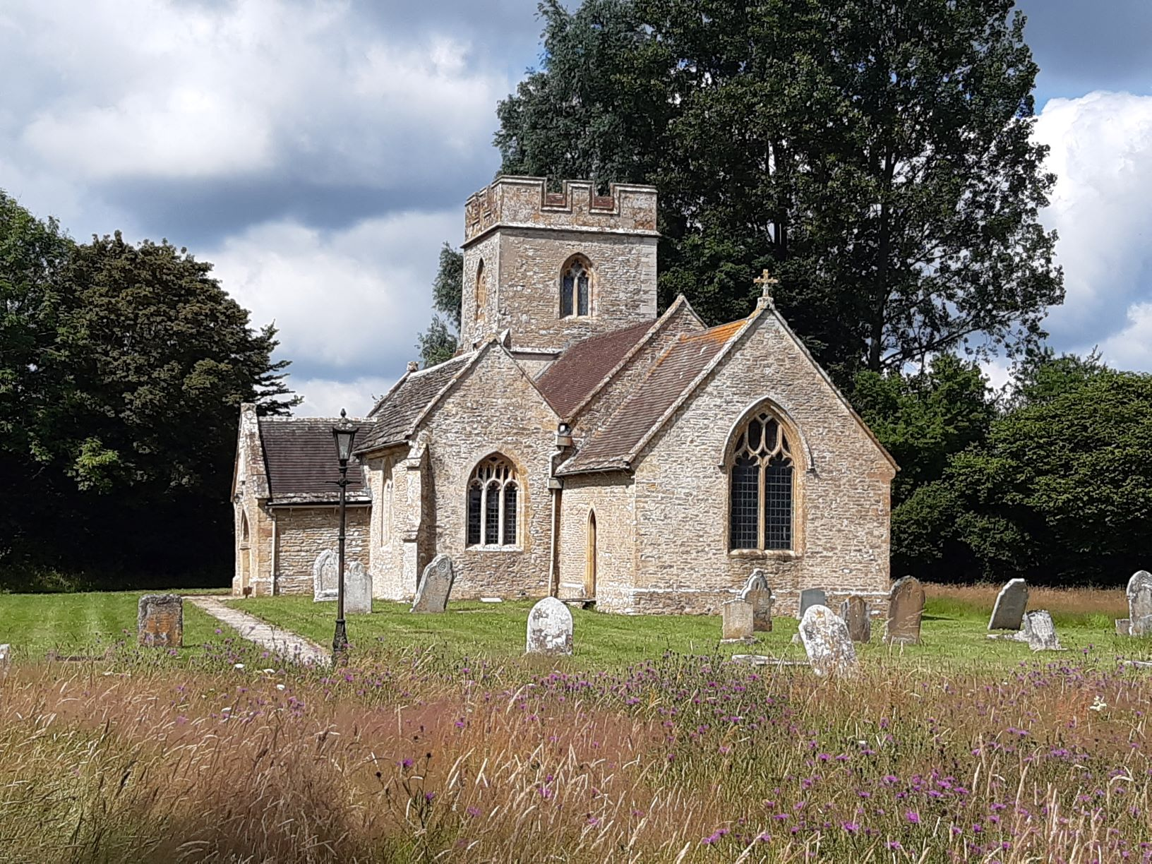

HOLNEST CHURCH

