St. Mary’s, Great Parndon.
SEPTEMBER 2021 News.

Priest in charge – Revd Richard Attew –Tel 01279 315044.

Services - Sunday – 11:00am Holy Communion/ morning worship.
Wednesday – 9:30am Morning Prayer.
Thursday – 9:30am Morning Prayer.
St Mary’s is open for Sunday Worship – revised procedures. From Sunday 25th July the wearing of face masks will be strongly advised and the pews on the left-hand side will still be cordoned off, to maintain a socially distanced space. We will revert to service books, the communal prayer book and votive candles. The hand sanitisers, one way system and open doors will remain. We will also sing the final hymn, wearing face masks. We will be offering teas and coffees from mid September.
We have imposed a limit on people attending baptisms and funerals, of 50.
Wednesday virtual Evening Prayer Group
This is held on Wednesdays at 7pm via Zoom. Please contact Paul Bartlett (tel. 01279 868524) if you wish to join.

Next PCC meeting – Tuesday 7th September
Please pray for our PCC members as the next few month’s activities are planned.

Church Litter Pick – Saturday 22nd August.
A big thank you to Richard, Ray, Janet, Alison, Marjorie, Peter, Paul B and Paul N who collected 8 large bags of rubbish from Katherines estate. Harlow Council will donate £100 for all successful litter picks which will be given to Harlow Women’s Refuge.

Harlow Chorus Concert -Saturday, 11th September - The Gift of Life.
This will take place at All Saints church, Hockerill, Bishop’s Stortford.
Peter Mountsteven has 5 unreserved tickets @ £12.00 each now with more available from tickets@harlowchorus.org.uk . Peter is one of the singers, so it would be good to support him.

Macmillan Coffee Morning – Friday 24th September.
We hope to host this at St Mary’s church on the above date – between 10:30am and 1:00pm. Watch out for further details and posters nearer the time.

ECO tip. –recycling used postage stamps.
Marjorie is collecting used postage stamps for St Clare’s Hospice. You can leave them in the metal sweet tin at the back of church, under the notice board behind the font.

Congratulations to Nigel and Linda Apps as they have recently celebrated their Golden Wedding Anniversary.
Foodbank. Peter Button is happy to take donated items from St Mary’s to the Foodbank each week. Please leave items in the usual place next to the font.
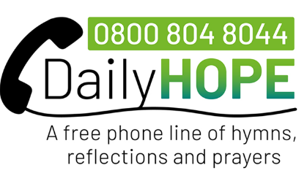
For help:
The Church of England has launched a free 24-hour phone line, Daily Hope, offering hymns, prayers & reflections (0800 804 8044).
Email; https://www.churchofengland.org/more/media-centre/coronavirus-covid-19-guidance-parishes/daily-hope-phone-line.

