From the Vicar September 2021

Discovering a ‘New Normal’……
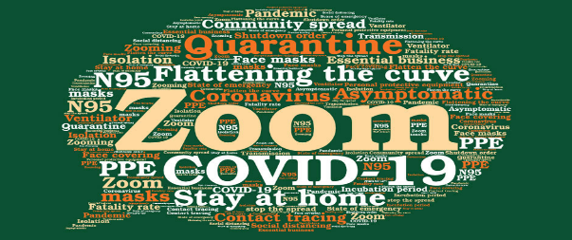
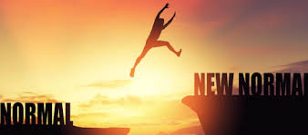
Since March 2020, the arrival of the Coronavirus pandemic has generated a remarkable vocabulary of words which have become familiar to us all – including terms such as Covid-19, virus, lockdown, social distancing, face masks & shields, stay at home, stay safe, furloughed, elbow bump, Zoom, online/’virtual’ engagements, jabs, and – summing it all up - unprecedented!
Throughout this extremely challenging and difficult time, we’ve also been told that this dangerous virus will remain with us for the foreseeable future, and that we will have to discover and embrace a ‘new normal’ – but what might that involve?
Here’s a few musings to consider…..
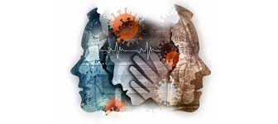
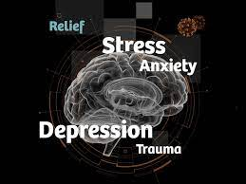
The experience of trauma has been common as the pandemic continues. However, trauma is not ‘in the event’ itself, but a ‘mind-body’ response when our capacity to adapt is overwhelmed, creating changes in our brain’s functioning and our emotions too, such as confusion, inability to concentrate, numbness, sadness, anxiety, agitation, even anger. Not everyone will experience trauma from a particular event, and those who do may not experience the same kinds of trauma responses.
This means that there’s been a wide variety of reactions throughout the pandemic, including now as most Government restrictions have been lifted; some people feeling anxious about mixing with others and preferring to continue staying at home, others happy to discontinue face masks and social distancing and freely mixing in the company of others, and a huge spectrum of responses between these two….and that means that there will be many differing understandings and forms of ‘new normal’
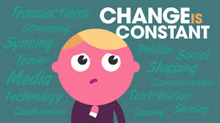
arising as well.

Throughout the pandemic, the one ‘constant’ has probably been ‘change’ – which has required the need for adaptability, flexibility and resiliency in almost everything we do, including
- Working from home, and/or adapted office space practices with colleagues
- Schooling at home with on-line provision, as well as adapted in-person schooling
- Use of ‘virtual meetings’ via Zoom or Microsoft Teams, whether for work, for leisure pursuits, for safely interacting with family and friends
- Shopping online and/or shopping in-person and observing retailers’ restrictions or requests concerning face masks, social distancing, etc.

Continued…..
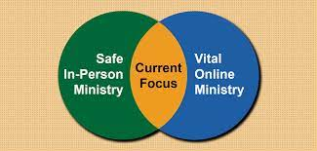
- Generating hybrid approaches for most of the things we enjoy doing, including of course accessing public worship – some people are thrilled to return to in-person services, others feel uneasy and hesitant about doing so and prefer to enjoy on-line worship provision….
a ‘both/and’ approach will likely be an essential feature of ‘new normal’ for most people as we continue to learn to live with Coronavirus.
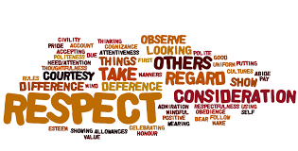
I’m certain there’s much more that could be said about discovering a ‘new normal’ which I’ve not mentioned (or even thought about yet!), but in drawing this reflection to a close, may I offer you the following thought…..

Whatever may continue to change and alter as ‘new normal’ gradually emerges for us all in various forms, what surely remains constant is God’s love for us….his desire that WE trust his love and seek the abundance of life he longs for us to experience in our lives, AND to truly ‘love our neighbour as ourselves’ – which means practicing the values of patience, understanding, consideration and respect for the needs, differing views, and especially the safety of others, whose ‘new normal’ might be a bit different!

With the assurance of my continuing care, and prayers, for the safety and wellbeing of you and your loved ones,
Vicar John
