GRATWICH NEWSLETTER  AUGUST 2021  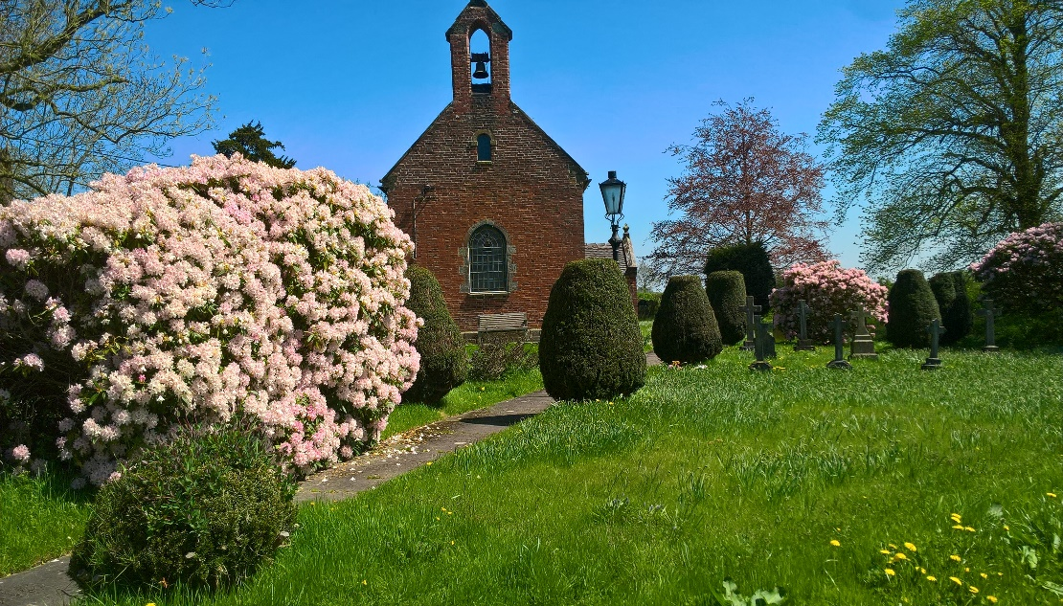  Tell out my soul the greatness of the Lord  Unnumbered blessings, give my spirit voice  Tender to me the promise of his word  In god my Savour shall my heart rejoice. | GRATWICH SERVICES IN AUGUST  SUNDAY 1st 7.00pm Evening Prayer via ZOOM  SUNDAY 8th 11.15am Holy Communion IN CHURCH  SUNDAY 22nd 7.00pm Evening Prayer IN CHURCH  SUNDAY 29th 10.00am AREA SERVICE – Greatwood Primary School, Tean  It is not necessary to book a seat or wear a mask in church but if you feel you would prefer to wear a mask that’s fine.  There will still be hand sanitising and social distancing for the moment.  Blimey actual Summer Weather in July and hot enough to make hay as well!!  We made ‘almost’ hay and had it wrapped as we don’t have a barn to keep hay in.  It brought back memories of long ago (eee when I was young!) haymaking at home in-between milking times and in the evenings – small bales by pitchfork, not like today with large round bales moved with tractor spike.  It was hot work and I suppose tiring at the time but travelling back up the field on top of a load of bales was the best thing ever.  100 CLUB – JULY - drawn at the Evening Service on 25th July  1st Bonnie Cotton 2nd David & Co Woolley 3rd Carol Woolley  The 100 club started it’s new year in July – if you would like to join/rejoin please contact Sue Capewell 01889 502241 (Church Treasurer) ASAP.  The next draw will be at the evening service on 22nd August in church .  EASY FUNDRAISING FOR ST. MARY’S  As you may (or may not) know the PCC are raising funds to re-wire the church (new heaters and lights too), have the water connected and install an eco-toilet in the churchyard.  If you register with www.easyfundraising.org.uk and support St. Mary’s church Gratwich, when you shop on-line (as most of us do!) they will donate money to St. Mary’s. It doesnot cost you anything (or make your purchases any dearer) but would be a big help to church funds. Have a look there are 100s of companies to shop from so there will be some you buy from I am sure.
The Uttoxeter Area of Churches  Invites you to  AN AFTERNOON TEA!  Sunday 15th August 3.00 – 5.00pm  At Marchington Woodlands Village Hall ST14 8PF  Join us for an afternoon of activities for all the family – and tea & Cake!!  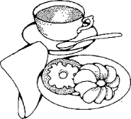  *****************************************************  MARCHINGTON OPEN GARDENS  7th and 8th August 11.00am – 5.00pm  £5 Entry by wristband  available from Marchington Shop (next to the church)  www.marchingtonshop.co.uk  Refreshments and wine tasting at the shop  Also Refreshments served in some of the gardens.  *********************************************************  St. John the Baptist Church,  Stowe by Chartley  Pet Service  Sunday 5th September 3.00pm  All welcome to come along with their pet/pets  To Book a place please phone: 01889 270114/01889 270596 | The article below was written by Mrs Elizabeth Statham who farmed at Elm Farm, Bramshall and is borrowed from Bramshall Newsletter.  She was born in 1895 and was the grandmother of Robert Statham who farms there now.  The House in Gratwich used by the Postman to mend boots in was situated in the corner of the Church Croft by the road and called “The Postman’s Hut”. The ruins of which are still there in the nettles.  BRAMSHALL AS IT USED TO BE  How well I remember the lovely countryside around Bramshall: the footpaths, especially the unique one which was raised over three feet down Bennett’s Lane, which has unfortunately been allowed to go astray and would have been much more valuable in these days of heavier traffic. At the termination of this path we turned in across the field opposite, to cross the railway over the bridge and so on to the Great Northern Line.  Past this we went over a stile and through a field to a rather shaky plank with only one handrail over the brook. A coppice lay opposite, after which we came out onto the main Stafford Road.  To view Bramshall from Loxley Hall was well worth the effort, not only of knowing most of the fields by name, but also all their associations over so many years.  Coming back to the village, which used to be a hive of activity, we saw the local Baker’s shop, Wheelwrights, Butchers, Cobblers and not forgetting the busy little Bramshall School, where concerts were held and local talent used. These were worthy to be remembered. I recall the Whist Drives and the Dance Music to gramophone (by special permission) in the good old days, when most of us appreciated our limitations but made the most of them.  There was the postman on his early morning round, delivering letters, then collecting boots to repair to occupy himself for the rest of the day at a house in Gratwich. He came back about six in the evening to collect the post and take it on to Uttoxeter in time for the G.P.O. mail coach to Stafford.  This returned during the night with the next day’s post.  I think the well, which supplied the majority of drinking water for the village, deserves a mention. Regularly one could see folk shouldering their buckets attached to yokes which were worn across their shoulders. This well was called “Incroft Well”, where the water was filtered before use. Most pumps were terribly hard to use and I remember that the water tended to be the same.  If anyone has any information about Gratwich in the past please let me know – it would be lovely to put it in the newsletter. Jenny  For further information about anything in the newsletter, please contact:  Rev. Charles Dale 01889 500428: email: revcharles.dale@btinternet.com  Jenny Talbot: 01889 50241 email: jenny477@btinternet.com  Facebook: St. Mary’s Church Gratwich

