BREAKING OF THE BREAD
He whom the universe could not contain is present to us in this bread. He who redeemed us and called us by name now meets us in this cup. We take this bread and this wine. In them God comes to us that we may come to God.

GIVING OF COMMUNION
The table of bread and wine is now made ready. It is the table of company with Jesus and all who love him. It is the table of sharing with the poor of the world with whom Jesus identified himself. It is the table of communion with the earth in which Christ became incarnate. So come to this table. It is Christ who invites us to meet him here. Communion is shared.

AFTER COMMUNION
POST COMMUNION COLLECT
NOTICES

THE BLESSING
May Christ, who out of defeat brings new hope and a new future, fill you with his new life; and the blessing of God Almighty, Father, Son and Holy Spirit be among you and remain with you always. Amen.

HYMN
Go in peace to love and serve the Lord. In the name of Christ. Amen.

Communion may be served from two stations in church. Gluten-free bread/wafers are available.
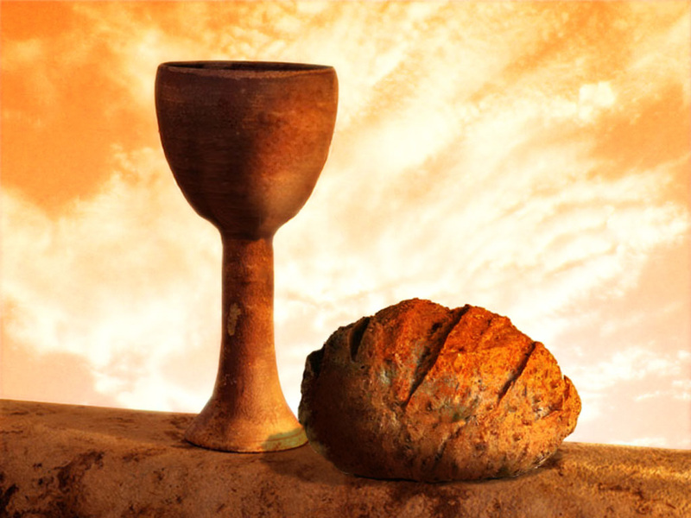

Please join us after the service for tea or coffee and if this is your first time here, please make yourself known to the sidespersons, wardens or clergy.

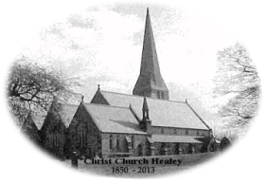
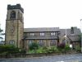
St Ann’s Belfield, Christ Church Healey and All Saints Hamer

Benefice Communion Service

THE PREPARATION
WELCOME AND INTRODUCTION
The Lord be with you and also with you.
We have come to worship God our Father; to acknowledge his power and authority, to give thanks for his care and keeping, and to offer ourselves in the service of Christ, our Risen Lord. Amen.

He is the Creator: he gives us life and breath.
He is the Preserver of all life: he sustains us day by day.
He is Redeemer of his people: he shows us his love in Christ.
He is Lord of lords: he controls all things.
O God and Father, we bring you our love and praise and give you thanks for all your goodness, through Jesus Christ our Lord. Amen.

HYMN

CONFESSION and ABSOLUTION
We come to God as one from whom no secrets are hidden, to ask his forgiveness and peace. Let us in silence remember our own faults and failings.
In the community of Christ’s church and in the presence of all God’s people, we confess that we have sinned in thought, word and deed. We have not loved God, cared for God’s world, nor respected God’s people as we should. We own our responsibility and pray for God’s pardon.
GLORIA (sung or said)

COLLECT
THE LITURGY OF THE WORD
BIBLE READING:
This is the word of the Lord. Thanks be to God.

HYMN

GOSPEL READING:
Hear the Gospel of our Lord Jesus Christ according to ...........
Glory to you, O Lord.
This is the Gospel of the Lord. Praise to you, O Christ.

SERMON

CREED (sung or said)

PRAYERS OF INTERCESSION
Lord, hear us. Lord, graciously hear us.

Merciful Father, accept these prayers for the sake of your Son our Saviour, Jesus Christ. Amen.

THE PEACE
Christ in you, the hope of glory: this is the gospel we proclaim!
To crown all things there must be love, to bind all together and complete the whole. Let the peace of Christ rule in our hearts. The peace of the Lord be always with you and also with you.

HYMN
During this hymn our gifts are offered.
Generous God, creator, redeemer, sustainer, at your table we present these gifts, symbols of the work you have given us to do; use them, use us, in the service of your world to the glory of your name. Amen.

THE LITURGY OF THE SACRAMENT
THE EUCHARISTIC PRAYER
The Lord is here. His Spirit is with us.
Lift up your hearts. We lift them to the Lord.
Let us give thanks to the Lord our God. It is right to give thanks and praise.

It is right to praise you, Father, Lord of all creation; in your love you made us for yourself. When we turned away you did not reject us but came to meet us in your Son. You embraced us as your children and welcomed us to sit and eat with you.

In Christ you shared our life that we might live in him and he in us. He opened his arms of love upon the cross and made once, for all, the perfect sacrifice for sin.

On the night he was betrayed, at supper with his friends he took bread and gave you thanks. He broke it and gave it to them saying, “Take, eat; this is my body which is broken for you. Do this in remembrance of me.” Father, we do this in remembrance of him: his body is the bread of life.

At the end of supper, taking the cup of wine, he gave you thanks and said. “Drink this all of you; this is my blood of the new covenant which is shed for you for the forgiveness of sins. Do this in remembrance of me.” Father, we do this in remembrance of him: his blood is shed for all.

As we proclaim his death and celebrate his rising in glory, send your Holy Spirit that this bread and this wine may be to us the body and blood of your dear Son. As we eat and drink these holy gifts make us one in Christ, our Risen Lord.

With your whole Church throughout the world we offer you this sacrifice of praise and lift our voice to join the eternal song of heaven: holy, holy, holy Lord, God of power and might, heaven and earth are full of your glory. Hosanna in the highest.

THE LORD’S PRAYER
As our Saviour taught us, so we pray:
Our Father in heaven, hallowed be your name,
your kingdom come, your will be done, on earth as in heaven.
Give us today our daily bread.
Forgive us our sins as we forgive those who sin against us.
Lead us not into temptation but deliver us from evil.
For the kingdom, the power, and the glory are yours now and for ever. Amen.

