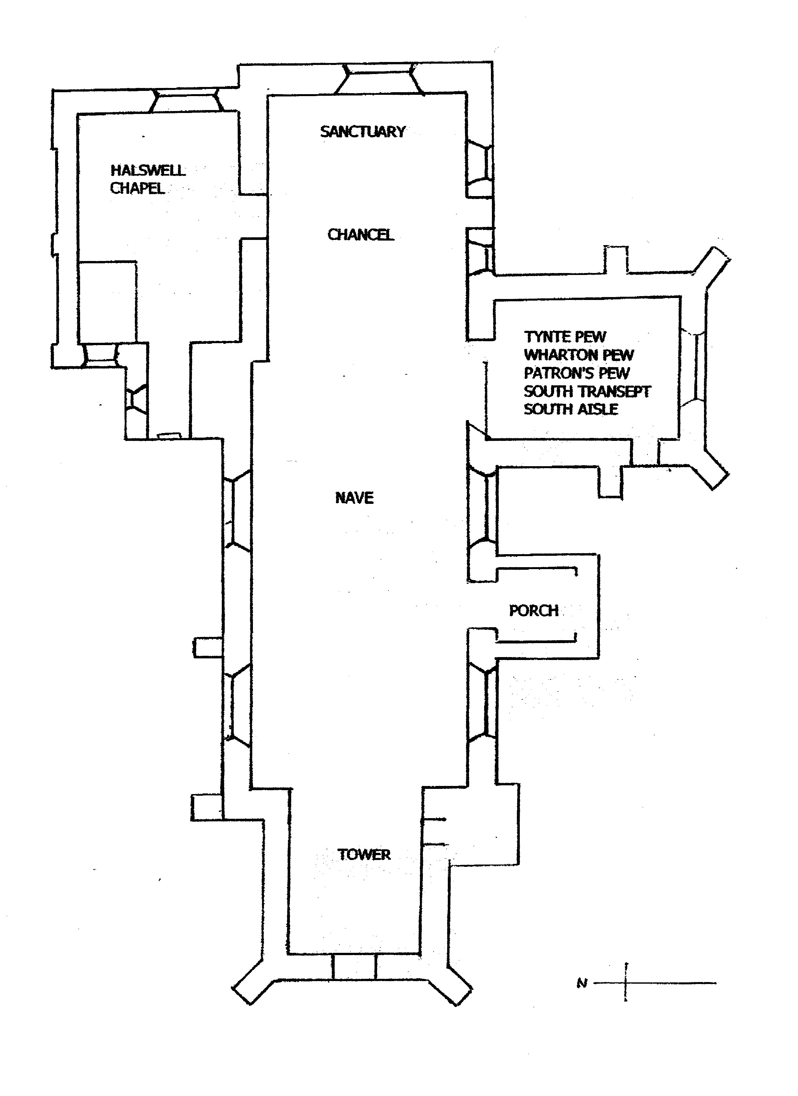
The Church of St Edward, King and Martyr
Notable features as described in the guidebook
Nollekens monument to
Sir Charles Kemys Tynte
(Pevsner comments on this)
15th Century Font
Unique 18th Century Clock (outside the Church). Single hand.
Painting showing assassination of the patron saint
Tudor
Must see !
14th Century Piscina
Early 18th Century panelling
Pulpit (1630) and Tester (1690)
Hatchments

