Joy and hope in Kondoa, despite pandemic
Latest reports from our companionship diocese in Tanzania provide a mix of good and worrying news. The main positive news is that eight new ministers were ordained on 11 July, an annual round of confirmation services has just begun and construction of a new Cathedral in Kondoa is proceeding much faster than expected. This is all against a background of the rapid spread of the Covid-19 virus. Across sub-Saharan Africa less than 2% of the population has been vaccinated, and Tanzania is at the back of the queue for vaccines, as its previous president, now deceased, had refused to recognise the threat.
In an email message regarding the pandemic, Bishop Given reported: “The situation is very serious and the government now has admitted this and is taking the situation seriously. Now we cannot travel unless it is necessary and you need to have masks. We are encouraged to stay home. On 2 July the government announced our third wave of Covid19 and the president spoke from her heart about the bad situation and that people are dying. Before this, under the late President Magufuli, people when they died from Covid19, it was recorded that they had heart failure but now they are admitting they died from Covid19. It is now open. And indeed people are dying! We are now praying for the vaccination to come as the government has allowed it to come! Please pray for us so that we too can have the vaccination. This will save the lives of so many people who are now dying!”
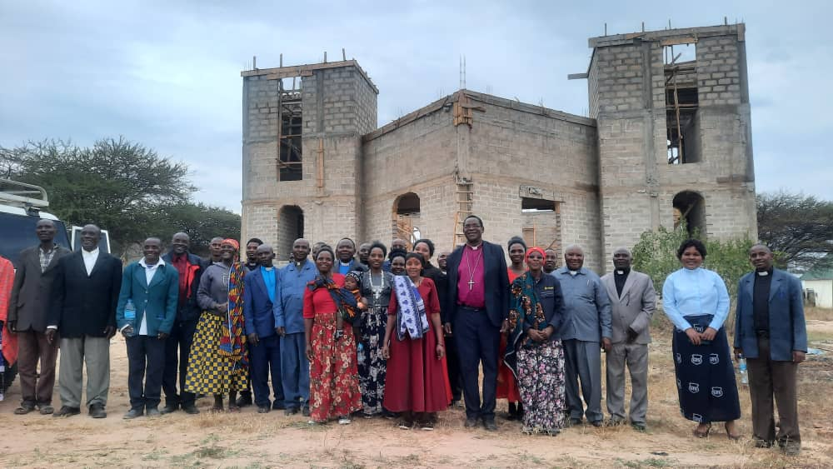
The photo shows new ordinands and their families visiting the new St Paul’s Cathedral under construction. This is being built near the Cape Town to Cairo highway running through Kondoa, on land adjacent to the new Diocesan primary school. Bishop Given says: “I thought the building will take five to ten years to finish! I hope and trust God will provide for us to finish if not in November even next year, when we celebrate our ten years of our mission work of servanthood in this missionary Diocese! My faith has increased to another step, that to God nothing is impossible!”
14 July 2021

