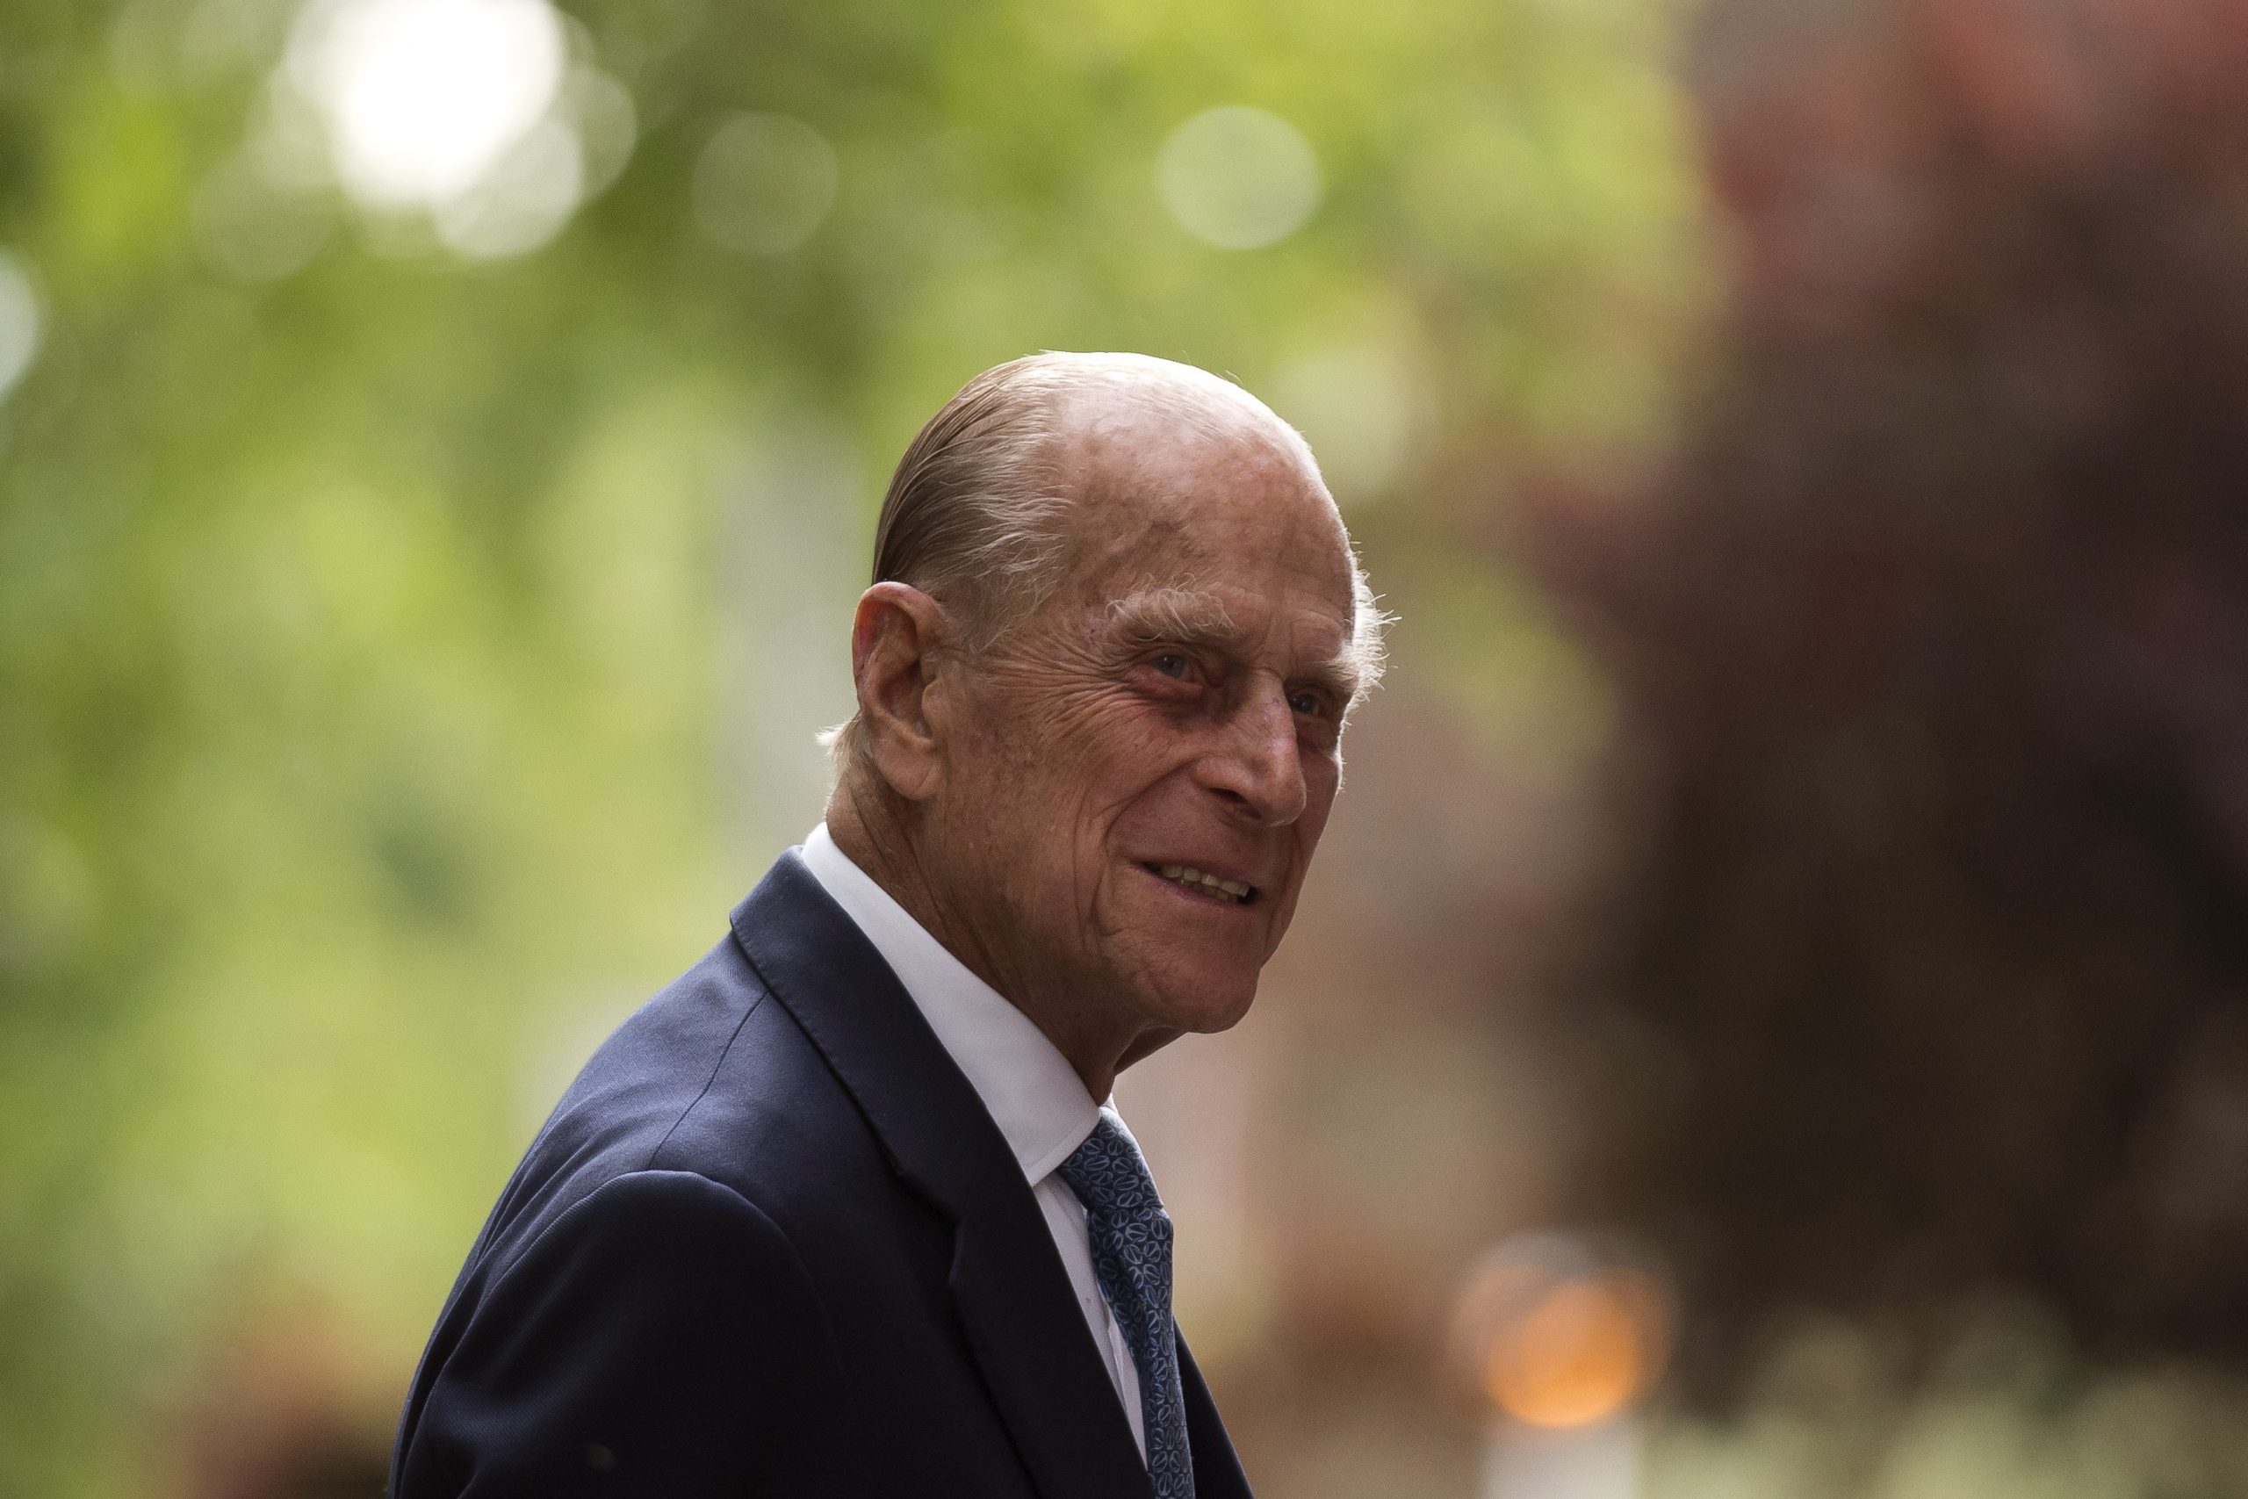
Photo courtesy of the Press Association

God of our lives,
we give thanks for the life of Prince Philip,
for his love of our country,
and for his devotion to duty.
We entrust him now to your love and mercy,
through our Redeemer Jesus Christ. Amen.

