His Royal Highness, The Prince Philip,
Duke of Edinburgh

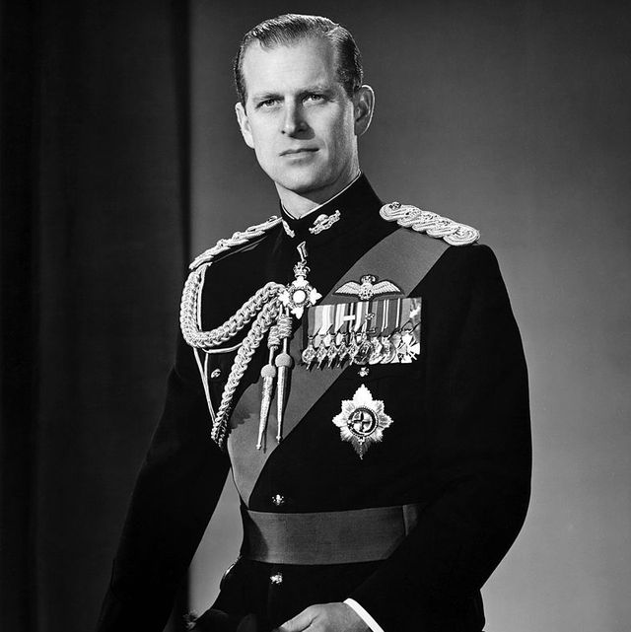
1921 – 2021
REFLECTION AND PRAYERS

REFLECTION
When someone in the public eye so long and so intensely observed dies there are a range of emotions we go through. Let’s take time to reflect on those emotions. We will mourn the death of the individual, in this case the Duke of Edinburgh; we will feel for his wife, our Queen; we shall think of the wider family, itself so much a subject of speculation and opinion in the media.
In these coming days we deliberately reflect on and name the reasons we grieve. Among those reasons may be:
- We recall a significant loss and bereavement of our own.
- We feel a little more alone in the world because another so familiar face, voice and character is gone from us. So many others that were part of our growing up, our childhood, adulthood and mature years have gone. Added together it almost overwhelms.
- Perhaps we are reminded of our own mortality and the nearness of our own parting this life. How will we be remembered? Who will grieve and be affected by our death? What should I still do or say before I die and do I have the courage or strength to do it?
- Things of value, significance and order seem to slip as Prince Philip dies; the value of service, of resilience of character, the purpose of life, the constancy and consistency of a life well lived. We wonder are these things passing too.
However much we have watched the television, read the papers or followed his life story, none of knows the Duke of Edinburgh. We have had partial glimpses. It is the same for anyone in the public eye and has been true of him, Her Majesty and the royal family as of few other families. But their doors are not open all the time; their conversations not all made public; their inner motives and feelings not known.

So we mourn, grieve and feel today. But I ask we deepen our listening to ourselves and bring that listening to God. Perhaps say to the Lord:
‘I grieve today for these reasons. I bring you my whole, vulnerable, perhaps scared or angry self. You Lord know me completely and love me dearly. Hold me in life, as you hold your servant Philip in death, secure and safe. Amen’.

THE PRAYERS
In this moment of sorrow the Lord is in our midst and consoles us with his word: No eye has seen, nor ear heard, nor the human heart conceived, what God has prepared for those who love him.
Jesus said: Blessed are the sorrowful; they shall be comforted.
Christ is in our midst. And always will be.
We remember Philip’s marriage and family life. For over seventy years of partnership, mutual care and support. For times of distress and joy faced as husband and wife. We remember all who are married and families in distress for any reason, including the impact of loss and bereavement this past year.
Christ is in our midst. And always will be.
With gratitude we remember Philip’s gifts of character that enabled him to be a leader in wartime; that gave him the vision to encourage young people to aspire and achieve through the Duke of Edinburgh Awards; and that made him an early prophet of the damage we were doing to the environment and its wildlife – God’s creation for which we are responsible.
Christ is in our midst. And always will be.
We rejoice that Philip had passions and interests he was able to follow; his love of poetry – over 200 volumes were in his library; his skill as a painter and interest in developing his technique; his competitive spirit and working as leader of a team in carriage driving and part of a cricket team; his promotion of innovation in British industry and desire to understand its processes.
Christ is in our midst. And always will be.
We recall that he was among the last people to connect two world wars; born during the fragile peace after the First and serving with distinction in the Second. For his continued interest in the armed services and especially of the Royal Navy we give thanks. We entrust all currently serving and all who have sought to maintain peace and bring reconciliation after conflict.
Christ is in our midst. And always will be.
Finally we remember his role as a human being; in relationship with his children and grandchildren; for his humour; for the almost countless engagements, events, parades, ceremonies and religious services attended and miles travelled by land, sea and sky. For his vivid humanity, his eventual frailty and ultimate mortality. Whatever our titles, roles and calling, in the midst of life we are death, to whom can we turn for help, but to you O Lord?
Christ is in our midst. And always will be.
God of our lives, we give thanks for the life of Prince Philip, for the love he shared among us, and for his devotion to duty. We entrust him now to your love and mercy, through our Redeemer Jesus Christ. Amen.
Merciful God, be close to all who mourn, especially The Queen and all members of the Royal Family. May they know the hope of your promises and the comfort of your love, through Jesus Christ our Lord. Amen.
May Christ our Lord give us peace. Amen.
~~~~~~~~~~~~~~~~~~~~~~~~~~~~~~~~~~~~~~~~~~~
The prayer response: ‘Christ is in our midst. And always will be’, is found in the Orthodox Church liturgy at Easter time. Prince Philip was baptised in the Greek Orthodox Church and it seems appropriate to acknowledge that link.
~
The Church of England has created an online Book of Condolence.
You can access that at:
https://www.churchofengland.org/remembering-his-royal-highness-prince-philip

