Spring sunshine brings signs of hope, light and brighter days ahead, and we write to update you, that we are planning on returning to worshipping in our church building on Palm Sunday - Sunday 28 March at 11:30am.

Holy Communion - Palm Sunday
28th March at 11:30am

Until Sunday 28th March we will be maintaining our closed church policy during this lockdown, opening for maintenance and cleaning visits only.

We are a responsible and committed PCC ensuring a Covid-secure Church and environment each time we gather together.

We will be observing and worshipping in accordance with latest government rules and Church of England guidance extant at the time.

We continue to pray for all who are affected by the impact of the Covid-19 pandemic and hold you and your families in our prayers.

Pray that all goes well so that on that day we will wake and say:
"Let us go into the house of the LORD." (Psalm 122:1)

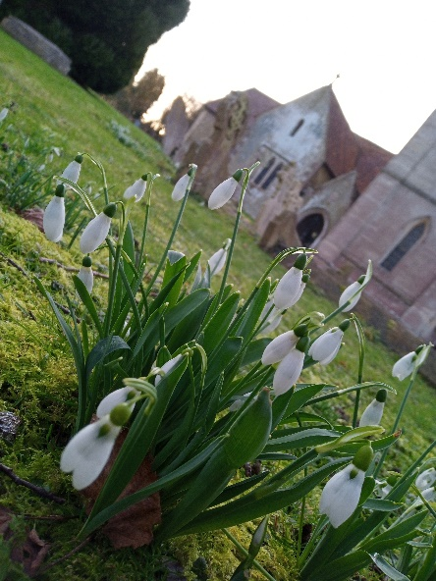

Have a blessed week ahead, stay safe and stay well.

With best wishes,
Kelvin.

St. Peter's Church, Milton Bryan
'Where God's Love is present'

Mr. Kelvin B White. LLW & Churchwarden.
4 Church End, Milton Bryan, Bedfordshire, MK17 9HR.
Tel: 01525 210337. kelvinbrucewhite@gmail.com

