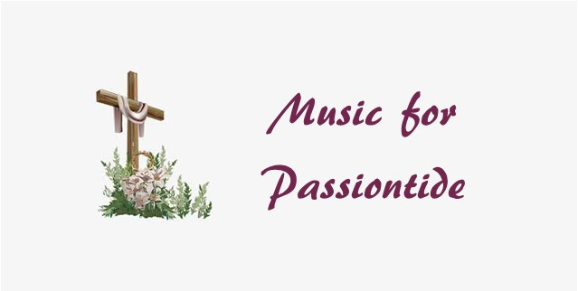

TO LISTEN TO EACH PIECE PLEASE PRESS ‘Ctrl and left click’ ON YOUR MOUSE/TOUCHPAD

https://www.youtube.com/watch?v=RnkSFKJ4rC0, opening chorus Bach St Mathew passion
https://www.youtube.com/watch?v=Zry9dpM1_n4 Erbarme dich from St Mathew passion
https://www.youtube.com/watch?v=74Q33UL7ugc Purcell -Hear my prayer oh Lord
https://www.youtube.com/watch?v=de_OPTtfZdw Tallis- Lamentations Queen’s six
https://www.youtube.com/watch?v=DWyG4wqU0Tw Lobo- Versa Esta in Luctum Tenebrae
https://www.youtube.com/watch?v=nXYbEyvVXUk. Os Justi- Bruckner. Beautiful anthem
https://www.youtube.com/watch?v=74PLyulsJ04 Drop drop slow tears Kenneth Leighton
https://www.youtube.com/watch?v=4YA9LSBLOB0 short animation, seasonal- Spring….
https://www.youtube.com/watch?v=hTO9ms_eIEY Beethoven 4th Piano Concerto Lang lang and Christoph Eschenbach- Beethoven’s kindliest concerto.
https://www.youtube.com/watch?v=zW9pv4j00Dk Teo GErtler, Sarasate- Zigeunerweiser Nothing to do with Easter or Lent- but a heart warming performance from an amazing young violinist. On a 3/4 size instrument!

..\..\OneDrive\Email attachments\VIDEO-2020-06-05-17-39-16.mp4

