Maundy Thursday (1st April)
Sung Eucharist of the Lords Supper
and Watch at the Altar of Repose (ONLINE ONLY)
Youtube/Facebook channels or
Church website: www.holytrinityweymouth.org

HOLY TRINITY CHURCH OPEN FOR EASTER WORSHIP
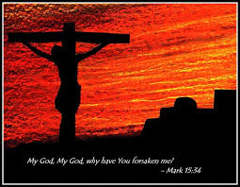
Please follow HANDS – FACE - SPACE instructions Book to attend 07396627753

GOOD FRIDAY (2nd April)
2.30pm LITURGY OF THE DAY
LIVE broadcast from Holy Trinity church
Worship with us on Holy Trinity Facebook page

EASTER DAY (3rd April)
8am Said Eucharist
10am The Easter ceremonies PARISH EUCHARIST OF THE RESURRECTION
LIVE broadcast from Holy Trinity church.
Worship with us on Holy Trinity Facebook page
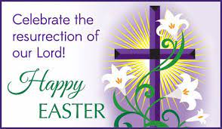

Please note that those NOT ATTENDING CHURCH can watch our services live or on our Youtube/ Facebook and website channels at your convenience. WEBSITE ADDRESS www.holytrinityweymouth.org

