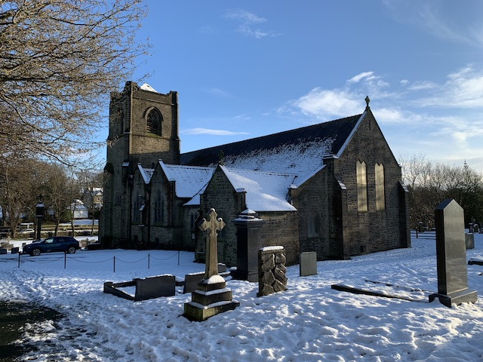

Sunday, 31 January 2021
Dear Friends,

I hope all are safe and keeping well. Our little one in Tokyo is a week old. With borders closing we so appreciate photos. Reading with a five year old continues. Unicorns now appear on screen. No distraction and no idea how she does it! Sledging is happening in Hamburg. Viewed from a window or deep in soggy mud the countryside is a lifeline. We hope to do the Big Garden Birdwatch. Saw weasel in the garden this week.

This week saw Holocaust Memorial Day. The theme was, be the light in the darkness. Survivors emphasised that any kindness, when surrounded by suffering, indifference, and persecution, is powerful. Talking to the horrors of the past and situation today it was truly humbling.

This has been a challenging week because of the dreadful news of 100,000 Covid-19 deaths since the pandemic began. It is hard to imagine the scale of grief and loss that lies behind that figure.

Right now we are really ‘in it’. We want to get on with our lives but can’t yet plan ahead as we would like. We can see that the new lockdown is beginning to work and we know that the vaccines will make things better. Right now we are facing a longer lockdown and a longer period of restrictions than we had expected. We need patience and we need help to get through.

God has promised to be with us and help us get through. We know he is able to because God created and sustained this wonderful world in which we live. We know he wants to because he showed us how much he loves us by coming to live with us in Christ on the first Christmas. We know that he can understand what it’s like to be us because Christ was man as well as God and experienced what it was really like to be human. We can trust God to help us through.

This Sunday is Candlemas, when Mary took Jesus to Jerusalem to present him to the Lord 40 days after he was born. At St Michael’s we remember when we took our children to Church to present them to the Lord at baptism. We renew the vows we made to God on behalf of our children at their baptisms and we made for ourselves at our confirmation. We renew our promise to trust God and God promised to be with us always.

At 2pm for around 25 minutes tomorrow (this Sunday 31st January) is our special zoom Candlemas baptism anniversary service. This year there is a theme, ‘Trusting God in the pandemic’. Having enjoyed seeing so many folk at our zoom Christingle, we thought we would attempt Candlemas on zoom! You are very welcome to join us. It would be wonderful to see you.

In preparation we would like to encourage you to make a family candle [see below] and bring it along, together with a small container with a little bit of olive oil in it. If you don’t have a candle, no worries, just watch and enjoy. During the service we will:

- Bless the candles, so we can use them during the year to remind us that Jesus is with us in our homes.
- Bless the olive oil and make a sign of the cross on each other’s foreheads to remind us of our baptisms.
- Renew the vows we made on our children’s behalf at their baptisms and we made for ourselves at our confirmation.
- Pray together, thanking God for and asking his blessing on our families and praying for the local community in these difficult times.
- Sing favorite baptismal songs – Susan will sing and we can join in at home.

Do let me know if you would like to come along and I will send you an invitation.

Every Sunday during lockdown we continue to meet on zoom at 11am for Sunday Worship. Do let Judy know at judyknott3@gmail.com or call on 01282 859956, if you would like an invitation or more information. Last week around 50 joined us to pray, sing, think about and and learn more about God together.

To mark 100,000 deaths from the virus the Archbishops are calling people to prayer every evening at 6pm from February 1st. You can find out more information and a range of resources at https://www.churchofengland.org/resources/prayer-nation

The Diocesan Sunday service this week is from St Christopher’s Lea and Emmanuel Preston and is led by the Revd Pete Hamborg. You can watch on Sunday via this link to the Diocesan YouTube channel. It is available now for any who need access in advance.

Please take care. Thinking of everyone. You are always in my prayers. If there is anything you need don’t hesitate. I love to talk and if there are ever any special prayer requests please give me a call or message. The one thing I can always do, in any circumstance, is pray!

With love and many blessings,
Rev John

A TRADITIONAL PRAYER FOR CANDLEMAS

