Restoration of the Bells – Stage 1 Cleaning the Belfry and Clock Chamber
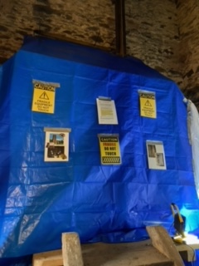  Protecting the Clock | 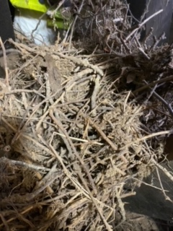  Removing the Jackdaw’s Nests
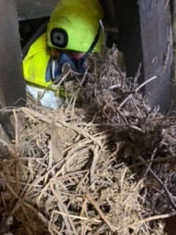  Needs Complete Personal Protection | 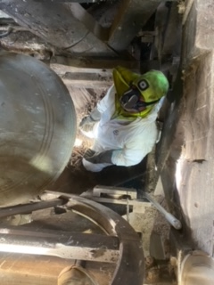  Cleaning Under the Bells
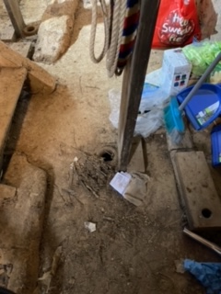  Clock Chamber Floor | 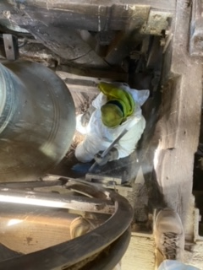  Again ... Yet More!!

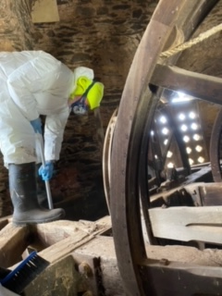  Precarious Balancing... | 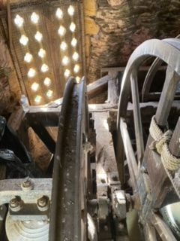  but Getting There
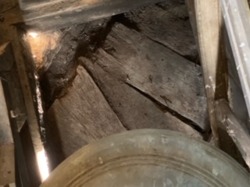  Clean – but Still Watch Where You Tread | 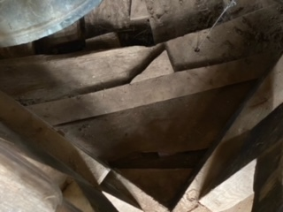  SPOTLESS!!
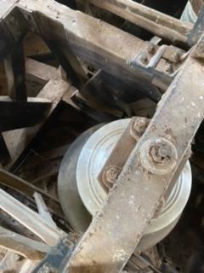 | 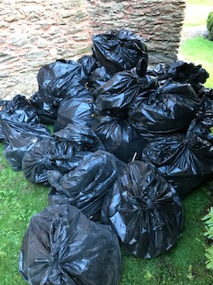  Just Some of the Debris from the Belfry
|
Photos Courtesy of Wessex Commercial Cleaning Ltd

