Despite the Covid-19 pandemic, the Parish Magazine
for the Presteigne Group of Parishes has never failed to appear.

WE NEVER CLOSED! No, that’s another institution. Ed.

During 2020 we published the usual, printed versions for February, March, September, October and December/January 2021. Due to restrictions we could only provide e-magazines for the other months (including, unusually, August) as well as, additionally, for December/January 2021. However these can be sent only to those for whom we had email addresses.
.
Stand by for easier times!

The Parish Magazine
2021
We don’t know what the future holds. But these dates are offered for now:

Deadline dates for Copy and Artwork
as at 20th February 2021

Wednesday 24th March April issue
Wednesday 21st April May issue
Wednesday 19th May June issue
Wednesday 23rd June Jul/Aug issue
Wednesday 18th August September issue

We welcome announcements (remember them?) and appreciate contributions from anyone and everyone from our churches and parishes, groups, schools, the Town Council, our friend in Lingen, our gardener and our occasional nature-noter. We include requests for support from community groups and charities. We hope to inform and entertain you.

Artwork (logos, etc) should be not too complicated (we may one day be printing again in black only on a photocopier so avoid colour and keep designs simple). Articles as well as artwork must be set to fit an A5 page with narrow margins. Email please to: standrewsintray@btinternet.com

The parish magazine

Presteigne With
Discoed, Kinsham, Lingen and Knill

Due once again to the Covid-19 pandemic we cannot, print, deliver or put on sale this magazine in its traditional form.
When we can, we will.

Here instead Is the COlourful
FREE Online March 2021 Issue

There is no need to print this Parish Magazine if you just want to read it on screen. But if you wish you can print all or selected pages of it.

Best way: print the A4 pages to both sides (Duplex) of A4 paper in
landscape; select ‘short-side stapling’.

Note: The ‘inside’ pages have been consecutively numbered on each sheet - unlike the pages which normally make up a magazine.

You are encouraged to forward this magazine to others by email or as hard copy, as above – on condition that it is not added to, or the text altered in any way.

If anyone wishes to be added to our emailing list
they should email me: see below.

We reach out to everyone connected or not connected with our churches not only with gratitude to the many who care for us, keep us safe, fed and supplied; but also with awareness of those each of us misses. We all share these difficult times.

Keep safe, keep well and keep smiling through.
Roger W G Curtis
Editor
standrewsintray@btinternet.com

The Presteigne Group of Parishes
RECTOR
The Revd Preb Stephen Hollinghurst, Rectory, St David’s St, Presteigne LD8 2BP
Rest day Tuesday 01544 267777 email revsteve.hollinghurst@gmail.com
CURATE
The Reverend Debbie Venables 01544 267663 email revdebbiev@aol.com

PARISH OFFICERS

ST ANDREW’S PRESTEIGNE with ST MICHAEL’S DISCOED
Churchwardens Mr Keith Hatfield The Old Laundry, Broad St, Presteigne LD8 2AG 260566
Mr Andy Hammersley 4 Chapel Terrace, Pound Lane, Presteigne 267857
Mr Dilwyn Price Lugg View, Discoed 01547 560234
Mrs Lizzie Smallpage 37 Hereford St, Presteigne 260190
Hon Secretary Mrs Hilary Marchant Fold Granary, Broad Street, Presteigne LD8 2AG 260363
email: presteignepcc@gmail.com
Hon Treasurer Mrs Judi Charlton 9 Clatterbrune, Presteigne LD8 2LB 267420

ALL SAINTS KINSHAM
Churchwarden Mrs Myra Chilman The Cottage, Kinsham. LD8 2HN 267701
Mrs Lynne Deakins Kinsham Farm. SY7 OEA 267798
Hon Secretary Mrs Sarah Chilman Westfield, Kinsham LD8 2HN 267261
Act Treasurer Mr Anthony Adlard Old Priory, Titley HR5 3RR 231627

ST MICHAEL AND ALL ANGELS KNILL
Churchwardens Mr William R Davies Knill Farm, Presteigne LD8 2PR 267348
Mrs Evelyn Exton 12 Gravel Drive, Kington 230404
Hon Secretary Mrs Pat Thornton 13 Silia Meadow, Presteigne 260717
Hon Treasurer Mrs Noorissa Davies Knill Farm, Presteigne LD8 2PR 267348

ST MICHAEL AND ALL ANGELS LINGEN
Churchwarden Mr Robert Nisbet Court House Farm, Lingen SY7 0DY 267452
Hon Secretary Mrs Trish Nisbet Court House Farm, Lingen SY7 0DY 267452
Hon Treasurer Mr Tim Whittome Camp Hill Cottage, Lower Lye HR6 9TA 07885 520536

YOUR PARISH MAGAZINE TEAM

Editor Mr Roger Curtis Ashley Cottage, Roddhurst, Presteigne LD8 2LH 262846
email: standrewsintray@btinternet.com

Trade Adverts Mrs Di Hammersley email sadvert98t@btinternet.com 267857

Collation and Distribution
Mrs Marion Rowlatt 260466

Team Support Mrs Clare Stevens (Social Media, Publicity), Mr Chris Rowlatt (Printing)

ll telephone area codes are 01544 unless shown otherwise

Services in the Presteigne Group of Parishes
March 2021

This is what we are planning, but plans can change…

March 7th 11.00 Holy Communion (CW) Presteigne
Lent 3

March 14th 9.15 Holy Communion (BCP) Knill
Lent 4 11.00 Morning Prayer (BCP) Presteigne

March 21st 11.00 Holy Communion Presteigne
on Passion Sunday (CW)

March 28th 11.00 Holy Communion (CW) Presteigne
on Palm Sunday

April 1st 7.30pm Holy Communion Presteigne
on Maundy Thursday

April 2nd Noon Readings and Prayers Presteigne
on Good Friday

April 4th 8.30 Holy Communion (BCP) Knill
EASTER 9.30 Holy Communion (BCP) Lingen
Kinsham invited to join Lingen this year
11.00 Family Communion (CW) Presteigne
6.30 Holy Communion (CW) Discoed

Please remember…
* two-metre-distancing must be maintained in church at all times
* face coverings must be worn (unless you are exempt)
* use the hand sanitizers provided
* no mingling or socialising in the church or churchyard

From the Registers
Funerals
Pat Philips Presteigne
Dot Nicholls Knill
Caerwyn Hefin Jones “Wyn” Lingen
Our thoughts and prayers are with family and friends
1
The Rector Writes…
A couple of weeks ago an ill-informed and highly critical article appeared in The Spectator which basically predicted the imminent demise of the Church of England as we know it.
This article was picked up by several newspapers, perpetuating the misinformation contained in the original, and causing concern and alarm among members and supporters of Parish Churches across the country.
In response to this inaccurate “reporting”, the Archbishops of Canterbury and York wrote a joint open letter seeking to set the record straight and to answer some key questions posed by media voices during the Covid crisis.
I’ve already circulated the full version of the Archbishops’ letter to members and friends of our churches, but here is a slightly edited version which covers all the main points…

If you’ve been following the media coverage of the Church of England over
the course of the coronavirus pandemic, one question you might have seen is: ‘Where is the C of E?’
Let us offer an answer.
We have been burying the dead, comforting the bereaved, feeding the hungry and praying for our nation. We have been doing this not as superheroes,
but as human beings living through the same crisis as everyone else:
grieving, home-schooling, worrying, getting sick, shielding, isolating, weeping.
With that said, we fully understand — and indeed share — the anger and frustration felt by some that the government ordered public worship to be suspended during the first lockdown. We share the anxiety felt by many over the sharp fall in collection plate donations with fewer people currently attending church. We weep with and pray for our clergy who have been on the front line for nearly a year now.
One thing is abundantly clear: the Church of England has been a bedrock
of faith, love, hope and compassion in this country for centuries through wars, plagues and pandemics — we still are, and we will go on being just that.
You can imagine our shock, then, when we read in the media about what is supposedly happening to our beloved church. That the parish system, with its beautiful vision of serving every inch of the country and every person in it,
is being systematically dismantled. That clergy are being made redundant.
That there are plans to somehow centralise everything and for services,
even beyond Covid, to be online rather than in person.
So let us try to set the record straight.
There are no plans to dismantle the parish network. We are committed to our calling to be a Christian presence in every community. The suggestion that all we do is cut back clergy numbers is not only untrue and unhelpful, it creates unnecessary anxiety. We need more clergy and they are coming forward in
record numbers.
Continued on next page
2
Of course we get some things wrong, but it would be irresponsible for the leadership of the church to ignore the severe challenges of Covid and the financial hit that comes with it.
But our efforts are focused on enabling churches to stay open and for clergy
to flourish. The very reason the Church of England has survived and flourished over centuries is because ministry has evolved.
There are rascally voices around who want to undermine the church — it was ever thus. But the real story is that we so believe in that vision of serving every inch of the country, and every person in it, that we are having to expand what it is to be the church.
There is no central plan for all of this. How could there be?
Each diocese is its own legal and charitable entity and makes its own decisions. But there is a central and local vision. It is to be centred on Jesus Christ and flowing from that to encourage the Church of England to embrace new ways of serving the nation — not to dismantle what we have inherited,
but to build upon its proud and treasured foundations.

So there you have it!
These are certainly difficult times for everyone and for every institution.
We are all climbing a very steep learning curve.
We are all having to find new and different ways of doing what we do.
Although it will be wonderful to pick up where we left off before the pandemic, the best of the new and different ways will hopefully continue long after life has got back to normal.
How far in the future that will be is anyone’s guess.
In the meantime, we keep calm and carry on as best we can.
It’s not always easy, but that’s what our churches, their leaders, their officers, their clergy and their ministers are trying to do.
Please hold us in your thoughts and prayers…
Keep safe and well!
Stephen
Church Services Update
As you will note from the March Services page, we are continuing to hold services weekly in St Andrew’s Presteigne and monthly in Knill.
These will hopefully be augmented by our Holy Week services in Presteigne.
On Easter Sunday, we hope to return to our usual Festival pattern, as shown.
However, if you’d like to come to the Easter Service in Lingen (only)
we’re going to have to ask you to book seats in advance
so that we can all stay safe
and we can avoid turning people away from the door.
Please phone Robert on 01544 267452 to book for Lingen.
We’ll need to know how many people from your household are coming
and we’ll need your contact details for track and trace.
3

March News from Lingen
Planning a transformation?

If 2021 is the year you plan to start transforming
your garden then our next online talk is a must!

The March Hare....

In medieval societies in Europe, the March hare was protection, good luck, and messages from the underworld. The rabbit is seen as
a trickster figure in many western mythologies. And of course the March Hare was a guest at the famous Mad Hatter’s tea party in Lewis Carroll’s ‘Alice In Wonderland’.

Times are still quiet here in Lingen; we hope that once given a CV19 reprieve we’ll have some regular events returning to the locality.

MORTIMER MEDICAL PRACTICE CV19 vaccination programme updates are available on the ‘lingenweb ’site www.lingen.org.uk ‘news’ page.

YOUNG PHOTOGRAPHER COMPETITION calling all budding young photographers from North Herefordshire, South Shropshire and Powys.
“NATURE ON YOUR DOORSTEP” is the theme for the competition, entry is FREE & you
can use your phone or camera. Competition ends on March 31st 2021, gift vouchers will be awarded to the best three entries in each age group & certificates will be sent to all entrants. Age groups are: 6 to 11 years, 12 to 15 years and 16 to 18 years. Full entry details are on www.lingen.org.uk ‘news’ page.
Lingen Dark Skies There’s been a number of requests from our local stargazers to PLEASE turn off any unnecessary outside lights after dusk. Thank you.

‘SILVER STORIES’....want to have a story read to you over the phone by a ‘Silver Reader’ and help our local children with their reading skills?
Full details on www.lingen.org.uk ‘news’ page.

‘lingenweb’ (www.lingen.org.uk) keeping you up to date with news,
events and general information.

Have a great March...the month when we officially say “goodbye to winter” and “hello to spring”. Christine Moore
5
4
Christine Moore

Have a great March...the month when we officially say “goodbye to winter” and “hello to spring”.

On the 2nd March see how Simon Cain and Simon Quin created a garden from scratch at Hurdley Hall, Churchstoke that would suit the harsh, rocky landscape of the Welsh Marches. Their talk illustrates how they have overcome the challenges of their location creating extensive borders, ponds, stone walling, topiary and a kitchen garden that has been merged into the landscape with traditional hay meadows, streamside walks, woodlands and an orchard. For more information see the website www.ngs.org.uk, email gail.jones@ngs.org.uk or telephone 0797 410 3692

Here are more alleged announcements from other church magazines. [Tank gOOdness we alway cheque car full e.]

Eight new choir robes are currently needed due to the addition of several new members and to the deterioration of some older ones.
Pot-luck supper on Sunday at 7:00 pm. Prayer and medication to follow.

The ladies of the parish have cast off clothing of every kind. They may be seen in the basement on Friday afternoons.

The Young Farmers will be presenting Shakespeare's ‘Hamlet’ in the Church Hall on Friday at 7 pm. The congregation is invited to attend this tragedy.

The church will host an evening of fine dining, super entertainment and gracious hostility.

Cyngor Tref Llanandras a Norton

PRESTEIGNE & NORTON TOWN COUNCIL

From the meetings held in January 2021

Setting of Budget for 2021-22: Members agreed a budget for the 2021-22 financial year of £69,510 equating to a Band D precept of £54 per year, a reduction of £1 from 2020-21. Full budget on website.

Planning Applications: 7
20/2135/FUL Grid Reference: E:331524 N: 263988 Proposal: Erection of
2.4m high palisade fence and gates Site Address: Unit 1, Broadaxe Busi-
ness Park, Presteigne, Powys LD8 2UH. Resolved no objections be raised.

20/2134/FUL Grid Reference: E:331491 N: 264052 Proposal: Erection of
fence and gates. Site Address: Unit 5 Presteigne Industrial Estate,
Presteigne, LD8 2UF. Resolved no objections be raised.

20/2052/FUL Grid Reference: E:330547 N: 266049 Proposal: Erection of steel frame/ clad outbuilding for general purpose agricultural building and store,
creation of hardstanding area and erection of 3 metre high boundary fence.
Site Address: New Barn, Norton, Presteigne, Powys, LD8 2EU. Resolved to object to the 3m height of the fence and also to question the designation
being given as agricultural as in appearance it seemed industrial.

Planning Decisions:
20/0753/REM Land at Jack’s View, Norton: Approval 8th December.
20/1861/TRE Land at rear of Greystones, St. David’s Street, Presteigne: Approval 8th December.
20/1862/TRE Land at rear of Greystones, St. David’s Street, Presteigne: Approval 8th December.
20/1600/FUL Norton Wastewater Treatment Works: Approval 22nd December.

Dark Skies/Lighting:
Prior to the commencement of the formal meeting Members heard from
Leigh Williams of Powys County Council on the recent full survey of the
street lighting in Presteigne and Norton. Lighting was to be upgraded and improved with energy consumption being reduced. Once the changes had been made there would be just two options for light use – part night dim (dimming at midnight) and part night (off at midnight). The survey included some proposals to remove lighting columns that it was felt were no longer needed as these still incurred inspection and testing costs. There would also be the option to add some new lights in areas not adequately covered at present. He was looking to carry out the work in the 2021-22 financial year. In response to Member’s questions he confirmed that the Industrial Estate lights were under Welsh Government and one estate was under the housing association. Members agreed with Kerem Asfuroglu that these areas could be tackled once the main work was complete and there was more justification to ask for change. Cllr. Kirkby asked if motion sensor lights were an option and Mr. Williams confirmed that this was possible but that the way the electricity supplies were arranged this was not a saving energy wise.
Kerem Asfuroglu was pleased to announce that he had managed to get one manufacturer interested in sponsoring the fittings for the heritage lighting project and he would have more information in due course. In response to a further query he confirmed that if necessary he could delay the lighting trial until the first week in March in order to accommodate an extension for the Christmas lighting period. Mr. Williams reminded Members that in any event delaying any later would mean the nights had drawn out too much for a realistic trial to take place.

Surgeries: Currently suspended due to the coronavirus pandemic.

Full Minutes are available on the website –
http://www.presteigne.org.uk/Town_Council
Tracey Price, Clerk.

Email presteigneandnortontc@outlook.com

Telephone 01547 528575

Continued on next page
6
7

March in the Garden

At last some mild weather to remind us that spring should not be too far away.
The ground has thawed and grass is growing again.Has your mower been serviced? It will be needed once the ground has dried out.
Hard prune coloured stemmed dogwoods and willows once their upper buds begin to swell. Prune Hydrangeas, cutting off spent flower heads back to a strong pair of buds. Cut back 1/3 of the oldest stems to their base if the plant is overcrowded. Tidy up ferns by trimming off last season’s dead fronds.
When soil conditions permit clean up and fertilize herbaceous borders. Split overcrowded clumps of plants and discard the old woody centres. Cut ornamental grasses back hard followed by general tiding up wearing gloves. Congested clumps can now be lifted and split.
Re-pot, or replace the top layer of compost of plants grown long-term in containers, adding some slow release fertilizer. Start dormant dahlia and canna tubers into growth in a frost free greenhouse. Start rooting cuttings of fuchsias and chrysanthemums in a propagator. Greenhouses need plenty of ventilation on sunny days. Annual climbers grown from seed need a long growing season, best sown this month.
Add fresh gravel or chipped bark where appropriate to paths and the surface of pots and troughs to freshen them up.
Start to make successional sowings of lettuce and other salads indoors or under cloches. Sowings of peas, broad beans and cabbage may be possible outdoors depending on soil conditions (protect from mice and slugs). Early maturing varieties of potato can be planted from late March for lifting in June if protection from May frosts. Plant onion and shallot sets once the soil surface dries out. Towards the end of the month germinate tomato and leek seeds in pre- warmed compost.
Overcrowded snowdrops can be lifted and replanted in small groups whilst still green. Complete rose pruning this month.
John Chrimes

8
MARCH: The Month at a Glance

Mon 1st Feast of St David of Wales.
Frederick Chopin born, 1810

Tue 2nd BBC Four TV launched, 2002

Wed 3rd Alexander Graham Bell born, 1847

Thu 4th Antonio Vivaldi born, 1678

Sat 6th Michelagniolo di Lodovico Buonarrotti born 1475

Sun 7th 11.00 Holy Communion Presteigne

First episode of Round the Horne broadcast,1965

Wed 10th The first successful test of a telephone by A G Bell, 1876
Sun 14th 9.15 Holy Communion Knill
11.00 Morning Prayer Presteigne
‘Mothering Sunday’*
Mon 15th Dennis the Menace first appeared in The Beano, 1951
Wed 17th Feast of St Patrick (born in Wales?) of Ireland
Sat 20th Feast of St Cuthbert of Lindisfarne
Sun 21st Passion Sunday
11.00 Holy Communion Presteigne
Census Day (First census of England and Wales: 1801)
The Beatles’ first performance at the Cavern Club, 1961
Wed 24th ’The Great Escape’ from Stalag Luft III, Poland, 1944
Sun 28th British Summer Time begins: clocks go forward
Palm Sunday
11.00 Holy Communion Presteigne
Mon 29th The Royal Albert Hall opened by Queen Victoria, 1871
Wed 31st The Eiffel Tower in Paris opened to visitors, 1889

* Since the sixteenth century it has been the custom to attend, on the fourth Sunday in Lent, a church service in the nearest important church or cathedral – one’s 'Mother' church.

April preview

Thu 1st Maundy Thursday:
7.30pm Holy Communion Presteigne
Fri 2nd Good Friday: Noon Readings and Prayers Presteigne
Sun 4th 8.30 Holy Communion Knill

9

10

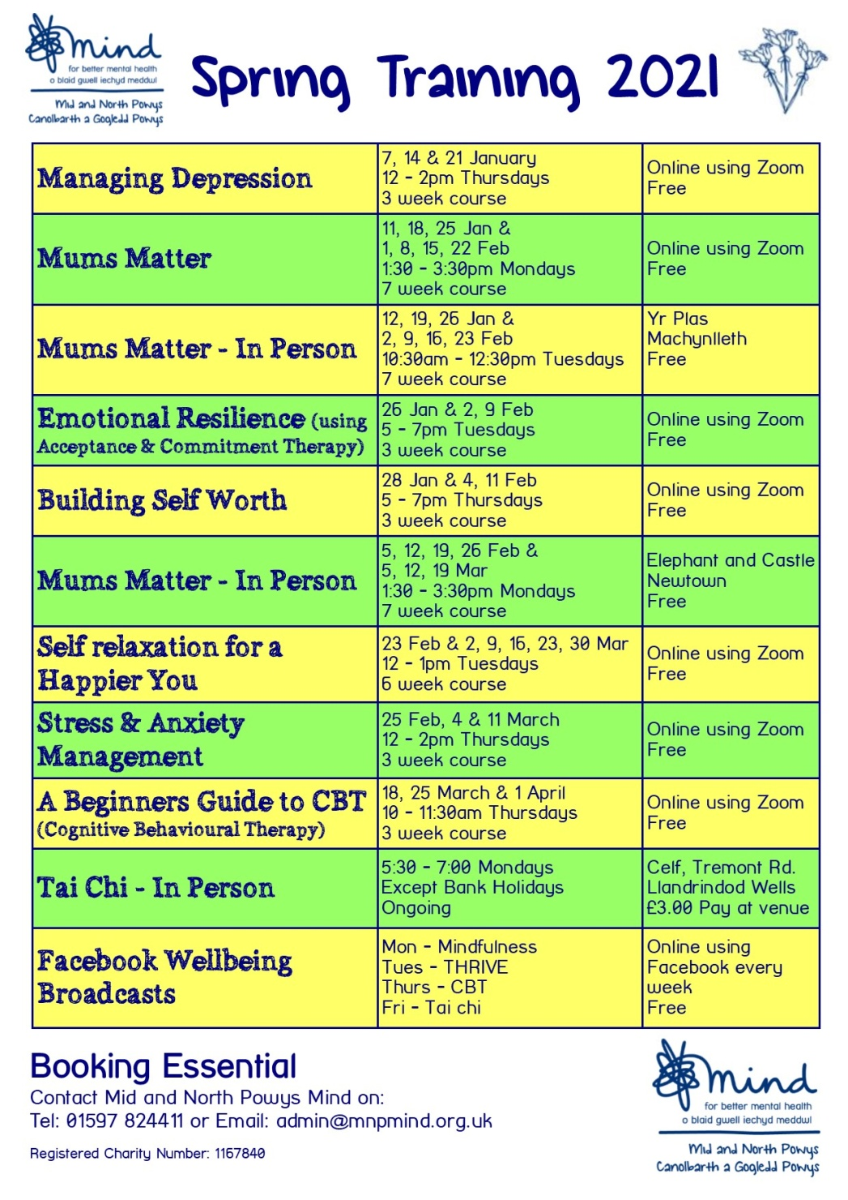
11

