St Peter Warmsworth
Parish Magazine

2021

The story behind two headstones
There are a couple of graves in our churchyard that caught my eye so I decided to investigate who these people were and the lives they may have led.
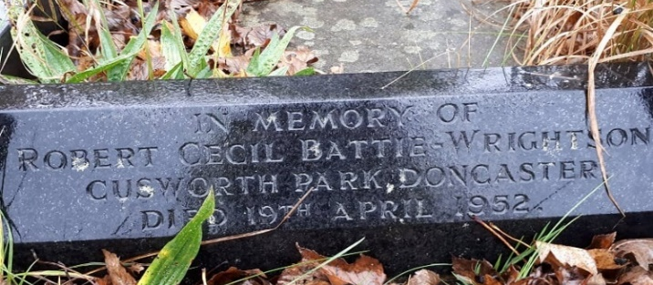
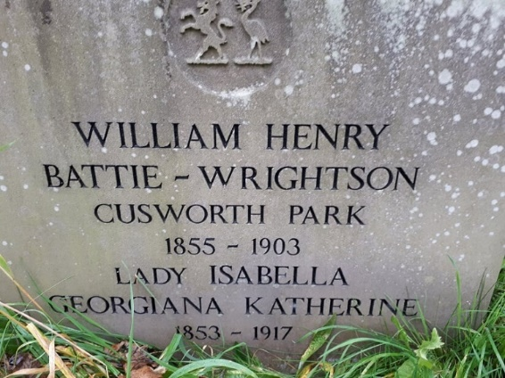

William Henry was the eldest son of Charles Thomas, Rector of Warmsworth, and his wife Georgiana. He was born at Warmsworth and baptised at the old St. Peter’s Church on 3rd August 1855.
At the new Rectory, besides his parents, were William’s siblings plus several servants. In 1861 these were John Watson the groom, John Belton the gardener, Anne Birkley the nurse, Sarah Hewitt the cook, Elizabeth Robinson a housemaid and Mary Johnson a nursemaid. Quite the houseful! It is interesting that none of the servants were locals.
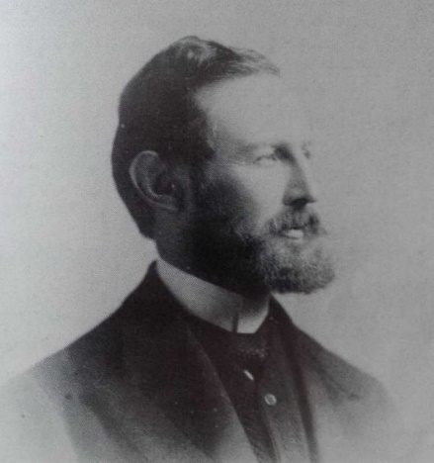

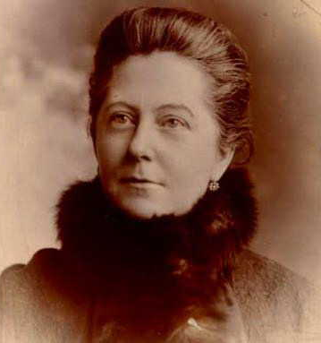
Ten years on and the staff had all changed; the gardener and his wife had their own cottage along with the coachman and his family.
Living in the Rectory with 15-year-old William and six siblings were a lady’s maid, a parlour maid, cook and three other servants to care for the family’s needs.
By 1881 the Reverend Charles Thomas had relocated to Hemsworth and employed a governess from Sweden among his staff. His son William went on to be educated at Eton and qualified as a barrister. On 7th August 1884 William Henry Thomas married Lady Isabella Georgiana Katherine Cecil. Her father was Lord Burghley, Earl of Exeter. They married in Marylebone, London at the Church of St. Thomas, Portman Square; the service taken by William’s father. After the wedding the couple lived at Warmsworth Hall, one of the country houses of Lady Isabella’s family.
By the time of the 1891 the couple had two young children, Robert and Barbara (the only children they would have) and William was a magistrate. They had nine servants, including a butler, footman and Eleanora Tait, the housekeeper-cum-cook (think Downton Abbey!).The same year William inherited Cusworth Hall via childless great uncles and took on their name, Battie-Wrightson, by Royal Licence.
Tragically, four years later William collapsed with a brain haemorrhage and died on 28th April 1903 aged 47.
Within five days of her husband’s funeral Lady Isabella had a legal battle to secure the family home for her son Robert who was 15 at the time. His uncle, Charles Freeman Thomas, contested that Cusworth House was rightly his and requested the Battie-Wrightson’s to vacate immediately! It cost Lady Isabella an out-of-court settlement of £20,000 to secure the home for her son until he reached 21 and inherited in his own right. It must have been a terribly testing time for the bereaved family. It may have been a blessing that Reverend Thomas had died before his second son unleashed this bombshell on his late first son’s family.
(I cannot find where Rev. Charles Edward Thomas was buried on 12 April 1903. Does anyone know?
Many improvements were carried out at Cusworth Hall during Lady Isabella’s time in charge. Such modern luxuries as a telephone, central heating and a lift were installed.
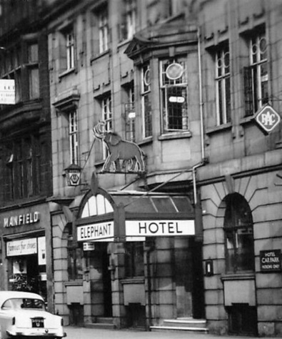
The hall was extended in 1907 with a new dining room and extra accommodation for servants; there must have been quite some partying going on. There was a great celebration on 24 August 1909 when Charles came of age and took up the reins of running the house and estate. Harrods came from London with huge marquees, which they filled with food and drink for the occasion; the whole village was invited.
Gradually Lady Isabella spent more time at Wothorpe Villa in Stamford where she had just four servants. Annie Middleton was secretary and companion to her Ladyship, the cook was Jane Benson, Wilfrid Morley the footman (who could do without one?!) and the housemaid was Annie Davy. A cosy household where Lady Isabella lived out the last few years of her life. She died 29th October 1917 aged 64 after developing pneumonia and was brought back to Warmsworth to be interred alongside William.
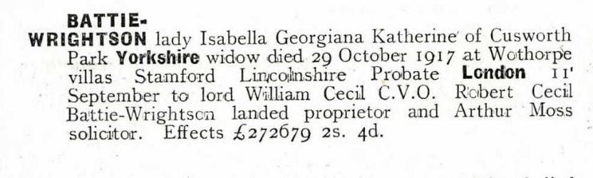
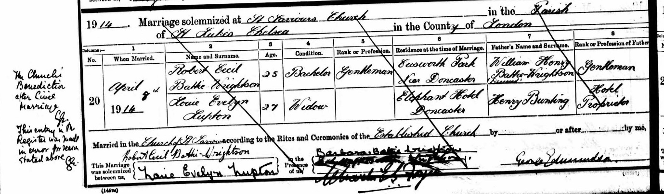
Meanwhile, Robert was residing at Cusworth Hall (or Park as it was known).
In March 1914 Robert married Louie Evelyn Lupton at a civil ceremony in Doncaster, followed by a church blessing in April at St. Saviour’s Church, Chelsea.

The event was mistakenly recorded in the Parish Register, witnessed and signed by all parties, but was crossed through and witness signatures scribbled out when the error was realised.
The woman Robert chose to marry caused quite a stir as Louie Lupton was the widowed daughter of the landlord of the Elephant Hotel which stood on Sepulchre Gate, Doncaster (now demolished).

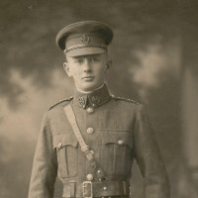
During the Great War, Robert served as a Private with the Army Service Corps.

1: Doncaster Heritage Services
Some sources mention that Lady Isabella had previously bought a commission for her son as a Lieutenant in the King’s Own Yorkshire Light Infantry where he served between1907 and 1912.

A rumour is that Robert struck an officer in the face and was discharged from the army. This could explain why he re-enlisted during the war as a Private.
It is obvious he spent little time at home with his wife. Robert spent much of his time socialising with his staff and in pubs, snubbed by his peers and the marriage eventually broke down. He met Christabel Florence Bentley, the divorcee of another public house landlord. Although he never divorced Louie, he had a lasting relationship with Christabel.
On 19 April 1952 Robert Cecil Battie-Wrightson died from a stroke. He was buried alongside his parents at the new St. Peter’s Church, Warmsworth. His will benefitted Christabel Florence Bentley to the effect of £41,000, the sum of his personal estate.
Cusworth Hall and Park passed to Robert’s sister Barbara, but the death duties of £280,000 were devastating and caused much of the house contents to be sold. Barbara (now married and known as Maureen Pearce and working as a nurse amongst London’s poor) did not return to live at Cusworth Hall and it was sold to Doncaster Council in 1961 for £7,500.
Mrs Pearce joined a Holy Order of St. Hubert taking the name Mother Mary Francis. Some historians note that Lady Isabella had threatened, earlier in her life, to cut off Barbara’s income if she converted to Catholicism.
When she died in February 1989, aged 98 years old, Mother Mary Francis was buried in the grounds of St. Mark & St. Hubert Church in the grounds of Cusworth Hall.
The research and writing – Lynne Rose
The headstone can be seen outside the building – look from the door to the graves immediately opposite and you should be able to spot it.
~~~~~~~~~~~~~~~~~~~~~~~~~~~~~~~~~~~~~~~~~~~~~~~~~~~~~~~~~~~~~
The Presentation of Christ in the Temple – Candlemas

February 2nd 2021

Almighty and ever-living God,
clothed in majesty,
whose beloved Son was this day presented in the Temple,
in substance of our flesh:
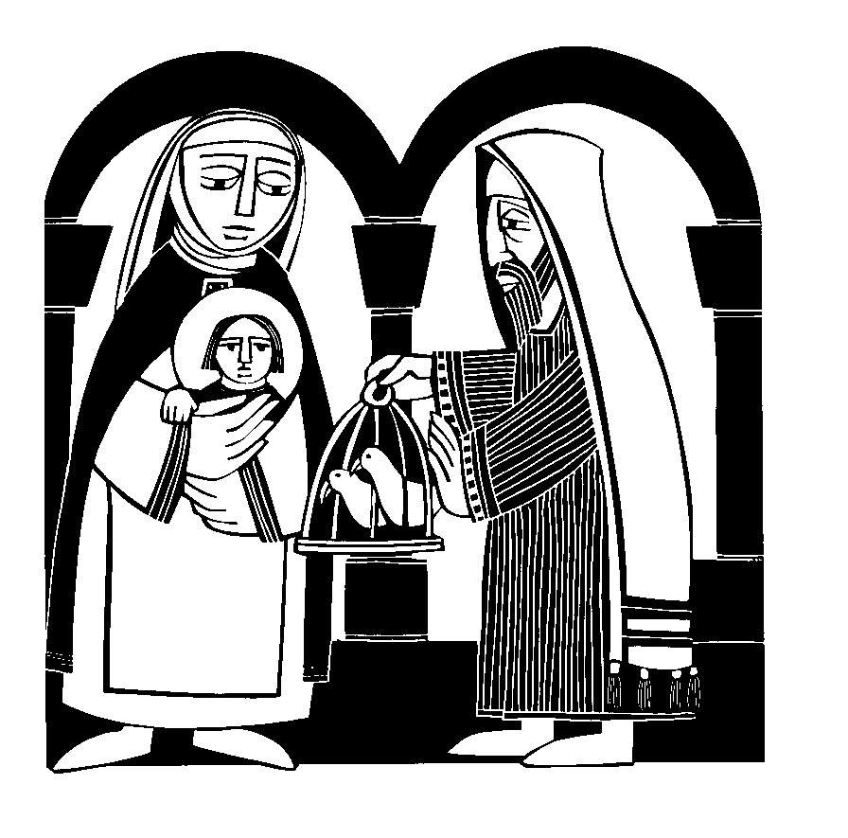
grant that we may be presented to you
with pure and clean hearts,
by your Son Jesus Christ our Lord,
who is alive and reigns with you,
in the unity of the Holy Spirit,
one God,
now and for ever.

We see Jesus with Anna and Simeon – Luke chapter 2 verses 24-38 and the sacrifice of the two young pigeons

Ready, steady, census

Households across Doncaster will soon be asked to take part in Census 2021.
The census is a once-in-a-decade survey that gives us the most accurate estimate of all the people and households in England and Wales. It has been carried out every decade since 1801, with the exception of 1941.
Census day is Sunday 21st March 2021 and it will be the first to be run predominantly online, with households receiving a letter with a unique access code allowing them to complete the questionnaire on their computers, phones or tablets from early March.
“A successful census will ensure everyone from local government to charities can put services and funding in the places where they are most needed,” Iain Bell, deputy national statistician at the Office for National Statistics, said.
“This could mean things like doctors’ surgeries, schools and new transport routes. That’s why it is so important everyone takes part and we have made it easier for people to do so online on any device, with help and paper questionnaires for those that need them.”
The census will include questions about your sex, age, work, health, education, household size and ethnicity. For the first time, there will be a question asking people whether they have served in the armed forces, as well as voluntary questions for those aged 16 and over on sexual orientation and gender identity.
Results will be available within 12 months, and personal records will be locked away for 100 years, kept safe for future generations.
There are also full and part time job opportunities available in Doncaster, please see https://www.censusjobs.co.uk/ for more information and to apply.
For more information on how the census works and can benefit our community visit www.census.gov.uk or contact Laurance.green11@field.census.gov.uk 07452 940363
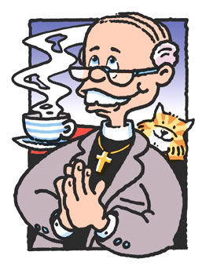
The Rector writes ...
“Well if you can’t trust a Vicar who can you trust these days?” That is a phrase you are less likely to hear now than at time since surveys in the public attitude to trust were started. From a position of being among the most trusted members of the community, the clergy have dropped to being no more, but thank goodness no less, trustworthy than a stranger.
What has caused that drop and how might the ordained respond ?
The reasons for the drop in trust can I think be listed fairly quickly:
- The many cases of abuse that have been revealed more clearly than ever in the recent reports.
- The continued appearance of clergy ready to speak, not always with much knowledge, on every moral topic.
- The significant reduction of Christian belief and church attendance means fewer people have any connection with a real vicar.
- The swiftness with which a story about an awkward or rude vicar spreads through a community.
You may have your own reasons for saying you do trust clergy but please put yourself among those who don’t and why they feel as they do.
So what’s to be done? Can the situation be reversed and do we need to reverse it?
I would say it is vital the trust in the vicar is restored and if possible scores as high as any person in the community. Each priest will be fallible and human, prone to sin and shortcoming – but should aim, under God to be reliable, truthful and honest. The reason is that the person is also the preacher. They speak on Sunday, at the wedding of Mary and Joe; at little Amy’s christening and at Uncle Ted’s funeral. So many words and if the mouth of the speaker is basically not felt trustworthy the things said about God; about hope and heaven; about grace and mercy; about Jesus and the Spirit, will likely not be believed either.
In a major document delivered at the last General Synod of 2020, the ne Archbishop of York, Stephen Cottrell, presented a vision for (please note FOR, not OF; this is something to work towards) the Church of England in the 2020s. In three simple words it was – Simpler, Humbler, and Bolder.
That word humbler really appealed to me. I have called for it repeatedly and did not feel I was heard. So if it is now coming what might a humbler church look like?
In my mind I see a church more ready to admit its mistakes and needs. This admission will not just be made before God but before our society. The mistakes will include the abuses in the past and the arrogance and cover up that occurred. The needs will include our unsustainable buildings without help from grants and openness to them having dual use and adaptation for the communities around them.
In my mind I see a church more ready to say ‘perhaps’ or ‘should we consider’, than ‘thus says the Lord’ or ‘the bible clearly says’. We live in an era where assertion is either seen or heard as arrogant or questionable; or it is the province of the rabble rouser and dangerous leader.
In my mind I see a church more ready to ask ‘how can we help?’ than ‘these are our rules’. A church more ready to say, ‘can we join in’ than ‘we will lead’. A church more ready to praise the good around it than the bad; the positive than the negative.
There is a whole series of images of the church at the start of the book of Revelation, the last book of the bible. 7 letters to 7 churches and though each church is named we think that in a way the letters are written to all churches at all times by God. They include words or praise and affirmation as well as of critique and shortfall. All the churches are a mixed bunch and so is the Church of England and so is St Peter’s. We do ourselves no favours if we ignore our failings and weaknesses. Honest appraisal need not result in despair but rather in renewal. And in part I think the Archbishop of York was right, it will need a humbler church.
I’m not going to miss the other two words, bolder and simpler but we have to start somewhere and with Lent not far away it’s a good time for reflection and humility – may we be a humbler church rather than a humbled one.
Parish Registers January and February 2021

Baptism None
Wedding None
Funeral Harry Shaw Robert Andrew Patrick (Andrew)
Ashes Joan Paddey Wendy Fisher
Sylvia Allsop Joan Lawley
Peter Stubbs Aileen Ruth Balogh
7 day light

Dennis Benfold
Janet and Michel Faure-Whitaker
~~~~~~~~~~~~~~~~~~~~~~~~~~~~~~~~~~~~~~~~~~~~~~~~~~~~~~~~~~~~~~~~~~~~~
WARMSWORTH LADIES’ CLUB

Hello

Sending New Year wishes to you all
and the hope that the days ahead
bring happiness and the chance
for us to meet again soon!
~~~~~~~~~~~~~~~~~~~~~~~~~~~

Disturb us, Lord, when
We are too well pleased with ourselves,
When our dreams have come true
Because we have dreamed too little,
When we arrived safely
Because we sailed too close to the shore.
Disturb us, Lord, when
With the abundance of things we possess
We have lost our thirst
For the waters of life;
Having fallen in love with life,
We have ceased to dream of eternity

And in our efforts to build a new earth,
We have allowed our vision
Of the new Heaven to dim.
Disturb us, Lord, to dare more boldly,
To venture on wider seas
Where storms will show your mastery;
Where losing sight of land,
We shall find the stars.
We ask You to push back
The horizons of our hopes;
And to push into the future
In strength, courage, hope, and love.
Prayer attributed to Sir Francis Drake
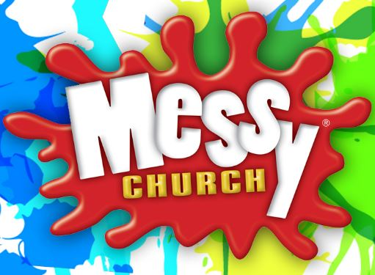
What has Messy Church been up to during the long lockdown of 2020?
In March 2020 Messy Church stopped as we could no longer meet together safely.
We carefully studied the advice from the Diocese and from the Messy Church Organisation and we realised that making the Hall Covid secure would require more helpers than we could muster. We also realised that, although we are very young at heart, many of us were uncomfortably close to the ‘vulnerable’ age group.
We asked ourselves 2 questions
1) How can we keep on telling the stories of Jesus Christ in these challenging times?
2) How can we keep our Messy Church Community together so that they continue to know that they are loved?
After much prayer and head scratching we decided to keep in touch by delivering good quality activity bags, every month, to each child that would help them to explore the stories.
Our next step was to learn to post our sessions on our Facebook page.
Now posting on Facebook is way more difficult than you would think and we would never have managed without Caroline Meadon’s expertise and sheer determination. The Lord provides all we need!
In October we decided to ensure that each family had a copy of Luke’s Gospel as we explored Harvest. There were puzzles to do and a bag of bread mix so we could all join together in making bread. Our families sent some great pictures of their loaves.
In November we set off on the Journey to Bethlehem with more puzzles and a Christian Advent Calendar for each child. We also included a Topz Gospel to help expand their understanding of the stories we were reading.
December’s bag had everything you needed to make your own Christingle so that, on Christmas Eve, we could do our Messy Christingle online together and we could sing Away in a Manger along with Angela, Helen and Rudolph the Red Nosed Reindeer. Then we watched as Ian lit the Advent Candles.
There have been lots of other bags and we will be happy to tell you all about them. We have had photos of growing seeds and Lego models along with lovely feedback from our families. We plan to continue in this way until it is safe for us all to meet again in 2021.
A big thank you to all our families for your support and encouragement and also to St Peter’s congregation for your prayers and to Dorothy who kindly bought all our Christingle oranges for us. Each month we have delivered Christian stories and activities to 50 children in our parish.
God bless you all. Caroline Taylor
~~~~~~~~~~~~~~~~~~~~~~~~~~~~~~~~~~~~~~~~
A favourite walk

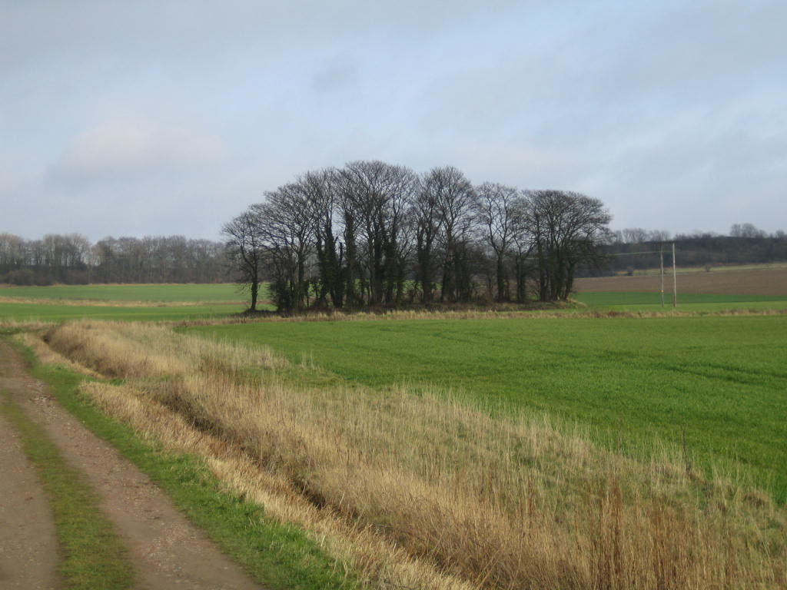

One of my favourite walks is St. Helen’s lane in Barnburgh opposite the Crown Inn.

I lived in Barnburgh for six years before I got married and never ventured up this lane but in recent years have walked it many times.

It’s quite a nondescript lane between two fields but halfway up the lane, in a field on the right, lie the ruins of St. Ellen’s chapel in St. Ellen’s field. The ruins lie close to what was part of the Roman Ricknield Street, now known as Hangman Stone Road and they are preserved in a copse a few yards away from a dried up and filled in well. It is believed that the Chapel was dedicated to Ellen, the Celtic goddess of armies and roads but was later re-dedicated by the early Christians to Helen, the mother of the Emperor Constantine. It is known today as St. Helen’s Chapel and St. Helen’s lane.

In 1948 excavations of the site were undertaken by Doncaster Art Gallery supervised by Canon Whiting, the vicar of Hickleton. One of the most interesting discoveries of the excavations was a carved cornice piece of the Perpendicular period( 15th century). Another find was a stone, hollowed out in the centre which may have been a holy water stoop. Among other discoveries were odd pieces of glass, probably window glass, roofing tiles, a clasp from a book, pieces of a human skull, and a Henry IV penny of about 1412 or 1413.
The chapel was a ruin as far back as the 1600s but still visible at that time were tombstones within the chapel which bore the arms of several notable families as well as the arms of Edward, John and Edmund, the three sons of King Edward III. Today if you look across the field to the ring of trees surrounding what was once a holy site, you would be forgiven for thinking it underwhelming but it is visible proof that many people worshipped here as far back as the Roman times but it’s significance as a site of special interest dates back further before it was sanctified by the early Christians. There is evidence of finds, not just Medieval or Roman but worked flint pieces dating back as far as prehistory.

Although the spring known as St. Helen’s Spring or Well was filled in many years ago there is still a culvert running down the lane and each time I’ve been it’s been a fast running stream so whether this is a remnant from the spring I don’t know. The original spring was renowned for its valuable medicinal properties which is probably why the site was deemed sacred by the early Christians.
Jill Sharp

Looking back and thanks

December 31st 2020. I’m sat here thinking, what was New Year’s Eve like last year? Well last year we had a choice, how to spend it, and who to spend it with. This year the choice has been made for us. Stay safe, STAY AT HOME.
Looking back over the last year, so much has happened.
We had lockdowns, during which we were unable to meet family and friends. Shopping was only for essentials. Many people thinking that a cupboard full of toilet rolls, were more important than other things.
Mental illness has been on the increase, along with domestic violence, loss of jobs, loneliness, depression.
All this due to a deadly virus, COVID 19, affecting so many people throughout the world. Affecting people’s everyday life, affecting the way we do things. The way we now look at the world.
So very many families have lost loved ones. So many who were ill for so long, have recovered, but are still dealing with long Covid.
So let’s take a look back.
During our first lockdown, twelve weeks, and it was only March, I remember thinking gosh it’s going to be June before we get back to normal. I think we all thought we would have our normal lives back after the lockdown, how wrong can you be.
My letter had arrived asking me to shield, until 16th June. It seemed so far away. What was I going to do stuck in my bungalow for three months. I would only be able to ring, or FaceTime my family. I wouldn’t be at Church; I wouldn’t be at Total Praise Choir; no coffee mornings, no community Lunch. My life, everyone’s life, had been put on hold.
I remember thinking, stop feeling sorry for yourself, and think positive.
I had wardrobes, drawers, cupboards, all in need of a good tidy out. A good place to start and also to fill my days .
Then I thought about Church and my Church family. I love the worship together on Sunday’s; the Thursday morning Eucharist; the practice of the hymns on Friday night. What was I going to do? The more I thought about it, the more things came together.
Instead of my Bible reading every morning I would read morning and afternoon and I would do Compline every evening. Instead of feeling angry and so down with what was happening, I would thank God, for what I had. For every Blessing he has given me, for everything he has done for me, for my amazing family; my Church family; my Cursillo family; my Total Praise family; my Holy Land pilgrimage family. I have so, so, much compared to many.
Although I thank God every day in my prayers for what I have, I felt this was a reason to thank him even more. He was keeping me safe. This, along with contact with many people, kept me going.
Eventually we were back in Church. Only a building I know, but a special place, somewhere to meet people, to meet my Church family, to worship together again. Ian has worked so hard to put these services together and to make our Church a safe place to meet.
Slightly different to how our worship used to be; no wine; no hymns; no hugs, but we are there for each other, God has made sure of that.
2020 was a special year for us as a family. I would be 80, my daughter 50, and my granddaughter 30. Even though we have had a tough year, we all celebrated and our celebrations were very different but yet wonderful. Something else to thank our amazing God for.
As we look back, to what has been a very different year for us. Let us remember how much this year has taught us. It has certainly taught me not to take thing for granted. To be there for others, especially those less fortunate. Not to judge, to admit to being wrong, but most of all
to be thankful for what I have.
After you have read this, why not sit quietly for a moment, and think,
WHAT HAS 2020 taught me.

Love you all, Maureen
OUR PRAYER LIST - FEBRUARY 2021

1st As we begin a new month, we give thanks for the faint signs of spring, particularly the greater light in the afternoons.

2nd Today is Candlemas when the church remembers the baby Jesus being presented in the temple. We marvel at Simeon as he recognises this baby as the long awaited Messiah.

3rd We pray for those who are suffering from the Covid virus either at home or in hospital.

4th We give thanks for the medical staff in all hospitals and particularly in DRI, but also all those based in GP practices and working in the community.

5th We pray for those who are bereaved; whatever is the cause of their loss, the pain of that loss is still the same.

6th We give thanks for all of the bulbs that are now either showing, or just peeping through in the yearly miracle of new life.

7th Today is the second Sunday before Lent, we pray that we can be worshipping and sharing the word of God together sooner rather than later.

8th We pray for those whose businesses have been affected by the lock down, that they will get the help that they need.

9th We give thanks that the vaccination programme is being rolled out and give thanks for the people who are volunteering to help with this work.

10th We pray for those who are missing the company of their friends and family; we give thanks for the telephone and for those with the skills to use the internet.

11th We pray for the regular Thursday morning congregation, whether they are sharing worship together, or as they wait for the service to resume.

12th We give thanks for the services that are broadcast on the radio or TV and those available on line; they make us part of a larger congregation.

13th We pray for our football teams, in particular the non-premier teams who may be struggling financially. The game brings pleasure to so many.
14th Today is the Sunday before Lent; it is the Sunday designated by the church as Racial Justice Sunday. We pray that people everywhere will be treated justly, whatever their ethnicity.

15th We pray for care home residents and the people who work there and care for them.

16th Today is Shrove Tuesday. As we prepare for Ash Wednesday we can think of our own ways of marking the season of Lent.

17th Today is Ash Wednesday. We think of the liturgy for this day; for the rite of ashing and as we think of our Lord Jesus’ journey to the cross.

18th Although there are signs of spring, it is still cold. So we pray for those who may struggle to keep warm in their own homes.

19th We pray for school children, whatever their age and whatever level of education they are at, as they continue to face disruption to their learning.

20th We give thanks for teachers and all people employed in education, as they work to try and ensure children receive their education by any means.

21st The 1st Sunday of Lent is Church Action on Poverty Sunday, the pandemic has brought more people into poverty, we give thanks for the work of this organisation.

22nd Today marks the beginning of Fair Trade Fortnight, let us all be aware as we do our shopping to look out for the Fair Trade logo or one showing commitment to fairness on our goods.

23rd We think about the various groups from church and community, who would normally be meeting on a regular basis; let us pray for each other.

24th We pray for those who suffer from long term illness or disability, for whom the pandemic is particularly hard.

25th We pray for all of our clergy; much of their work is unseen but they are as much in demand as usual; may they not be overwhelmed.

26th The General Synod begins today. We pray for our leaders as they have to consider changes and challenges to our churches.

27th As we approach the end of the month we give thanks for the signs of spring; they are becoming more obvious, in particular the lighter nights.
28th Second Sunday of Lent. In the gospel today we hear Jesus tell his
disciples the reality of life as one of his followers. We give thanks that despite that, they continued to follow him.

New Leaves

Creator God,
at the start
of this New Year,
when thoughts turn again
to beginnings,
starting afresh,
new leaves
and turning skeletons
free from cupboards,
be with us
as we gaze into the distance
of fresh mission grounds,
of hopes and dreams,
opportunities for service,
challenges
and uncertainties.
Take our fears
and turn them into strengths.
Take our lack of faith
and empower us,
through the Spirit
who breathes life into this world,
whose presence is reflected
in the icy chill
of winter's breath,
as well as the comforting warmth
of a summer breeze.
Walk with us into this New Year
of opportunity.
Author Unknown

St Peter’s Church
Services

As this magazine goes out you know that we suspended worship for January. This was a voluntary decision. Before we were required to close, this time as explained elsewhere we made the choice ourselves. The PCC will review before the end of January but if we err on the cautious we are still unlikely to reopen unless we have reasons to feel that it is safe.
When we do return I expect we shall stay with the 9.30 and 10.30am repeated services. And Thursday at 9.30am. Funerals can take place in the building with a maximum of 28 people and currently no baptism and only emergency weddings.
When we do come back we expect those immunised and those awaiting their vaccination to still hand sanitise on entry; to wear a mask that covers mouth and nose through the service, to maintain 2 metre (6 foot) distancing at all times – walking, on arrival, while sitting, when taking communion and when leaving. We have noticed how close to each other people are getting to talk and that puts you both at risk.
All being well we shall come through this and no one will contract the virus but we must all keep safe and keep others safe by our consistent practice.
Thank you.
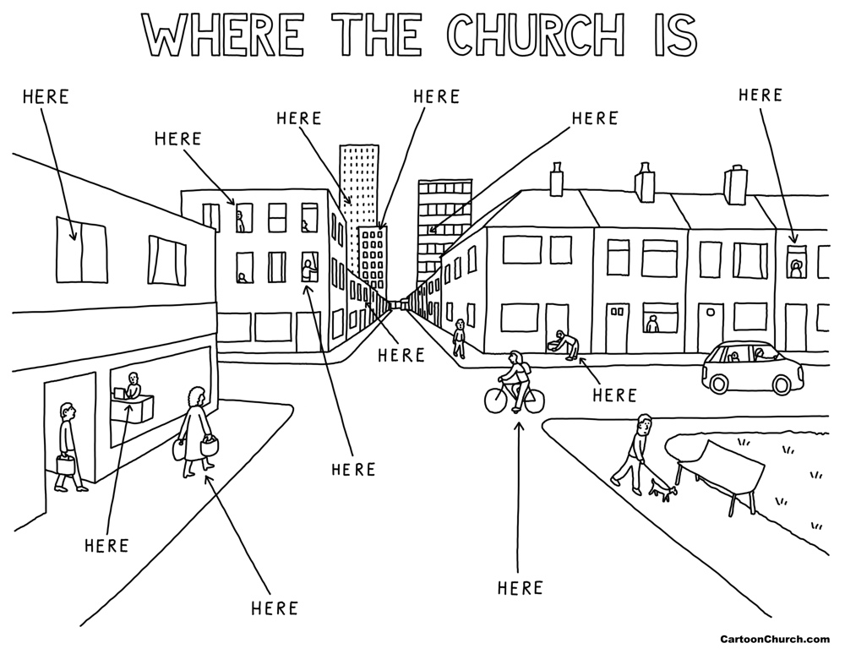
The magazine this month contains two cartoons today by the remarkable Dave Walker. His cartoons appear every week in the Church of England newspaper called Church Times. It is not an official newspaper, but with one other paper, The Church of England Newspaper, provides a weekly digest of news, letters, reviews, adverts and commentary on the Church of England.
Dave Walker has been most generous in letting his cartoons appear elsewhere and they have a distinctive style and wry humour. Yet like all good humour they can point out our silliness without being cruel and say things that might be hard to say even if we had more words to use.
The one above reminds us that if the building is closed the people are still out there – you and I are still in our homes, perhaps doing shopping, we are the Church! It is only the building that is currently closed – we are still in the business of being the people of God.
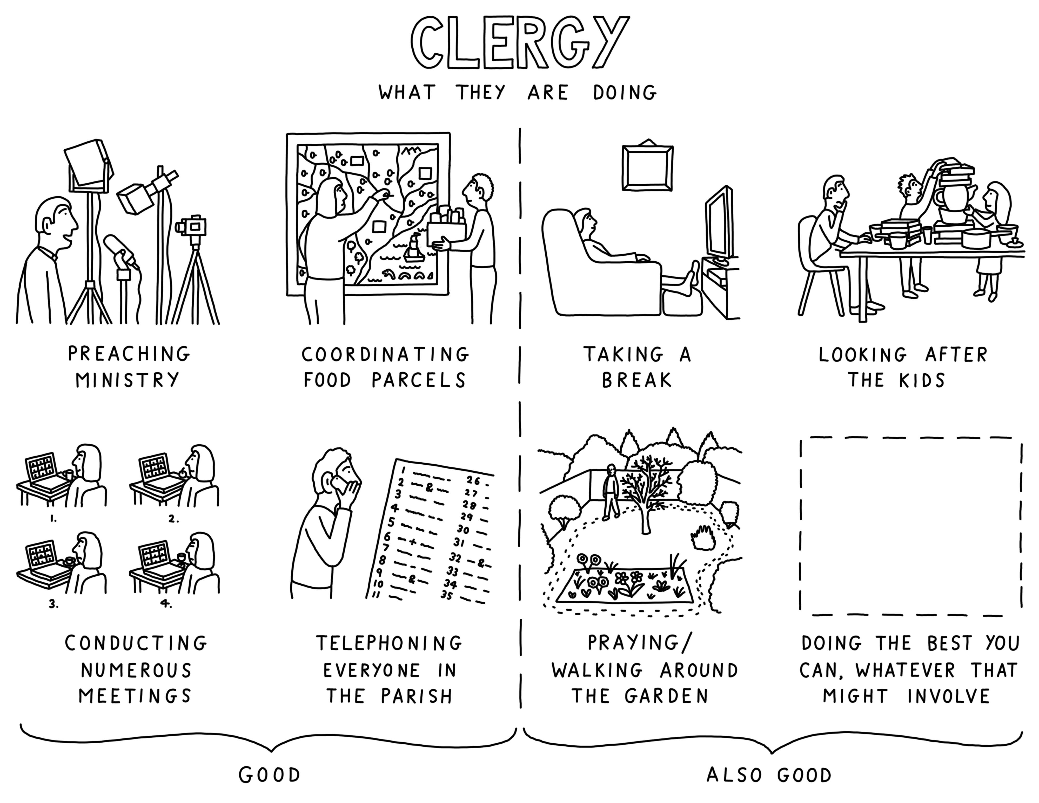
This second Dave Walker cartoon shows how some clergy have been using their time. Our Bishops Pete and Sophie have repeatedly encouraged us, the clergy of the diocese, to be careful with ourselves and not exhaust or demean ourselves in comparisons to others.
I have read more and had a major clear out of rooms. I’ve edited longer magazines and made more phone calls. I’ve taken more funerals and spent a great deal of time seeking to support the vacant parishes of the deanery – St Michael Rossington, St Luke New Rossington and All Saints Denaby Main.
To be honest I have also struggled more; missing our worship and study groups; missing coffee mornings and our buzz after worship on Sunday and Thursday. Last year Kenzie and I would walk to Sprotbrough and back but now he struggles to get to the Cricket ground and back and he is deaf.
A cartoon with you in it may see you doing things you did not do before; it might show you bored and even unhappy. But I hope it will also show you appreciating small things more and longing in a deep way for the things we had and perhaps took for granted.
Warmsworth St Peter
Worship in the new lockdown 2021

The Government allows places of worship to remain open in this new year lockdown. This is in contrast to the two previous times of restrictions; the first where we were required to close and the second where we were free to open. The advice from the Church of England and the diocese is that each PCC with their incumbent should now decide. If we are staying open to complete a new risk assessment; if not to make that decision clear and inform the bishop of Sheffield who will give immediate support to the decision.
I am extremely grateful to our PCC members who have replied to my request for their views. There has been careful, reasoned and nuanced thought. The majority view, including (and this carries real weight) that of both our Wardens, Maureen and Dorothy, is that we should close for January.
I am therefore announcing and will inform the bishop that we will close for the Sundays and Thursdays in January and then review.
I think it is appropriate to share the factors involved in the decision and do so asking they are received. This difficult time will not be helped if we critique each other or compare ourselves to others, or feel a compulsion to act against our judgement.
The factors that have been included are:
- The real spiritual and emotional benefit that attendance at services has brought people who have gone through so much already.
- The permission and advice allows us real freedom and balances that with real responsibility for people’s well being.
- We have had no recorded incidence of a Covid infection or trace while we have been open for worship and that is a tribute to the care we have taken after our risk assessment. People have felt and said they feel safe.
- There have been incidents where people have needed reminding to wear a mask; for the mask to cover mouth and nose; not to walk across pews or people. There have been groups and people closer than 2 metres talking to each other. The vigilance and the risks associated with the above are clearly increased now the variant virus is being detected in our area and before most people have been vaccinated.
- Our national and local society are asked to stay at home and reduce travel and contact; should we then opt out of that solidarity with them by making a journey to be with others in a way the majority are restrained from? What witness is it if we meet in a way they cannot or should not?
- How would we feel if as a result of our being open for worship there was an infection and in the worse case, hospitalisation or death among our congregation that their attendance may have caused?
I hope in reading the above you will feel the same concerns and difficulty in decision making that the PCC, Wardens and I as Rector have felt. But a decision must be made. The magazine for February will have additional pages to read and we will keep up the telephone calls we make to one another. These are simple ways to tide us over the next weeks. Some of you may still have the Prayers in a time of Coronavirus the Church of England issued as a booklet to hand. There is a national online Church of England service each Sunday to follow and BBC Radio 4 have a Sunday morning broadcast service and BBC 1 TV have a weekly service too. These are useful while we wait to meet again. And God willing, we will meet again soon.
The Rev. Canon Ian Smith - Rector of Warmsworth

