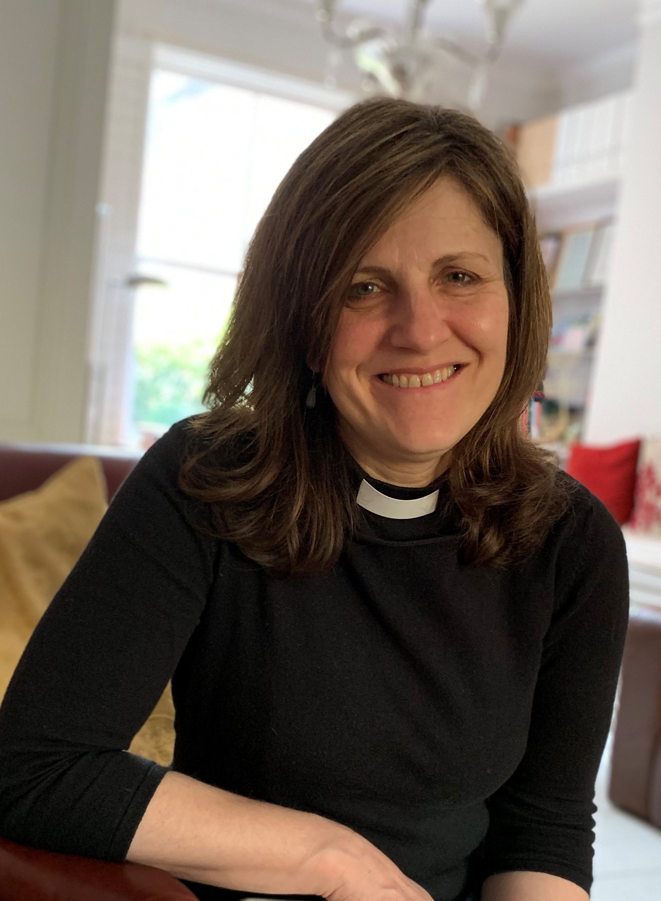

“We are delighted to announce that, subject to completion of all the necessary legal checks, the Revd Heike Prentice has been appointed as our new Vicar.”

Heike served her curacy at St Peter’s Church Hammersmith, and studied theology at St Mellitus College, London, while training as an ordinand at Chelmsford Cathedral.
Before being ordained, Heike worked as a PA and administrator in publishing, IT and education, then qualifying as a direction and leadership coach.
Heike is married to Alistair, they have three adult sons and two granddaughters, who they love to see whenever possible. Originally from Germany, she holds dual nationality.
About her appointment Heike says:
“I am absolutely delighted to have been appointed as vicar of Coggeshall, Markshall, Cressing, Stisted, Bradwell-juxta-Coggeshall & Pattiswick. I look forward to serving the people of this vibrant and diverse benefice, to be returning to Chelmsford Diocese and for us to settle in the beautiful Essex countryside.”

Please join us in praying for Heike, Alister and their family as she begins this new journey.

