10 January 2021
Baptism of Christ

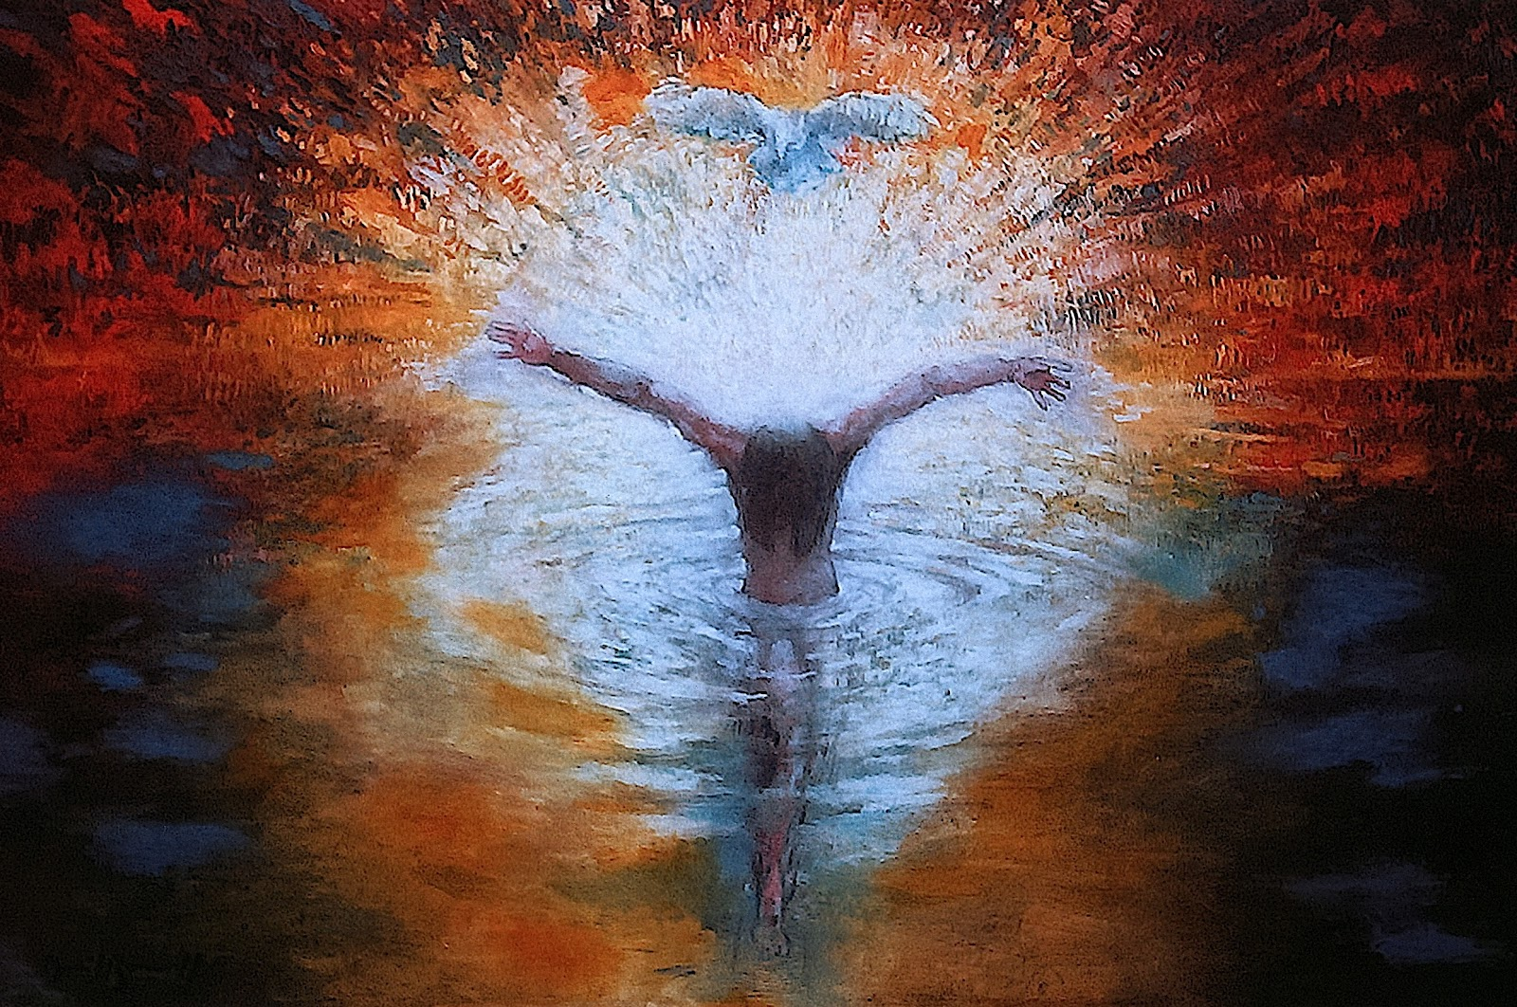

In the name of the Father, and of the Son, and of the Holy Spirit. Amen.

The Greeting
The Lord be with you and also with you.

Welcome to the water of life, come and remember your promises
We renounced evil, we repented of our sin, we turned to Christ.

Welcome to the family of God, born by his love, held in his arms
We are part of God’s family, precious and beloved.

God says to you “Look, my children in whom I am well pleased.”
Thanks be to God.

Hymn O Worship the Lord
O worship the Lord in the beauty of holiness!
Bow down before Him, His glory proclaim;
With gold of obedience, and incense of lowliness,
Kneel and adore Him: the Lord is His name!

Low at His feet lay thy burden of carefulness,
High on His heart He will bear it for thee,
And comfort thy sorrows, and answer thy prayerfulness,
Guiding thy steps as may best for thee be.

Fear not to enter His courts in the slenderness
Of the poor wealth thou wouldst reckon as thine;
For truth in its beauty, and love in its tenderness,
These are the offerings to lay on His shrine.

These, though we bring them in trembling and fearfulness,
He will accept for the name that is dear;
Mornings of joy give for evenings of tearfulness,
Trust for our trembling and hope for our fear.

O worship the Lord in the beauty of holiness!
Bow down before Him, His glory proclaim;
With gold of obedience, and incense of lowliness,
Kneel and adore Him: the Lord is His name!

Prayer of Preparation
Almighty God, to whom all hearts are open, all desires known,
and from whom no secrets are hidden: cleanse the thoughts of our hearts by the inspiration of your Holy Spirit, that we may perfectly love you, and worthily magnify your holy name; through Christ our Lord. Amen.

Confession and Absolution
Let us confess our sins.
Lord we have tried and failed to keep the promises we made at our baptism, confirmation and in our Christian life. Our words have wounded, our actions have hurt others, our lives have not spoken of love and faith in you. We are sorry and ask to be made whole again.

Lord of all time and eternity, you opened the heavens and revealed yourself as Father in the baptism of Jesus your beloved Son: by the power of your Spirit may you complete the heavenly work of our rebirth through the waters of the new creation; as our sins are forgiven, inspire us to live for you, through Jesus Christ our Lord. Amen.

Baptismal Waters Litany Written by the Rev. Melissa Reed
When they say: you are alone. These waters say: You are “with.”

When they say: You are too broken, damaged goods, too wounded, not enough. These waters say: Enough, beloved. Enough.

When they say: You are too brown, child. Too black. Too queer, child. Too fat. These waters say: Beautiful, child. Beautiful.

When they say: You are too addicted, stranger.
Immigrant, alien. Criminal. Too far gone, stranger.
These waters say: Home, neighbour. Welcome home.

When they say: We could sell these waters and turn a profit!
These waters say: We are the waters of the Jordan,
the waters of the Atlantic, the waters of the Tamar. We are free!

When they say: Fear. These waters say: Trust.

When they say: Commodify. Consume. These waters say: Life.

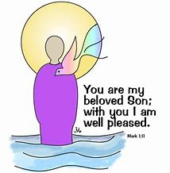

The Collect
Heavenly Father, at the Jordan you revealed Jesus as your Son: may we recognize him as our Lord and know ourselves to be your beloved children; through Jesus Christ our Saviour. Amen.

First Reading Genesis 1.1-5
In the beginning God created the heavens and the earth. Now the earth was formless and empty, darkness was over the surface of the deep, and the Spirit of God was hovering over the waters.
And God said, “Let there be light,” and there was light. God saw that the light was good, and he separated the light from the darkness. God called the light “day”, and the darkness he called “night”. And there was evening, and there was morning – the first day.
This is the word of the Lord. Thanks be to God.

Psalm 29.1-4,7,10.
The Lord shall give his people the blessing of peace.
1 Ascribe to the Lord, you powers of heaven, ♦
ascribe to the Lord glory and strength.
2 Ascribe to the Lord the honour due to his name; ♦
worship the Lord in the beauty of holiness.
3 The voice of the Lord is upon the waters; the God of glory thunders; ♦ the Lord is upon the mighty waters.
4 The voice of the Lord is mighty in operation; ♦
the voice of the Lord is a glorious voice.
7 The voice of the Lord splits the flash of lightning; the voice of the Lord shakes the wilderness; ♦ the Lord shakes the wilderness of Kadesh.
10 The Lord shall give strength to his people; ♦
the Lord shall give his people the blessing of peace.

Open our ears, glorious Lord Christ, to hear the music of your voice above the chaos of this world; open our eyes to see the vision of your glory, for you are our King, now and for ever. Amen.

Gospel Reading
Hear the Gospel of our Lord Jesus Christ according to Mark 1.4-11
Glory to you, O Lord.
4John the baptizer appeared in the wilderness, proclaiming a baptism of repentance for the forgiveness of sins. 5And people from the whole Judean countryside and all the people of Jerusalem were going out to him, and were baptized by him in the river Jordan, confessing their sins. 6Now John was clothed with camel’s hair, with a leather belt around his waist, and he ate locusts and wild honey. 7He proclaimed, ‘The one who is more powerful than I is coming after me; I am not worthy to stoop down and untie the thong of his sandals. 8I have baptized you with water; but he will baptize you with the Holy Spirit.’
9In those days Jesus came from Nazareth of Galilee and was baptized by John in the Jordan. 10And just as he was coming up out of the water, he saw the heavens torn apart and the Spirit descending like a dove on him. 11And a voice came from heaven, ‘You are my Son, the Beloved; with you I am well pleased.’
This is the Gospel of the Lord. Praise to you, O Christ.

Address

Let us declare our faith in God, using the baptismal creed.
We believe and trust in God the Father, source of all being and life,
the one for whom we exist.
We believe and trust in God the Son, who took our human nature,
died for us and rose again.
We believe and trust in God the Holy Spirit, who gives life to the people of God and makes Christ known in the world.
This is the faith of the Church. This is our faith.
We believe and trust in one God, Father, Son and Holy Spirit. Amen.

Prayers of Intercession
Lord, in your mercy hear our prayer.
And at the end
Merciful Father, accept these prayers for the sake of your Son,
our Saviour Jesus Christ. Amen.

The Peace

Blessed be Christ, the Prince of Peace.
He breaks down the walls that divide us: praise Christ who is our peace!

The peace of the Lord be always with you and also with you.

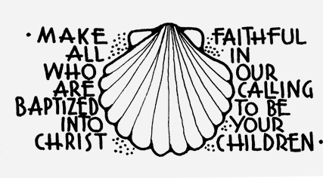

Taking of the Bread and Wine
As this bread was scattered and then gathered and made one,
so may your Church be gathered into your Kingdom.
Glory to you, O God, for ever.

Wisdom has built her a house;
she has mixed her wine; she has set her table.
Glory to you, O God, for ever.

The Eucharistic Prayer
The Lord be with you and also with you.
Lift up your hearts. We lift them to the Lord.
Let us give thanks to the Lord our God.
It is right to give thanks and praise.
Lord of all life, you created the universe, where all living things reflect your glory. You give us this great and beautiful earth, to discover and to cherish. You give us your love, even when things go wrong. Jesus knew hurt and pain. Through him you wipe away our tears and fill us with your peace. You made us all, each wonderfully different, to join with the angels and sing your praise:
Holy, holy, holy Lord, God of power and might, heaven and earth are full of your glory. Hosanna in the highest. Blessed is he who comes in the name of the Lord. Hosanna in the highest.
We thank you, loving Father, because, when we turned away, you sent Jesus, your Son. He gave his life for us on the cross and shows us the way to live. Send your Holy Spirit that these gifts of bread and wine may be for us Christ’s body and his blood. On the night before he died, when darkness had fallen, Jesus took bread. He gave thanks, broke it, and shared it with his disciples, saying: ‘This is my body, given for you. Do this to remember me.’
After they had eaten, he took the cup of wine, gave thanks, and shared it with his disciples, saying: ‘This is my blood, poured out for you and for many, for the forgiveness of sins.’
So, Father, with this bread and this cup we celebrate his love, his death, his risen life. As you feed us with these gifts, send your Holy Spirit,
and change us more and more to be like Jesus our Saviour.
Help us, Father, to love one another, as we look forward to that day
when suffering is ended, and all creation is gathered in your loving arms. And now with all your saints we give you glory, through Jesus Christ, in the strength of the Spirit, today and for ever. Amen.
The Lord’s Prayer
Our Father, which art in heaven, hallowed be thy name; thy kingdom come; thy will be done, in earth as it is in heaven. Give us this day our daily bread. And forgive us our trespasses, as we forgive them that trespass against us. And lead us not into temptation; but deliver us from evil. For thine is the kingdom, the power and the glory, for ever and ever. Amen.

Breaking of the Bread
We break this bread to share in the body of Christ.
Though we are many, we are one body,
because one day we will all share together in one bread again.

We do not presume to come to this your table, merciful Lord, trusting in our own righteousness, but in your manifold and great mercies. We are not worthy so much as to gather up the crumbs under your table. But you are the same Lord whose nature is always to have mercy. Grant us therefore, gracious Lord, so to eat the flesh of your dear Son Jesus Christ and to drink his blood, that our sinful bodies may be made clean by his body and our souls washed through his most precious blood, and that we may evermore dwell in him and he in us. Amen.

Words of Assurance (inspired by Psalm 139:1-6, 13-18)
Our God knows you by name. Our God knows what you fear. For you are fearfully and wonderfully made. In your name, God’s works are revealed again to us. Jesus become the bread and wine of our new life, to feed us spiritually to give us courage and strength to meet the day.
Thanks be to God. Amen.

Communion is received

Prayer after Communion
Lord of all time and eternity, you opened the heavens and revealed yourself as Father in the baptism of Jesus your beloved Son: by the power of your Spirit complete the heavenly work of our rebirth through the waters of the new creation; through Jesus Christ our Lord.

Father of all, we give you thanks and praise, that when we were still far off you met us in your Son and brought us home. Dying and living, he declared your love, gave us grace, and opened the gate of glory.
May we who share Christ’s body live his risen life; we who drink his cup bring life to others; we whom the Spirit lights give light to the world. Keep us firm in the hope you have set before us, so we and all your children shall be free, and the whole earth live to praise your name; through Christ our Lord. Amen.

Hymn Brightest and Best
Brightest and Best of the sons of the morning,
Dawn on our darkness and lend us Thine aid;
Star of the East, the horizon adorning,
Guide where our infant Redeemer is laid.
Cold on His cradle the dewdrops are shining;
Low lies His head with the beasts of the stall;
Angels adore Him in slumber reclining,
Maker and Monarch and Saviour of all!
Say, shall we yield Him, in costly devotion,
Odours of Edom and offerings divine?
Gems of the mountain and pearls of the ocean,
Myrrh from the forest, or gold from the mine?
Vainly we offer each ample oblation,
Vainly with gifts would His favour secure;
Richer by far is the heart’s adoration,
Dearer to God are the prayers of the poor

Blessing
May God the Father keep you in all your days.
May God the Son shield you in all your ways.
May God the Spirit bring you healing and peace.
May God the Holy Trinity drive all darkness from you
and pour upon you blessing and light. Amen.
The Holy Trinity, in whose name we were baptized, preserve us,
members of Christ, children of God, inheritors of the kingdom of heaven, saved by the waters, and filled with the Spirit.
Glory to God, Father, Son and Holy Spirit.

The ministers and people depart.

Copyright acknowledgement (where not already indicated above):
Genesis 1.1-5 © 1973, 1978, 1984 International Bible Society. Pub. Hodder & Stoughton
Introduction to the Peace (Living in the world) © Anglican Church in Aotearoa, New Zealand and Polynesia (Substantially adapted)
Final Acclamation (Father, Son & Spirit, Christian beginnings) © Michael Perham
Some material included in this service is copyright: © The Archbishops' Council 2000
Blessings and Ending (New Year). © The Archbishops' Council 2002
Collect (Baptism of Christ, Additional) © The Archbishops' Council 2004
Breaking of the bread adaption Vanda Perrett

