Latest News – 20th December 2020

Watch the service - Church of England partners with end of life charity Marie Curie for national online service

The Church of England’s Worship at Home for the fourth Sunday of Advent reflects on the experiences during the COVID-19 pandemic of those suffering from illness, bereavement and mental health setbacks. 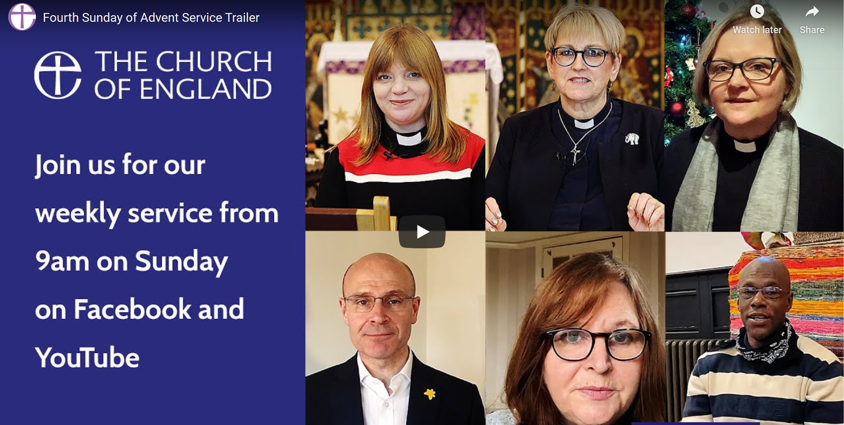
The service is to be broadcast from 9am on Sunday on the Church of England’s website, Facebook page and YouTube channel. The service remains available to view afterwards.
An order of service is available to download online.
All of the video content is manually subtitled. To turn these on, go to the bottom left of the video and click the filled-in box with two broken lines inside. The service is BSL-interpreted throughout.
**

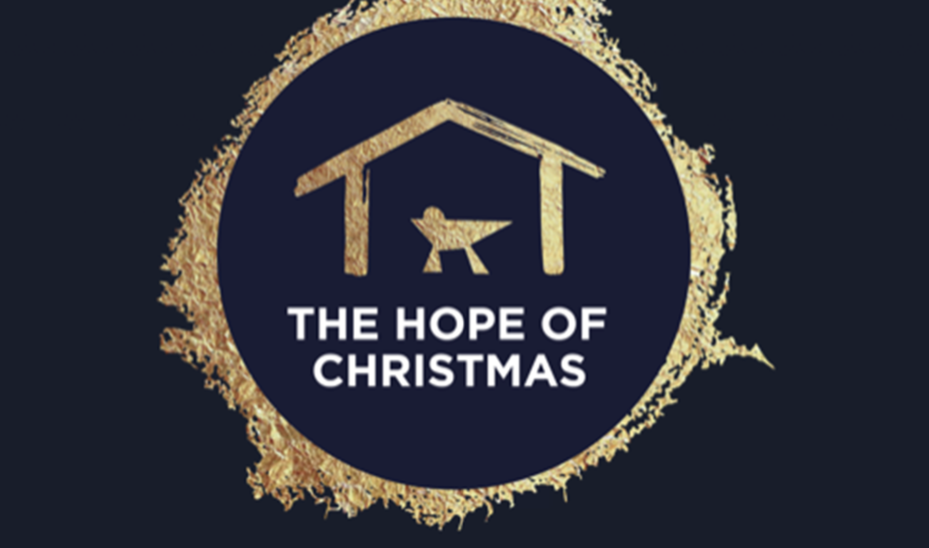

New Christmas resource

A great new resource produced by St Alban’s Diocese
They have created a nativity film with accompanying resources.
This project is called The Hope of Christmas and is focussed on Christ, God’s hope among us in a year like no other.
The film comes with accompanying resources to enable worship and mission for churches and schools this Christmas (either online or in person). There is a short promo film to give you an idea of the style.
PDFs are available for:
• School assemblies / collective worship
• Family and children’s worship and craft session
• All Age service
• Prayer resources
• Discussion session

The Diocesan Digital Advent Calendar - Days 1-12
A group of curates, led by Revd Sherine Angus (Alford Group of Churches) and Revd Rachel Reveley, Curate at Lincoln Cathedral and the benefice of Branston with Nocton & Potterhanworth) have been busy producing a digital Advent Calendar for the diocese which features short (between 1-3 minutes) festive messages from Bishop Nicholas and 20 other curates from around the diocese.
Each video has a title which provides a brief snapshot of the theme of the video, together with the name of the contributor.
Here is a link to the actual Advent calendar if you would like the joy of opening the window and seeing the message contained in it.
https://calendar.myadvent.net/?id=8058f3dd88b7026ff947a971c91baca9
***Please note this will be live from midnight on Tuesday 1st December 2020***

Outdoor congregational carol singing permitted in all tiers
29/11/2020
The Bishop of London, Sarah Mullally, has welcomed guidance from the Government permitting outdoor singing for places of worship in all tiers in England from 2nd December.
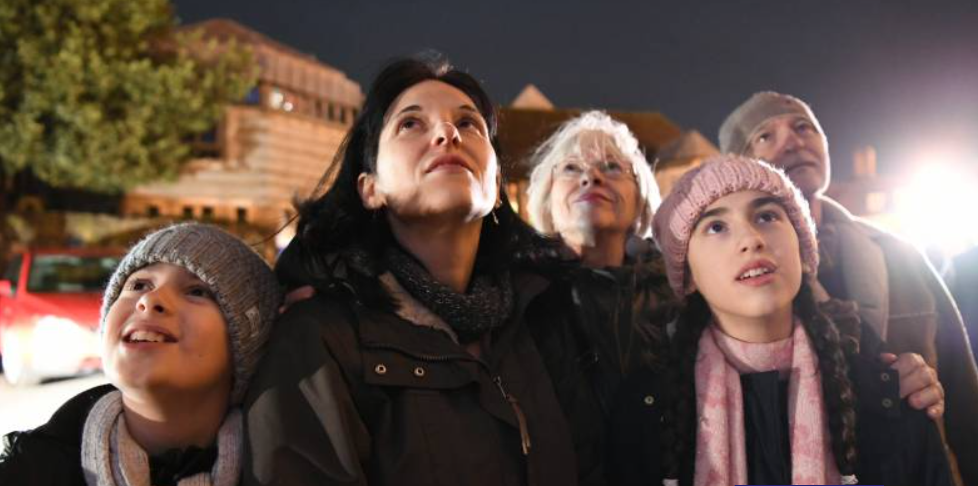
Guidance published by the Government on Sunday confirmed that indoor singing by both amateur and professional choirs will be permitted, and that congregations could sing carols outdoors, providing they are physically distanced.
The Church of England has also published an article giving tips to anyone planning to hold an outdoor carol service.
The maximum number of people present should take into account the area of the space and the requirement to maintain 2m social distancing at all times.
In 2019, 5.7 million people attended Advent and Christmas services in churches and cathedrals in England, while across the Church of England, more than 17,000 online services and events have been provided since March 2020.
Churches planning Christmas services are encouraged to complete a risk assessment to ensure that worshippers can be welcomed as safely as possible.
A special tag has been added to A Church Near You for each church to list services and events taking place outdoors. Last year the site featured more than 25,000 Advent and Christmas services and was accessed by nearly 7 million people. It has already received 50 million page views in 2020.
Bishop Sarah, who chairs the Church of England’s Recovery Group, said: “Singing is a very special part of our worship, especially at Advent and Christmas, so I know that the announcement that we will be able to come together for public singing outdoors this Christmas will bring comfort and joy to many.
“Advent and Christmas this year will not be the same as previous years but having outdoor congregational singing and indoor carol services with choirs is a reasonable balance and recognises our duty to protect and care for each other.
“Following news that the official number of people who have died and are Covid positive has reached almost 700 a day, we are mindful of the terrible toll this virus is taking in this country so I pray that our worship this Christmas will reflect the light and hope at the heart of the nativity story.”
The announcement was also welcomed by the Royal School of Church Music. RSCM Director, Hugh Morris, said: “The opportunity for everyone to be able to sing carols in some form is to be welcomed. For congregations to be able to raise their voices in song outdoors should really help to enable everyone to engage positively and actively with the message of Christmas.
"Allowing choirs to lead indoor services means that they equally have the chance to give joy to others – and the RSCM’s motto of ‘I will sing with the spirit, and with the understanding also’ is surely a guiding light for all those who will be singing in such choirs over the next month.
"It is of course so important to keep everyone safe in doing so, in order that we can all move forwards together into a brighter 2021."

Church of England and Christian Aid share service of lessons and carols with a global vision
The Church of England is joining forces with Christian Aid for a special service of lessons and carols with participants from around the world.

Through Bible readings, carols and reflections, the service - which premieres on the Church of England website, Facebook and YouTube accounts at 9am on Tuesday December 22nd – issues a challenge to stand up for “righteousness and justice”.
Lord Williams, the former Archbishop of Canterbury, who is Chair of Christian Aid, gives the sermon and there are contributions from Kenya, Portugal and around the UK. Music comes from the choir of St Martin-in-the-Fields, London, and the St Martin’s Voices group.
**

Presents, carols, turkey, an empty chair and a video call – Church of England launches film for a very different Christmas
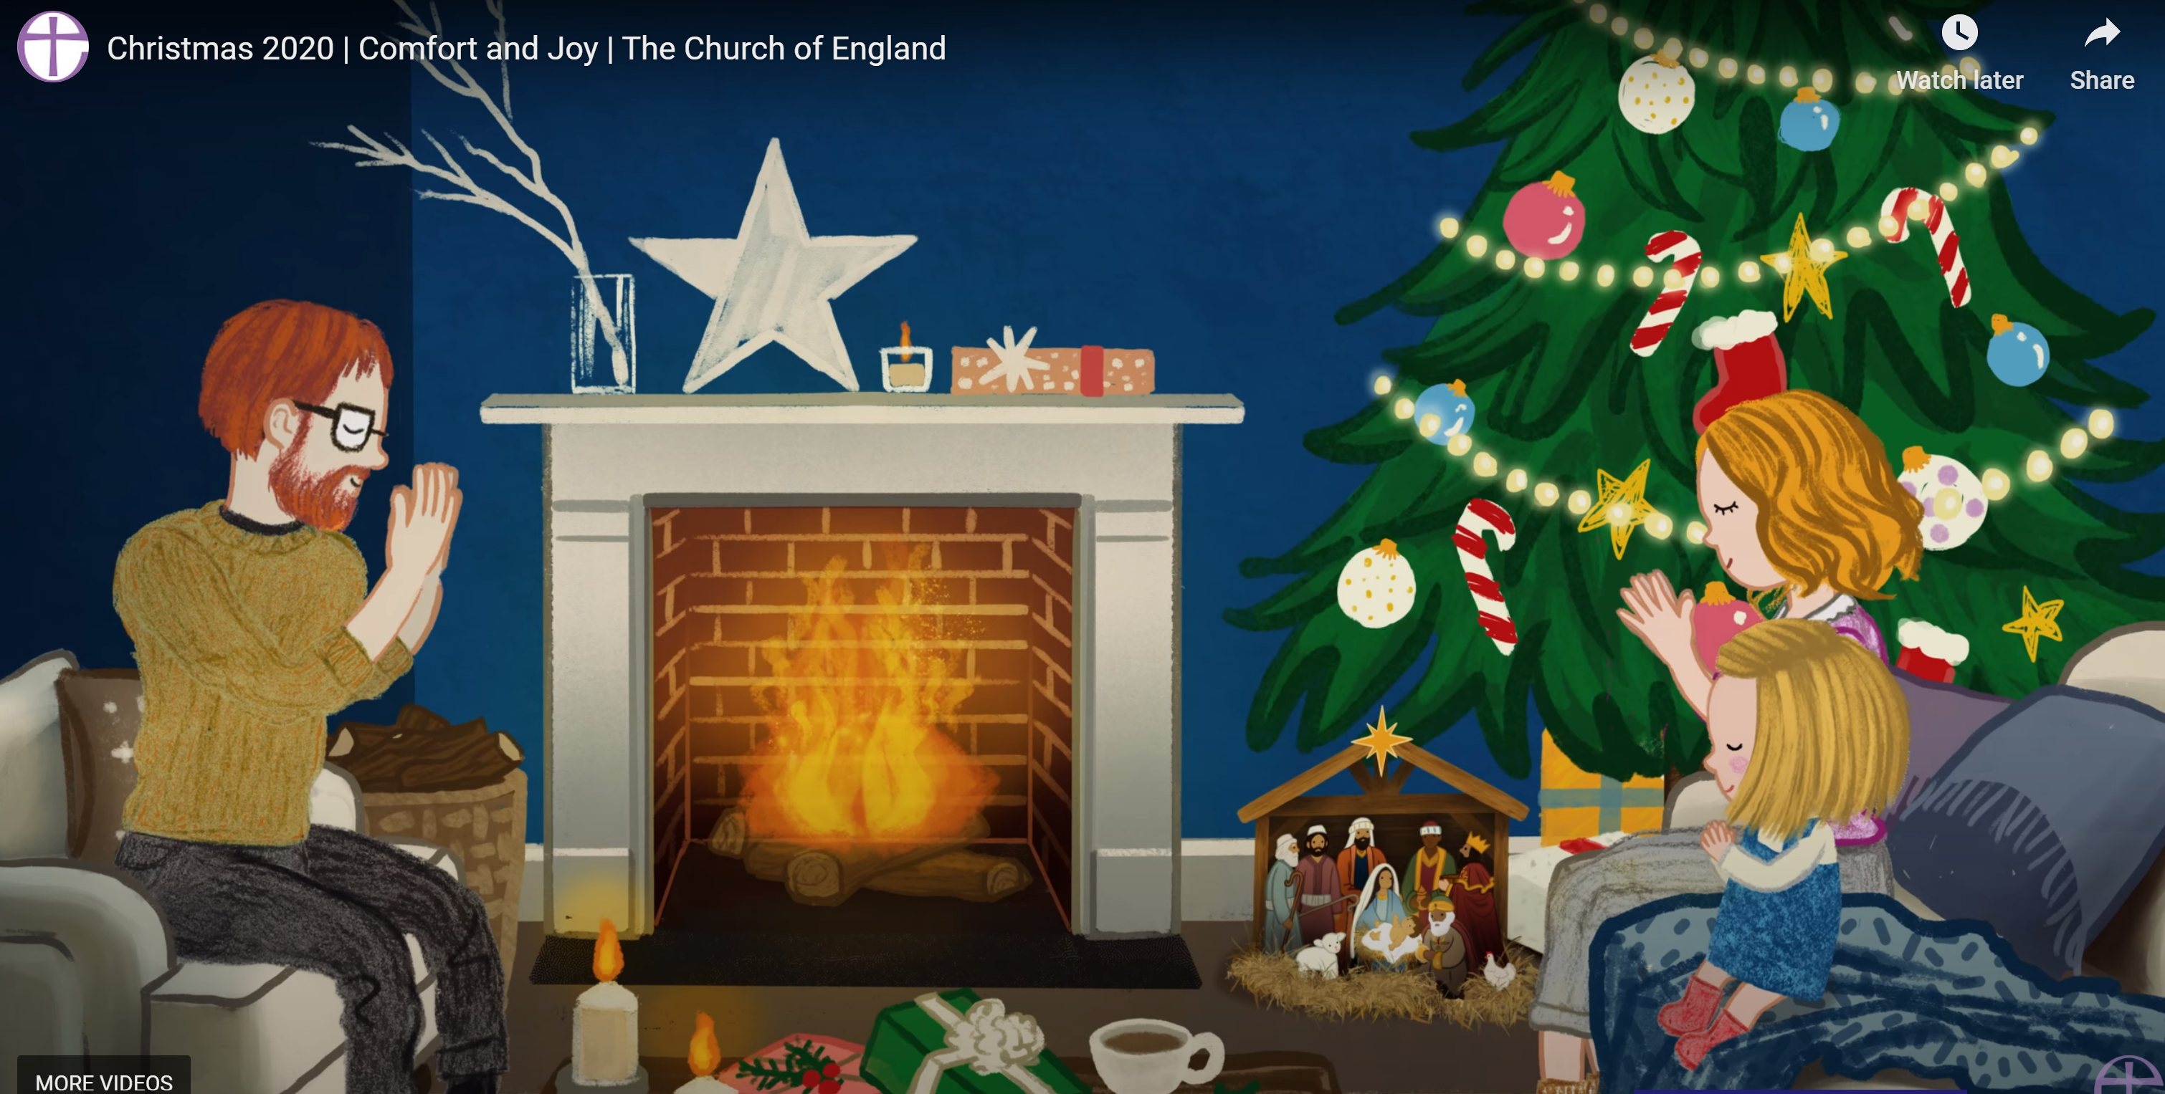
The Church of England has launched its annual Christmas film, with a message of Comfort and Joy after a year like no other.
The three-minute animated video can be adapted and personalised by parish churches and cathedrals for use ahead of Advent and Christmas.
Featuring various families preparing for and celebrating Christmas, the film is the centrepiece of the Church of England’s Comfort and Joy campaign. A programme of online services and reflections with content will be shared through December and up and until Epiphany.
The video, narrated by Martha Collison, the Great British Bake Off star and Instagram influencer, explores how the uniquely difficult circumstances of 2020 will shape the festive season ahead for many families. In one scene a man is shown wearing a mask. In another a woman, who is alone and unable to travel, celebrates Christmas with her family via a video call.
Describing the situation for many people this Christmas, the narrator says: “There’ll be presents we give and blessings we share, generous tables, crackers to pull - and empty places of those not with you, some that are gone forever, and some just not able to travel.
“We’ll have eyes filled with tears and hearts with love. Whether they’ll be arms around us or chats around screens and giggles on phones, we’ll still have trees to set up and cards to write, calendars to open, and carols to sing, candles to light and prayers to say and the greatest story of all, with light from the stable and the Christ child promising comfort and joy for everyone this special Christmas time.”

Patience and goodwill: meeting for Christmas as Covid-safe churches

During the Christmas period, where ordinarily nearly 6 million people would attend church buildings, churches, chapels and cathedrals across the country are preparing to allow people to come together as church, either virtually or in person with measures to help prevent the spread of Covid-19.

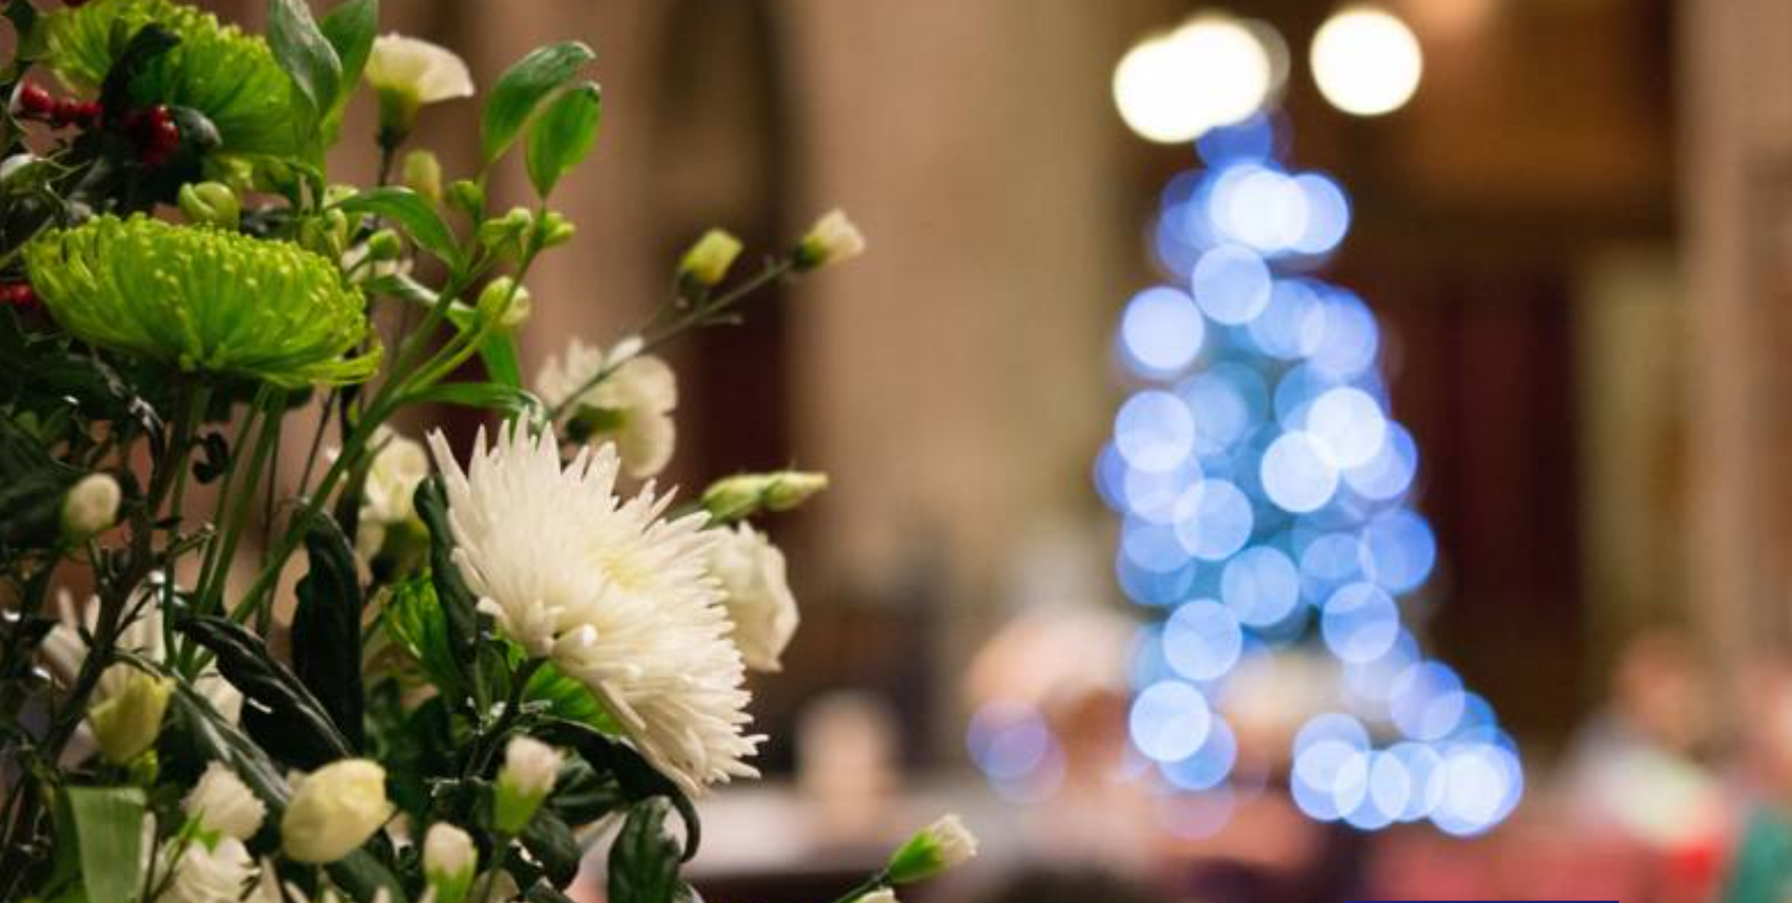
The Church of England’s ‘church finder’ website A Church Near You allows users to find Christmas services near them. This includes online services, outdoor services and indoor worship with Covid-secure arrangements. More than 15,000 services have already been listed.
The Archbishop of Canterbury will lead a service of Midnight Mass to be broadcast on the Church of England’s YouTube and Facebook channels, while the Daily Hope freephone line continues to offer worship, reflections and music for those who aren’t able to stream.
The Bishop of London, Sarah Mullally, who leads the Church of England’s Recovery Group, is encouraging churches to prepare carefully for Christmas services, so that as many people as possible can share in the comfort and joy of Christmas worship:
"We are looking forward to welcoming linked Christmas households into our church services and are glad that families can spend time together as we celebrate the birth of Jesus," she said. “I want to echo warnings of the Prime Minister and the Chief Medical Officer that in coming together, especially at home, we do everything possible not to put those who are most vulnerable at risk, limiting travel and contact with others outside our households as far as possible.
“Our cathedrals and parishes have already done a magnificent job of creating COVID-safe environments and we are extremely grateful for all they have done throughout the year. Coming together as worshiping communities both in person and online will bring comfort and joy to millions over the Christmas period.
“It is vital that we keep our focus on caring for one another; with greater numbers it will be important that all of us attending church services meet in a spirit of patience and goodwill, to ensure the safest environment possible for all.”
Covid-19 advice and guidance from the Church of England is updated regularly, as is Government guidance for places of worship.

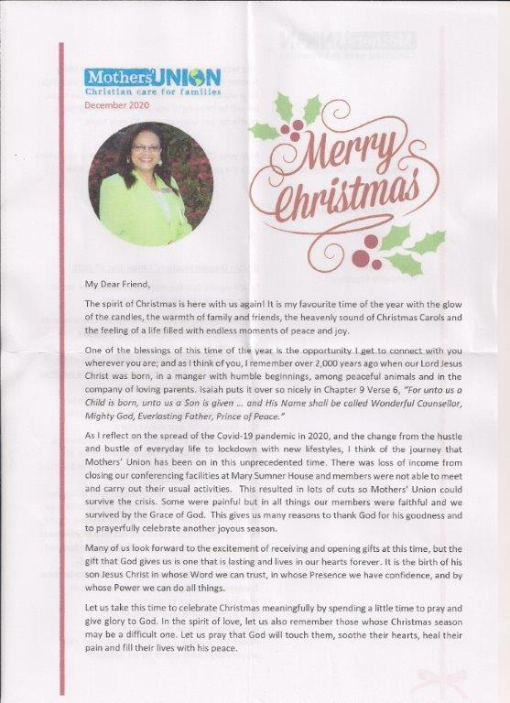

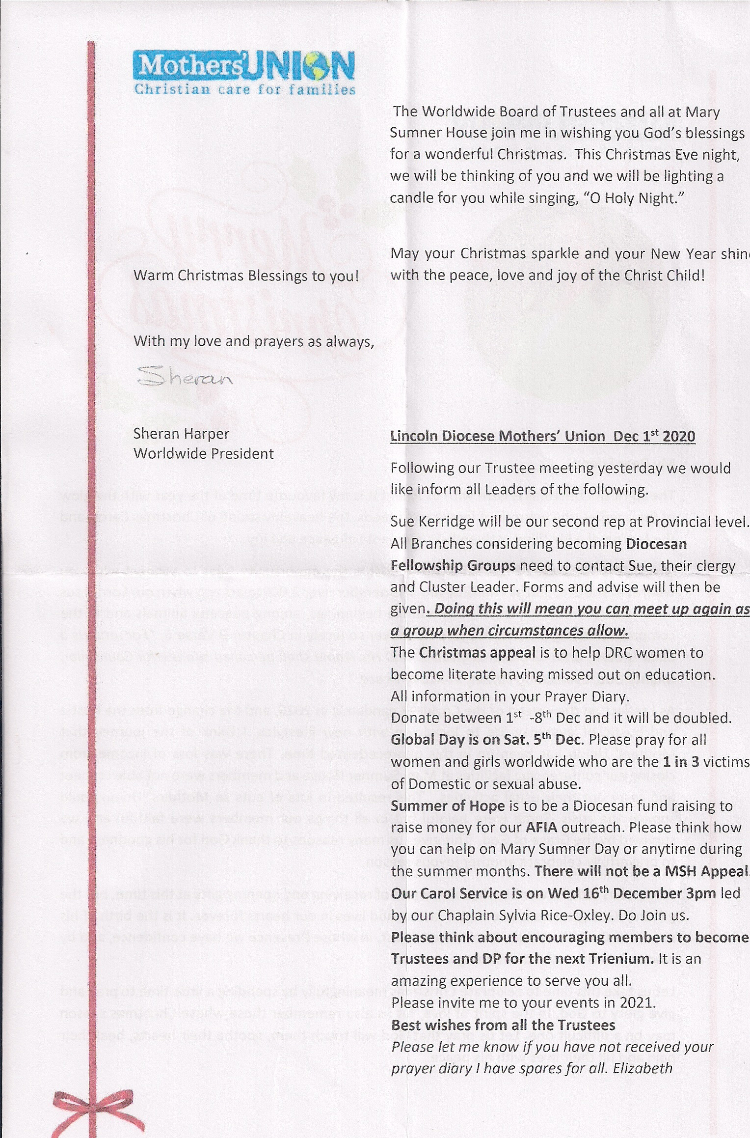
Lincoln Cathedral

The Chapter Letter 20th December 2020
With such big and deeply serious concerns engulfing our world at present it is easy to feel overwhelmed and anxious. To find ourselves sinking or being oppressed by a sense of darkness and an encircling gloom.
It is why festivals, community celebrations, twinkling lights, the singing of familiar carols, traditions and rituals, are all so important to human lives. They anchor us in a sense of belonging and solidarity, they give us the perspective of a span of years, way beyond ourselves. They kindle joy and hope in our hearts.
It is something this cathedral does in buckets and it is why the vision of the cathedral blazing brightly in the darkness is such a source of comfort and a sense of homecoming. It speaks to us of longevity, stability, hope and history.
Here in this place we gather to enact the story of the Christian faith, the story of God with us, in our celebrations and triumphs and in our moments of shared uncertainty or sorrow. We hear the message of the angels to Mary, to the Shepherds and to us: “do not be afraid.” Words of good news of great joy, the announcement of a reign of peace and goodwill, of salvation and rescue, through the immensity of God’s love made known in our midst in the gift of Jesus Christ.
What is so beautiful about this message of hope and reassurance, is that it is revealed to us so humbly in the small wonder of a vulnerable new-born baby, in a bright mysterious star and in the astonishment of ordinary workers on a night shift on the hills of Bethlehem.
The Christmas gift we celebrate is the promise of a God who is with us even in the mess and the darkness. God, who in sending the child Jesus demonstrated a passion and commitment to the flourishing and transformation of all creation.
Christmas will be different this year, simpler and smaller, but the message is no less profound. In some ways it puts us in touch with different aspects of the story. Mary far from her parents and siblings, having to make do with an environment that was makeshift and far from ideal for the birth of her child and soon to be chased into exile along with Joseph.
As we ponder the message of the angels “Do not be afraid, I bring good news of great joy!” may you know the peace of Christ in your hearts and homes this Christmas. A Christmas which feels like no other we have known.
DEAN CHRISTINE
**

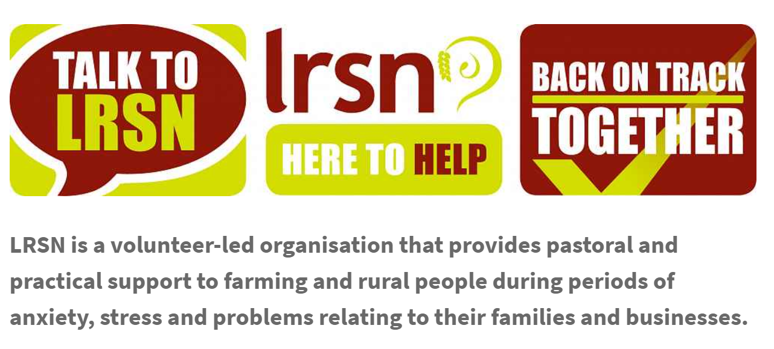
LRSN is open for business and ready, willing and able to help you, whatever your problem, wherever you are in Lincolnshire. If you or someone you know needs to talk through an issue, please contact us using our helpline number, 0800 138 1710. Visit www.lrsn.co.uk
**
RoadHoG November 2020 newsletter published
RoadHoG bus visits to Sibsey have been suspended for the lockdown period.
The November newsletter has been published http://roadhogbus.org.uk/wp-content/uploads/2020/11/112-November-2020.pdf
If you have ever considered joining one of our RoadHoG Teams and would like to attend a training session, please do get in touch with us. Attending the training will not mean that you will automatically have to regularly join a Team at a Stop, but you will get a taste of what we do and, whether you ultimately decide to work within the Project or not, you will be made extremely welcome. To arrange to join the training sessions, you can contact us through the website www.roadhogbus.org.uk or just type RoadHoG Boston into your browser and leave a message along with your contact details.

Take 1 minute a day to report your health daily on the COVID-19 Symptom Study app even if you are well. Help science beat the virus.
Find out more at https://covid.joinzoe.com/
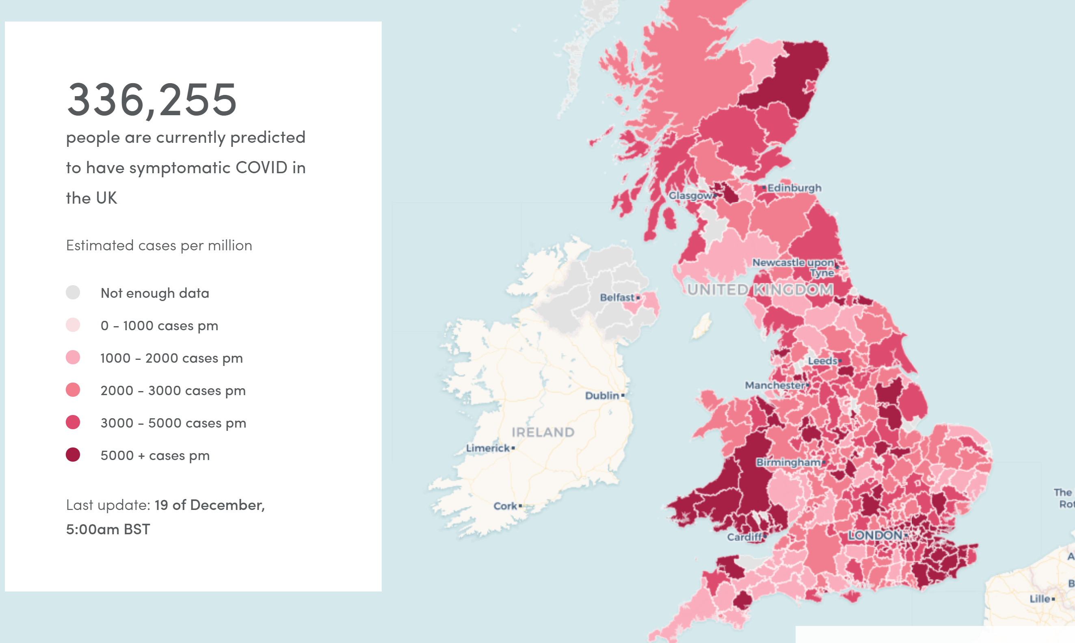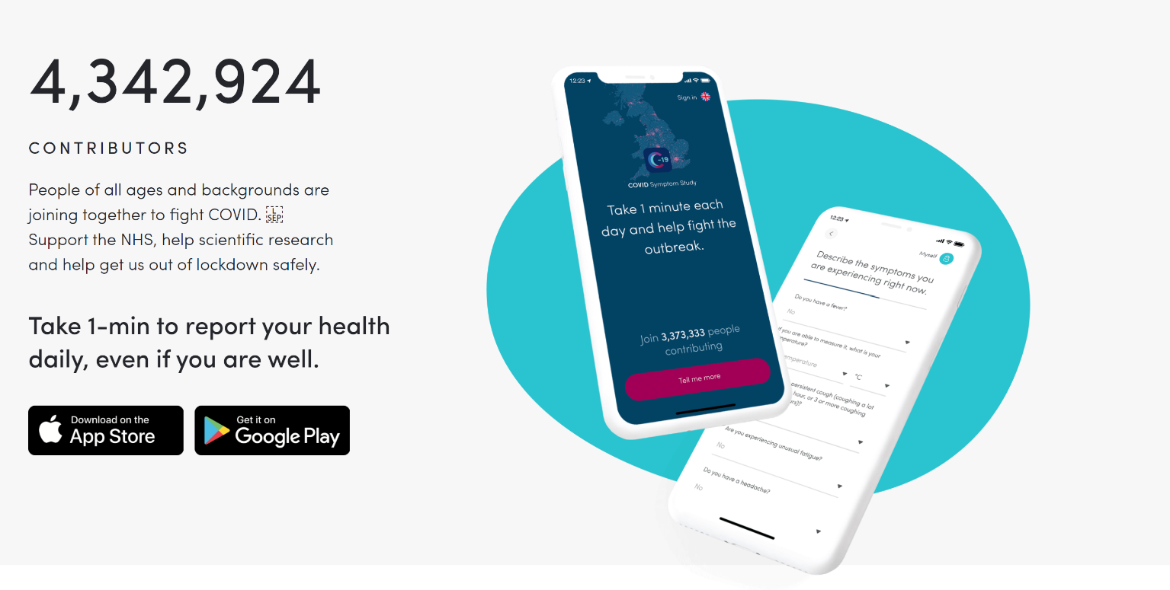
Latest figures
The Johns Hopkins Covid-19 Dashboard appears to be one of the best source for statistics on the spread of the virus. It is possible to see statistics and graphs for 188 countries with the latest known information.

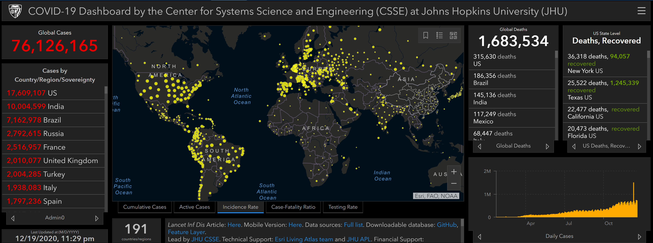

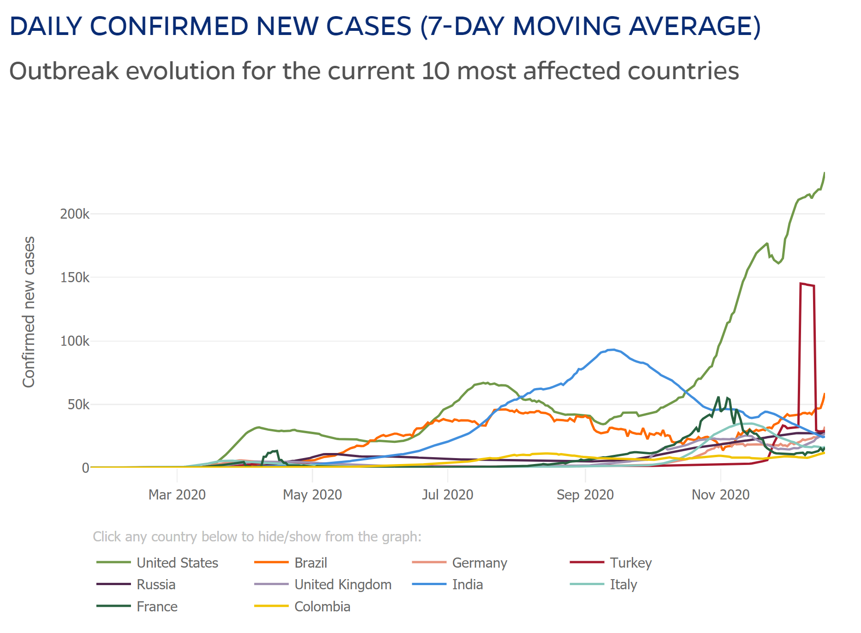

Mental health
- The Church of England has produced some mental health reflections to help you in this time of uncertainty. You can access them at: cofe.io/MentalHealth.
- The Mental Health Foundation has also produced some useful resources, which can be found at: https://www.mentalhealth.org.uk/coronavirus
- You can find a host of other mental health resources from a variety of different organisations and charities. https://www.mentalhealthatwork.org.uk/toolkit/coronavirus-and-isolation-supporting-yourself-and-your-colleagues/
https://www.mind.org.uk
- Some helpful books and resources are also available from Sacristy Press at https://www.sacristy.co.uk/books/coronavirus-church-resources#

Further links to mental health charities can be found on the NHS webpages at https://www.nhs.uk/conditions/stress-anxiety-depression/mental-health-helplines/

Topical Prayers

The Church of England website offers words you can use in your prayers for all kinds of situations ranging from the everyday to personal situations, family events and prayers for others. If you need some help finding the right words, please go to the Church of England website here

https://www.churchofengland.org/prayer-and-worship/topical-prayers

Advent and Christmas 2020
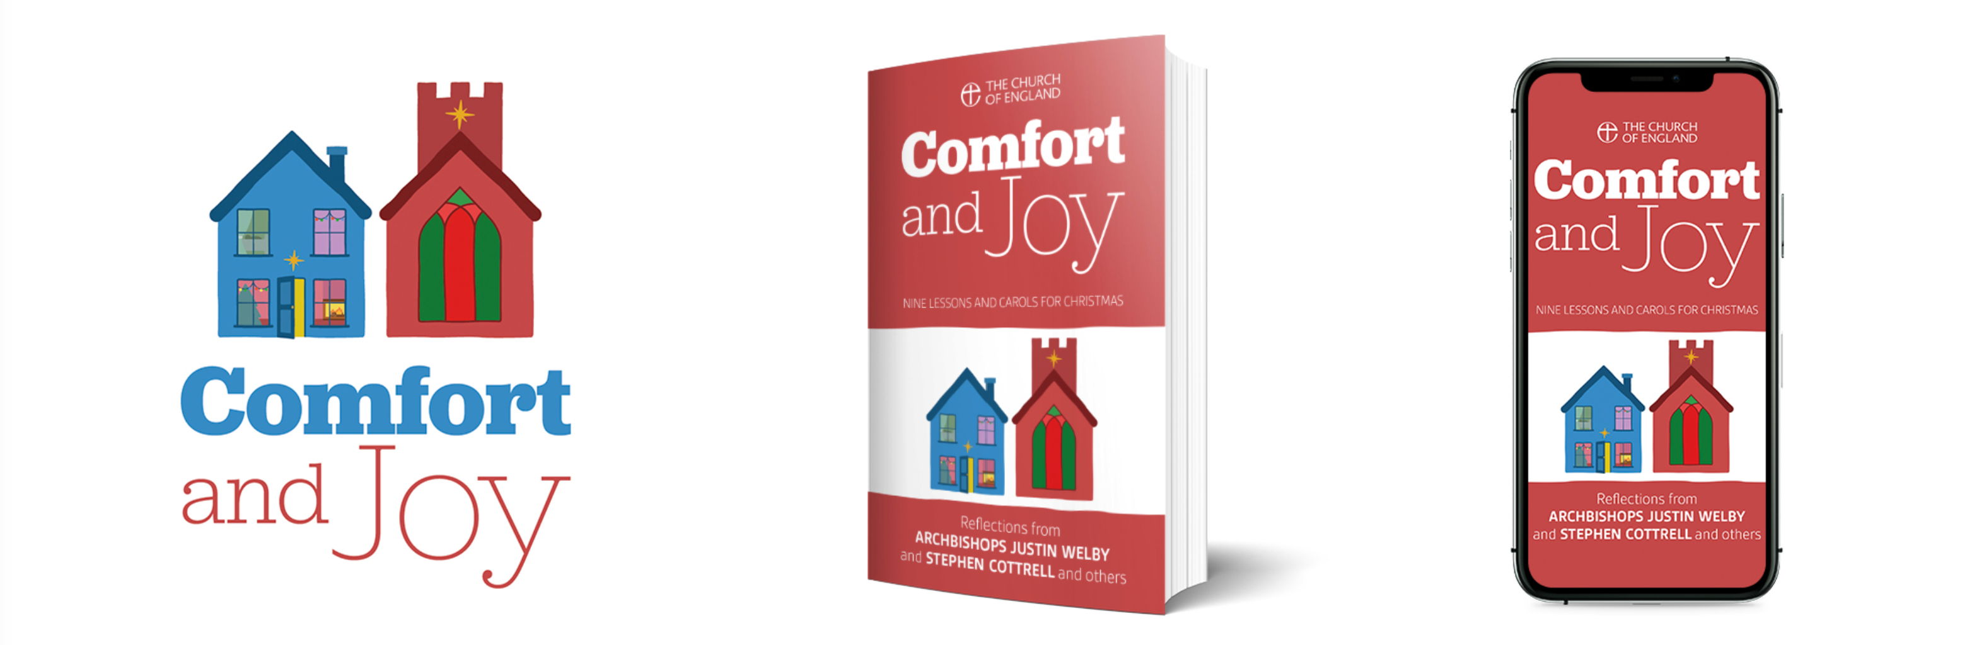
This Christmas the Church will need, in the words of St Paul in Romans 12.15, to ‘Rejoice with those who rejoice; weep with those who weep’. We will aim to celebrate where we can together in one place – but also embrace a wider community that wants to join in the celebration but may not be physically able – or emotionally ready – to do so. We hope that Comfort and Joy will enable us to build a campaign that both enables us to reconnect with the rich and joyous traditions of the past and to offer God’s consoling love in the present.

There will be weekly reflections published on social media and available by email and app for each Sunday of Advent. We have partnered with a number of public figures to produce short reflections exploring the theme. Comfort and Joy: Nine Lessons and Carols for Christmas mirrors the structure of a traditional carol service, exploring both biblical texts and the words of much-loved Christmas carols.
The reflections for each day from Christmas Day to 2 January feature contributions from Kate Bottley, Jonathan Bryan, Bob Chilcott, Martha Collison, Stephen Cottrell, Guli Francis-Dehqani, Chine McDonald, Sally Phillips and Justin Welby. The booklet is introduced by the Archbishops and has been edited by the Ven John Kiddle, Archdeacon of Wandsworth, author of the best-selling God With Us: Your Christmas Journey.
They will also be made available freely via audio, smart speaker, as well as via app and email formats with accompanying prayer activities for children and families.
Working with the Archbishop of York's Youth Trust and the Evangelism & Discipleship team, we will also produce a series of youth reflections in December.

National online services streaming dates
In collaboration with a range of Christian charities and organisations, we will produce nine online services throughout Advent and Christmas. This will include an online service for each Sunday of Advent, a Christingle with the Children's Society, nine lessons and carols and midnight services. Charities involved include Christian Aid, Church Army, Embrace and Marie Curie. The online weekly services have been very well received on social media and continue to attract a diverse audience including regular churchgoers, people exploring faith and a wide age demographic. They will all be broadcast on the Church's YouTube and Facebook pages.
- 20 December 9:00am - Worship at Home for the Fourth Sunday of Advent with Marie Curie
- 22 December 9:00am - Worship at Home: A service of Lessons and Carols with Christian Aid
- 24 December 11:30pm - Worship at Home: Midnight Mass with the Archbishop of Canterbury and the Bishop of Dover
- 27 December 9:00am - Worship at Home for the First Sunday of Christmas with Church Army
- 31 December 9:00am - Worship at Home: A service with the Archbishop of York on New Year's Eve
- 3 January 9:00am - Worship at Home for Epiphany with Embrace the Middle East

Daily Hope
Daily Hope is a free phone number (0800 804 8044) offering music, prayers and reflections as well as full worship services from the Church of England at the end of a telephone line. We are delighted that the Comfort and Joy reflections, services and some of the music will also be available throughout Advent and Christmas. This will enable as many people as possible to access the content we are developing.

