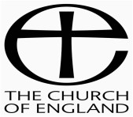
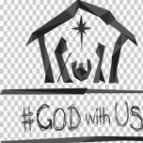
Parish of St. Mary’s Swynnerton & St. James’ Cotes Heath
Sunday December 27th (Christmas1) Contacts: Church Warden Ray Lewney: 01785 760366
Ministry Team: Nicky Beasley,01782 856656, Doreen English, 01782 796426,
Alex Baines, 07462 616426 June Steed, 01782 643183, Chris Stokes, 01782 796610
Children and Families’ Worker: Anna Hawkins, 07725 124583
Newsletter: chrisandjackie77@btinternet.com

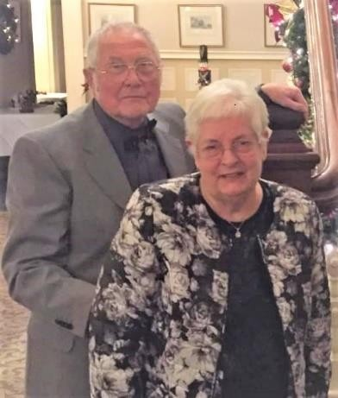
Congratulations to Carol and Martyn Turner who will be celebrating their Diamond Wedding Anniversary on 31st December. The Turners have been members of our church family for many years and have contributed as church wardens, in Sunday school, in the choir, with church and churchyard maintenance, on committees and synod, in pastoral care and prayer ministry and in countless other ways. We are grateful and wish them a very special day.

The gospel reading for Christmas 1 (December 27th) is Luke 2:15-21
When the angels went away from them into heaven, the shepherds said to one another, “Let us go over to Bethlehem and see this thing that has happened, which the Lord has made known to us.” And they went with haste and found Mary and Joseph, and the baby lying in a manger. And when they saw it, they made known the saying that had been told
them concerning this child. And all who heard it wondered at what the shepherds told them. But Mary treasured up all these things, pondering them in her heart. And the shepherds returned, glorifying and praising God for all they had heard and seen, as it had been told them.And at the end of eight days, when he was circumcised, he was called Jesus, the name given by the angel before he was conceived in the womb.

The sheep were securely enclosed, the fire was lit and the shepherds were thinking about settling down for the night.
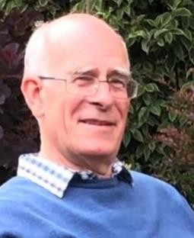
The silence was something unfamiliar to us these days –nothing but the noise of the sheep shuffling around.
So it would have been disturbing, to say the least, to have an angel appear, shining with the glory of God. No wonder they were afraid.
What’s more, the angel gave them some news which upset their plans for a quiet evening.
They were asked to leave their sheep and their warm fire, and venture down the hill to Bethlehem. But this they did – they changed their plans, did as they were asked, and were rewarded by the sight of this precious baby in a manger.
How often have we reluctantly had to change our plans? This year in particular, nothing has been
certain and we have had little control over what we do, as a result of the varying levels of infection. We’ve constantly had to react and respond to new rules and regulations – who we can meet and where, indoors, outdoors or shivering in the local park.
As I write this, will our best-laid plans for Christmas be scuppered the week before?

By changing their plans, the lives of those shepherds were transformed and they would never forget that night. We too have to accept that circumstances and events will always mean we need to rewrite our diaries.
But God’s plan for us and for the world hasn’t changed, from creation to the coming of the Messiah, His death and the
promise of our salvation, all moving along regardless of our own agendas.

The last few months have been confusing and disruptive but the words of the prophet Jeremiah can give us some comfort:
“For I know the plans I have for you, declares the Lord, plans for welfare and not for evil, to give you a future and a hope. Then you will call upon me and come and pray to me, and I will hear you.”

We will all be making ambitious plans for the new year, immunised and raring to make up for lost time with family and friends. But even as we do so, let’s remember those shepherds who were prepared to listen to God and follow HIS plans. Chris Stokes.

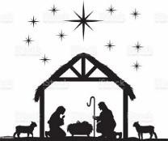
Worship for Christmas 1 (27th December)
“Do not be afraid. I bring you good news of great joy that will be for all the people.”

The night has passed and the day lies open before us. Let us pray with one heart and mind.
O Lord, open our lips.

And our mouths shall proclaim your praise.

As we rejoice in the gift of this new day, so may the light of your presence, O God, set our hearts on fire with love for you, now and forever. Amen.

Confession: Jesus Christ, risen Master and triumphant Lord, we come to you in sorrow for our sins, and confess to you our weakness and unbelief. We have lived by our own strength and not by the power of your resurrection.
In your mercy forgive us. Lord hear us and help us.

We have lived by the light of our own eyes, as faithless and not believing.
In your mercy forgive us. Lord hear us and help us.

We have lived for this world alone, and doubted our home in Heaven.
In your mercy forgive us. Lord, hear us and help us.

Apostles’ Creed:

I believe in God, the Father almighty, creator of heaven and earth. I believe in Jesus Christ, his only Son, our Lord, who was conceived by the Holy Spirit, born of the Virgin Mary, suffered under Pontius Pilate, was crucified, died and was buried; he descended to the dead. On the third day he rose again; he ascended into heaven, he is seated at the right hand of the Father, and he will come to judge the living and the dead. I believe in the Holy Spirit, the holy catholic church, the communion of saints, the forgiveness of sins, the resurrection of the body, and the life everlasting. Amen.

Collect:

God in Trinity,
eternal unity of perfect love:
gather the nations to be one family, and draw us into your holy life through the birth of Emmanuel,
our Lord Jesus Christ. Amen.

OUR FATHER …
Let us Pray
On this first Sunday after Christmas, we pray
for those who have been lonely because they couldn’t
see friends and family,
for those who were sad because they’d lost someone
they love,
for those who found the holiday a time of anxiety and depression,
for those who went to work and had no rest. We pray for light in the darkness,

In the name of Jesus, the light of the world, Amen.

We bring before God those who have no job and for whom 2021 will be a challenging year. We think of those with great responsibilities and all who struggle to keep going.
We pray for light in the darkness,

In the name of Jesus, the light of the world. Amen.

“God of hope, in these times of change, unite our nation and guide our leaders with your wisdom. Give us courage to overcome our fears, and help us to build a future in which all may prosper and share”.
We pray for light in the darkness,

In the name of Jesus, the light of the world. Amen.

Keep us, good Lord,
under the shadow of your mercy. Sustain and support the anxious, be with those who care for the sick, and lift up all who are brought low; that we may find comfort
knowing that nothing can separate us from your love in Christ Jesus our Lord.

Amen.

So Heavenly Father, we ask you
For the eagerness of the shepherds, The joy of the angels
The perseverance of the Wise Men, The obedience of Mary and Joseph, And the peace of Christ,
That we may enter the new year confident in the knowledge that you are entering it with us.

In the name of Jesus, the light of the world. Amen.

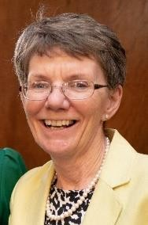
The grace of our Lord, Jesus Christ and the love of God and the fellowship of the Holy Spirit,
Be with us all, evermore, Amen.

Prayers contributed by Jackie Stokes

