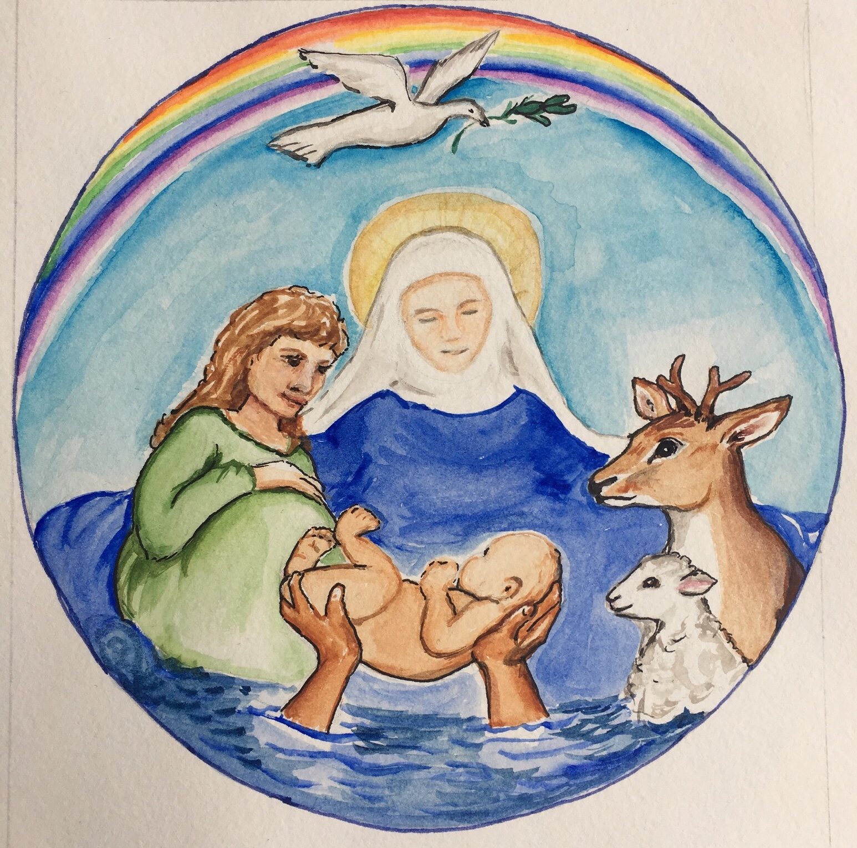
Barham Downs Churches

Adisham • Barham • Bishopsbourne • Kingston • Wymynswold

December 2020 Church Services
These dates and times are dependent of coming out of lockdown by 2nd December and assuming that masks will still need to be worn and sadly to limit numbers re. social-distancing requirements

6th Dec | Advent 2 (St Nicholas)
8 am 10 am  6 pm | BCP Holy Communion  Benefice Family Service  Said Evening Service | Barham  Kingston  Womenswold
13th Dec | Advent 3
09:30 am  11:00 am  17th Dec  6 pm | Holy Communion  Holy Communion  Carol Service | Barham  Adisham  Womenswold
20th Dec | Advent 4
09.30 am  11 am  4 pm  6.30 pm  22nd Dec  4 pm | Family Communion & Crib Service  Family Communion & Crib Service  Carol & Crib Service  Carol & Crib Service  Crib Service | Kingston  Bishopsbourne  Barham  Adisham  Womenswold
24th Dec | Christmas Eve
11.30 pm  11.30 pm | Midnight Mass  Midnight Mass | Bishopsbourne  Adisham
25th Dec | Christmas Day
10 am  10 am  10 am  27th Dec  10 am | Family Service  Family Service  Holy Communion  Eve of Holy Innocents  Benefice Service | Barham  Kingston  Womenswold  Adisham

The Benefice Weekly Wednesday 10.00 am Holy Communion Service is at St. John’s Barham
with Communion of One Kind (no wine) but not on the 30th December.

https://www.barhamdownschurches.org.uk/beneficepewsheet.htm
https://www.barhamdownschurches.org.uk/churchservices.htm

