St Mary the Virgin, Furneux Pelham
Statement of Significance

Furneux Pelham is a small village of scattered hamlets on each side of the shallow valley of the River Ash, not far from its source. The village is situated well away from main roads and is served by a network of narrow lanes. Notwithstanding its rural location the village is the home of a thriving community with a public house, village hall with clubs / social activities.

The church which is Grade II * listed is situated towards one end of The Street, the main thoroughfare of the village. Adjacent to the church is The Rectory (in private ownership), the village C. of E. Junior School is opposite and there are a number of old cottages varying in size and larger houses. Further west is Furneaux Pelham Hall, a 16th century manor house with many 17th century alterations. At the east end of The Street is the former brewery (now converted to houses) and The Brewery Tap public house.

The earliest part of the church building is the Chancel and is 90% maintained by the Church Commissioners. The lancet windows and architectural details of the Sedilia and Piscina confirm this part of the building as being from the middle of the 13th century. The Tower is believed to be of the 14th century so the Nave was built during these two periods. The Nave was substantially rebuilt in the 15th century with the North and South wall raised to accommodate the clerestorey windows and the North and South Aisles were added. The South Chapel (dedicated to St. Katharine) and the two storied South Porch were erected shortly after this time which leaves the building much as it is today.

Apart from the Chancel which now has peg tiles, the 15th century roofs remain as original. The Chapel retains its original polychrome decoration while the Nave roof is distinguished by its carved wooden angels these were restored and painted in the last quarter of the 20th century by a local artist.

At the west end of the South Aisle, (used as the Vestry) there is a chest tomb and a fine brass, believed to commemorate Robert Newport (died 1428) and his wife. An early 16th century brass plate commemorates another member of the Newport family who are believed to have been the major benefactors of the church building and responsible for the building of the South Chapel. The windows of the chapel contain very fine and noted examples of stained glass by William Morris and Byrne Jones.

Other items of note include a double sided carved and painted wooden Royal Arms dated 1634 on one side and 1660 on the other side. The octagonal Purbeck marble font bowl is possibly from the original 13th century building.

The building was restored in the 19th century however much of the original fabric survives and the north wall of the North Aisle retains its original rendering and gives a good indication of the appearance up to the end of the 18th century.

The church building remains in use for public worship and for non-liturgical, mainly fund raising activities and forms part of the united benefice of Braughing, Furneux Pelham and Stocking Pelham.

ROOFING WORKS
The re-roofing of the building in a material which will be enduring and water tight is obviously, of paramount importance; the current temporary roof covering has a limited life and is already showing evidence of letting water seep through into the building.
The roofs requiring works following the lead theft are the Nave, North Aisle, South Aisle, and Chapel. No works are proposed to the roofs of the Chancel, Kitchen Extension or South Porch.
Chapel, North and South Aisles
The material chosen for the Chapel, North Aisle and South Aisle is a Bauder high performance felt. This is a two layer modern bitumastic felt. The existing roof timbers will be overlaid with external grade 12mm plywood and adhesive primers fixed to the plywood rather than the historic fabric. Any repairs to the substrate timbers, e.g. parapet gutters to the South Aisle, will be completed in treated softwood to match adjacent timbers. It is proposed to keep the existing lead flashings, these were left in tact during the theft and their removal and replacement will cause unnecessary damage to the historic fabric. These can be monitored for signs of degradation by the PCC and replaced as necessary without impacting the rest of the roof coverings.
The aesthetic impact the change in material has on the Church is limited. The topography of the Church and graveyard means that the roof slopes are not visible when viewing the roofs from ground level. Further the parapets to the South Aisle and Chapel restricts all roof slopes. See photographs. The use of modern materials is required in this instance to ensure that a robust weatherproof finish can be provided with the available funds. The alternative is to leave polythene coverings until such time as funds do extend to a traditional sheet metal repair, which would cause untold damage to the rest of the Church fabric. The use of alternative roofing materials is not possible due to the presence of clerestory windows and parapets.
The existing historic fabric will not be significantly impacted by the provision of the felt products. The existing roof timbers will be overlaid with external grade 12mm plywood, secured with mechanical fixings. The adhesive primers will therefore be bonded to the plywood rather than the historic fabric. Therefore limiting the impact upon the historic fabric and ensuring a reversible repair is completed
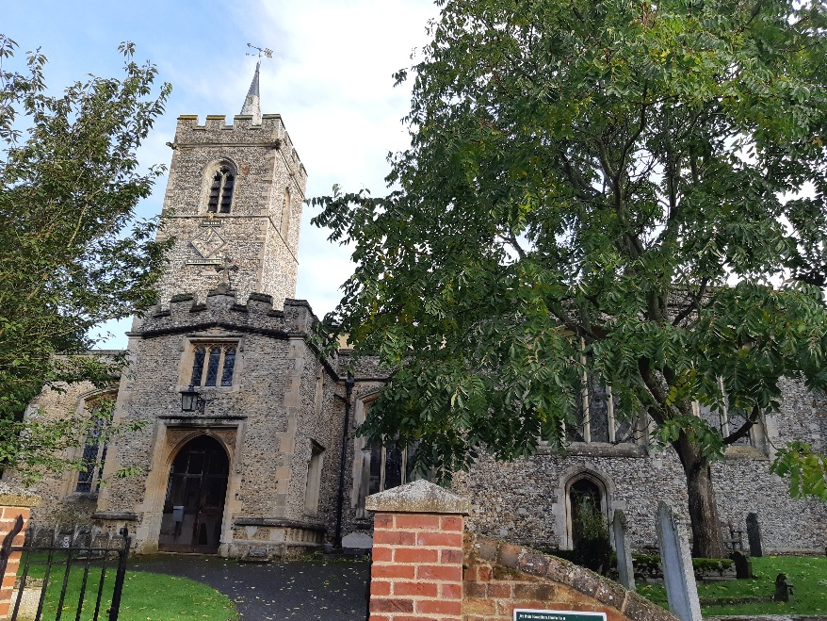
South Elevation of the Church as viewed from the road - presence of the parapets means the aisle and chapel roof coverings cannot be seen.
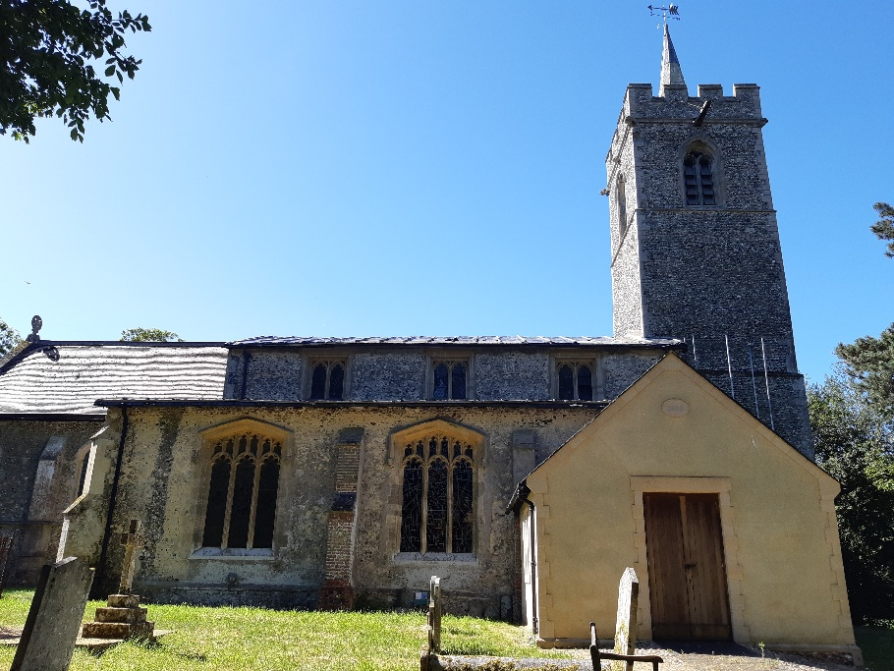
North Elevation of the Church with a very limited view of the North Aisle Roof; only the eave edge / gutter detail can be seen.

Nave Roof
The material for the Nave roof is natural slate. This requires a nominal increase in roof pitch to meet the minimum pitch for slates of 22deg. The current roof is 15 degrees and the increase will be achieved with timber furrings upon the existing roof timbers.
The East end verge derail will be provided with a timber bargeboard to conceal the modest ridge height increase of approximately 300mm.
The West end abutment detail to the tower will be reconstructed to meet the new ridge and pitch details. The existing abutment detail is in poor condition with weathering tiled details lost and patch repairs in render. The flint work will need to be carefully removed to the tower to allow a new soft red brick edge to be built along the line of the new roofline. This will enable a new lead flashing to be well dressed ensuring a robust detail.
Slates are already used as roofing to the Church’s kitchen extension and are considered a suitable traditional roofing material used in historic buildings. Slates could be laid on the existing roof slope but there is a risk that water ingress would occur during inclement weather. Since this is a permanent repair the PCC wish to complete this roof to the best of their ability.
The aesthetics of the Church will be impacted with a change in material from lead to slates and the change in roof pitch. The existing screening and topography limits direct sight lines to the roof and as such the roofline is not considered a highky significant element of the Church.
BUILDING REGULATION UPGRADES
It is not proposed to provide insulation to the roofs due to funding constraints and the urgency of the required works. The building is infrequently used and due to existing community facilities within the village unlikely to become a major community hub with extended heating requirements. If the provision of insulation if required for Building Regulation compliance we will liaise with statutory consultees and the DAC.

April 2020.

