GRATWICH NEWSLETTER  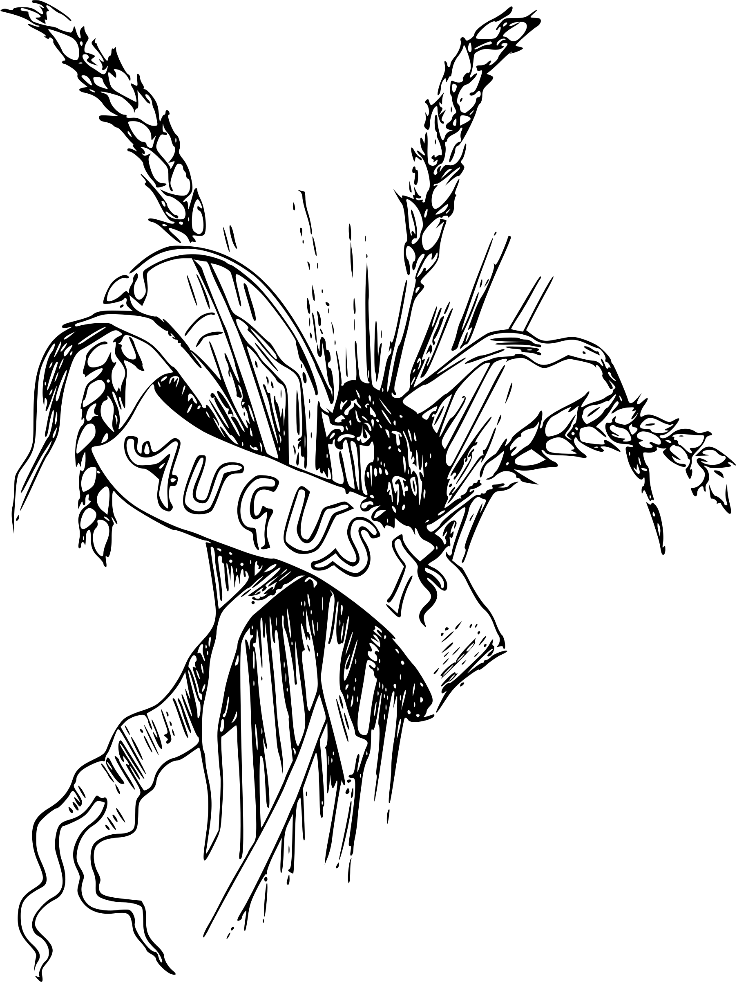  2020 | SUNDAYS AUGUST 2nd 9th 16th 23th 30th  As you know St. Mary’s church in Gratwich has been closed since April this year  and is likely to be so until at least the end of September, which sadly puts doubt as  to whether there will be a Harvest Festival Service this year.  The PCC felt that opening for services at present and not being able to have a  ‘proper service’ with hymns (there being a ban on singing) did not seem right.  The usual weekly Zoom service on a Sunday evening (7.00 – 7.30pm) will continue and if you would like to join the Zoom please let me know.  Also St. Mary’s in Uttoxeter are holding a10.00am service each Sunday – you have  to book a place as with social distancing there is a limit to the number of people  they can accommodate. Either by email to office.uttoxetercofe@gmail.com  or by leaving a message on 07971 277998  The Team at Lichfield Diocese Board of Finance have created a “Donate Now”  on-line facility on the Diocese Website (www.lichfield.anglican.org) to enable  people to give to their local church.  If you would like to donate to St. Mary’s in Gratwich go onto the diocese website  (www.lichfield.anglican.org), put Donate Now in the search box, then follow the instructions. Thank you.  Facebook Pages to join for church information, services and prayers:  St. Mary’s Church Gratwich  Lichfield Cathedral  Uttoxeter Area of Parishes  YouTube For Sunday Services  Uttoxeter holy communion
100 CLUB – JULY - drawn at the Zoom service on Sunday 28th June  1st Simon Capewell  2nd Molly Cotton  3rd Donna (c/o Mrs Johnson)  This was the first draw of the current year. If you would like to re-join/join the 100 club for the next 12 months please give Sue a ring (01889 502241).  Next draw will be at the end of August.  This month’s Area letter is from Rev. Charles Dale  Well it’s July already! Where is the time going! It is a strange time we are in and life seems to be evermore complex by the continual changes in government strategies for coping with Covid 19 and more than a little unsettling. Time doesn’t stand still and in these days of semi lockdown I am left wondering what the next move will be. We are moving to open our churches gradually, but it seems things aren’t going to be as they were for some time to come. Some things may never be the same again and that can be even more unsettling…  So what has kept me going?  I think I’m really blessed to be living where I do, with open fields and woods and quiet lanes to wander around and get the exercise I need - Oh how I miss my swimming time at the leisure centre though! It’s been a good to be able to spend important quality time with Janet and together we’ve enjoyed our daily walks out.  Since lockdown we’ve seen the daffodils, wood anemones, bluebells and a host of wildflowers come and go; all have been a great joy and the birdsong too, how delightful! We’ve been watching the robins in one of our nesting boxes rearing their young, and really proud of the mum and dad robins who raised at least three young ones and to see the youngsters clinging on to the nesting box opening before taking that first tentative flight …parents watching seemingly saying ‘come on you can do it’! The robins have been a fine example of patience, perseverance and loving care. They have bought much joy and pleasure, a God send you might say in these difficult times. | We’ve also been gardening and our labours have already and will continue to bear fruit as the season goes on. However, we need to make sure we tend to the plants and vegetables in order for them to grow and produce good fruit for us. And then there’s the hoeing and weeding!!…keeping the plants and vegetables clear of competing weeds…it’s a continuous task if we are to benefit from our labours and the God given rain and sunshine which gives the growth. We need, like the robins, to persevere, never to give in, but to go on caring even when we don’t feel like it.  It’s also been a joy and delight to be able to keep in contact with a number of people… via telephone, email and ZOOM! Who knew about that 12months ago? Friends and family are so important and through the technologies we have we are able to keep in touch, even at a distance!  All this puts me in mind of how important my faith and trust in God our heavenly Father is to me, especially in these times and of the need to persevere in giving thanks and to worship this great God of ours. Just like the continuous task of tending and caring for the plants and vegetables in order to get good fruits you only get out what you put in effort by clearing the weeds and tilling the soil. My faith has been a God send and a great anchor point for me in this time of semi isolation. Persevering in prayer and praise each day has brought peace and contentment and helped me to reflect on who and what I am and my calling to priestly ministry. A little like weeding and tilling! Having said that I do miss being at church with God’s people, worshipping and singing His praises together in community. For that is what we were meant for and I long for us to be together again. The signs are good, but all in God’s time and keeping.  ‘and lo, already on the hills the flags of dawn appear; gird up your loins, ye prophet souls, proclaim the day is near.’  Blessings and peace  Charles  For further information please contact:  Rev. Charles Dale 01889 500428: email: revcharles.dale@btinternet.com  Jenny Talbot: 01889 50241 email: jenny477@btinternet.com

