Two of the churches to which I am called to serve are dedicated to St Peter, these being Sibthorpe and Farndon, and we would have had celebrations of some kind in these churches and communities today.

On this rock (Peter) I will build my church.
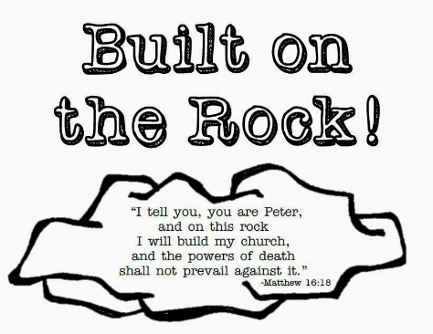
Matthew 16:13-19

Son of Man, Son of God
13 When Jesus arrived in the villages of Caesarea Philippi, he asked his disciples, “What are people saying about who the Son of Man is?”

14 They replied, “Some think he is John the Baptizer, some say Elijah, some Jeremiah or one of the other prophets.”

15 He pressed them, “And how about you? Who do you say I am?”

16 Simon Peter said, “You’re the Christ, the Messiah, the Son of the living God.”

17-18 Jesus came back, “God bless you, Simon, son of Jonah! You didn’t get that answer out of books or from teachers. My Father in heaven, God himself, let you in on this secret of who I really am. And now I’m going to tell you who you are, really are. You are Peter, a rock. This is the rock on which I will put together my church, a church so expansive with energy that not even the gates of hell will be able to keep it out.

19 “And that’s not all. You will have complete and free access to God’s kingdom, keys to open any and every door: no more barriers between heaven and earth, earth and heaven. A yes on earth is yes in heaven. A no on earth is no in heaven.

Who are your role models?
I’ll take a bet most of them seem to be pretty good at whatever it is you’re looking to them to model, whether its creative or musical skills athletic ability, leadership, academic success, parenting: the list goes on.
No one usually picks a role model with a list of flaws as long as their arm, much less are they picked to pioneer & found something as important as the church.
Today we remember Peter, the disciple who did have a list of flaws and other failings; yet stood up when he needed to.

Peter probably the disciple we know the most about from the Gospel accounts - Peter perhaps the disciple whom we all relate to the most. But possibly not the one who was voted as “disciple most likely to succeed”. Possibly not the one who sprang to anyone’s mind as a role model. Peter was the enthusiastic visionary, the one jumping up and down with all the ideas. “let’s do this.” “Hey yes I can walk on water”
Peter was probably the one who when he spoke the others rolled their eyes. ‘oh no, what’s he said NOW…? Peter was also the disciple who failed spectacularly, denying 3 times that he ever knew Jesus, but Peter was also the disciple who knew more than anyone the restoring power of God’s love, and forgiveness.
Peter gives us all hope –because he is not some kind of perfect Saint – Perfect Peter he is not, but Jesus loves him all through it and never loses his belief in what Peter can do, is called to do, will do.
To the others, to us, Peter is hardly the one who might be called the Rock. ‘He’s as flakey as a box of cereal’ a friend once said.
To Jesus however he’s got a calling, to be the Rock, the foundations, to build the church, to grow the Kingdom, in partnership with Jesus.

We don’t always make the right judgements about others or about ourselves, we fail to see the abilities and gifts we have been given – we seek strength, forgetting that it is in our weakness that Gods strength is made known.
We look for perfection and castigate ourselves when we fail, forgetting to understand that it is in our restoration that we become stronger and learn, and are given the ability to grow into our calling.
Jesus’s statement to Peter comes as a result of Peter’s declaration about him
You are the Messiah, the Son of the Living God
To which Jesus responds with You are Peter and on this rock I will build my church.
Perhaps the rock on which Christ build his church is not just Peter himself but the rock of faith, that statement itself “you are the Christ” tells us of Peter’s steadfast belief.
When we proclaim Jesus, in word, and in action, when we proclaim his love for us all, when we proclaim his forgiveness and his restoration to the broken world in which we live – then the foundations of our faith grow, and our church communities are built.
When we proclaim Jesus as the Christ our own lives his strength and restoration strengthens us, we too like Peter become rocks, on which the faith of others can be supported and grow.

The life as church, in our communities, the family of Christ is built on the proclamation of Jesus as the son of God. A proclamation that strengthens each of us; and gives us our foundations.
Our own faith and that of those around is a corporate faith, we are in this together.
Like Peter we fail and fall, we open our big mouths and put our feet in, but like him we can know forgiveness and restoration in our own lives and to offer it to others.
Like Peter we are also to be enthusiastic for our faith, for our relationship with God, we are to proclaim it loudly, some of us are going be more prepared to leap out of the boat and get our feet wet, others have louder voices! We must remember we are family, none of us are too flakey or flawed that we cannot be restored and called and used by God
None of us have it completely right either, we welcome each other into this family for the first time and every time, acknowledging our different gifts and callings and promising always to support each other, to be rocks for each other as we walk the path of life together, and build Christ’s church by our love and our actions.

Almighty God,
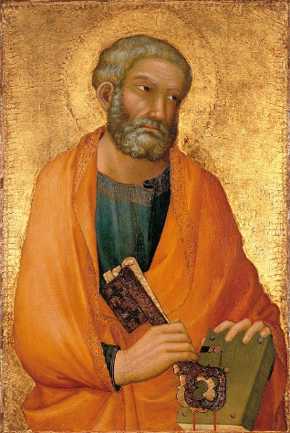
who inspired your apostle Saint Peter
to confess Jesus as Christ and Son of the living God:
build up your Church upon this rock,
that in unity and peace it may proclaim one truth
and follow one Lord, your Son our Saviour Christ,
who is alive and reigns with you,
in the unity of the Holy Spirit,
one God, now and for ever. Amen

