Over the past weeks we have had debates in our churches on whether or not to officially open the buildings, and how to make this as safe as possible for those attending for quiet prayer.
Risk assessment has been a key word and task, thus enabling the correct and proper procedures to be employed for each building.
We will then have to re-look at these as the 4th July is offered, at the moment, for the re-opening for worship. We do not know what this will look like; instructions come from government, via the Church of England, to the Diocese and through to Clergy and PCCs (Parochial Church Councils) for us to implement. Every Thursday new instructions and guidelines come out, and it takes a while to plough through everything, it seems as though one thing is settled and then it has to be changed. A debate for the last two weeks has been a role for the 70’s and over, as we know most of our rural church are managed by this age group and we could not manage without them. Therefore, it is assessing how to have a duty of care for everyone, physically, mentally, and spiritually, whilst offering inclusion for all.

I don’t know how you’re experiencing this current phase of COVID-19 life, but it feels to me like we’re in a time that mirrors those early weeks of lockdown; every day seems to bring a new announcement, or a teasing of a relaxation of restrictions, and many of us are beginning to feel our way into the possibility of spending quality embodied time with others, of visiting shops and gardens, of travelling to parts of the country that have been out of reach for the last three months.
But for others – those who are shielding, going into isolation as a result of contact with someone with the virus, or protecting others, or for whom normal life is marked by physical distance, social isolation and loneliness – this lifting of restrictions is a reminder of a lack of connection, companionship or community. Some may not have the confidence or will to come out of lockdown and need much more re-assurance of circumstances.
We seem to have spent a long time in limbo; yet can now move forward. As I write we have moved into phase 3 – whatever that means, I am sure in the next few days we will be informed.

Today I want to share with you a reflection by Revd Elizabeth Clark who is a National Rural Officer for the Methodist and United Reformed Churches working at the Arthur Rank Centre for Rural Ministry. In this she reminds us of the power of the psalms of lament and helps us to look both backwards and forwards through our COVID-19 experience.
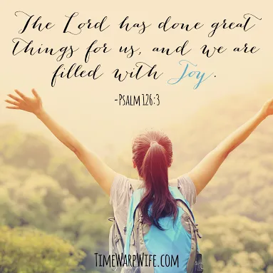
God is…

Bible Reading: Psalm 126

When the Lord restored the fortunes of Zion, we were like those who dream.
Then our mouth was filled with laughter, and our tongue with shouts of joy;
then it was said among the nations, ‘The Lord has done great things for them.’

The Lord has done great things for us, and we rejoiced.

Restore our fortunes, O Lord, like the watercourses in the Negeb.
May those who sow in tears reap with shouts of joy.
Those who go out weeping, bearing the seed for sowing,
shall come home with shouts of joy, carrying their sheaves.

Reflection

This psalm is a lament, probably written when the People of God were in Exile, far from home in a strange land. They’re looking back to a time when life felt good, possibly viewing the past through rose-tinted spectacles; after all, life is never perfect. However, in contrast to their present circumstances the past would have felt more hopeful.
Alongside the feelings of despair there is hope. They know God, the God of Abraham, Isaac, and Jacob, the God who had brought them out of the Land of Egypt. This is a God they can depend on even when things look bleak and they feel alone.

How do you feel today? Can you see God in what is happening?

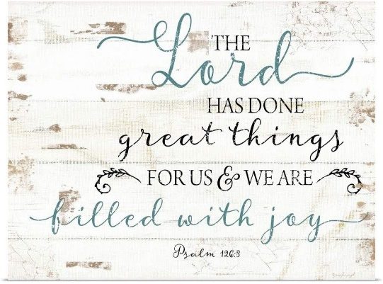
Here is a rethinking of Psalm 126 for today…

Psalm during Covid

How bright was life before lockdown!
How busy and noisy and fun.
We sang, prayed, and praised together;

God was good.

Now there is silence, and for some darkness,
loneliness and fear.

Where is God?

The silence is broken by loud insistent bird song,
The darkness is illuminated by a profusion of flowers and butterflies.
We exchange smiles and greetings with strangers.
As we learn to stop look and listen, we are surrounded by glimpses of God:

God is here!

God is good!

Prayer
Loving God
Help us to know your presence
even in the darkest times.
Remind us how much we are loved
and help us share that love with others.
In Jesus name
Amen.

Response
Ring someone today who you haven’t spoken with for a long time.
Go for a walk and thank God for everything you can see.

With love, grace and peace Rev Liz Murray

