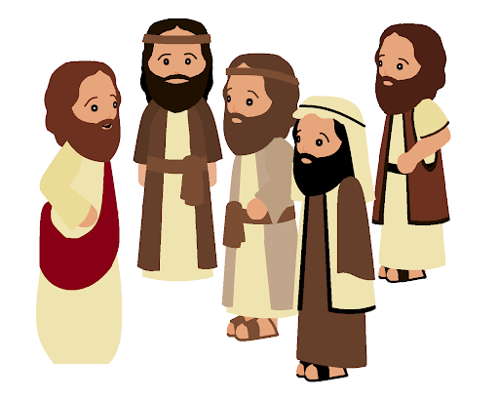
The United Benefice of
St Helen, Burghwallis and
St Mary Magdalene, Campsall
14th June 2020
1st Sunday after Trinity

The Churches will be open for Private Prayer

As you will have seen in the media, churches will be able to open for individual private prayer this week. There will be clear strict instructions to be followed in church to ensure that correct social distancing is observed and also so that the church can be cleaned after use.

This week we shall open for Private Prayer at these times:

Campsall: Monday 15th June 2.00pm – 4.00pm
Burghwallis: Thursday 18th June 2.00 – 4.00pm

This week’s gospel reading speaks about Jesus sending his apostles out to spread the Good News. They go out in twos to heal and to teach. They are expected to be self-sufficient, relying upon the generosity of those with whom they live. But there also is a warning for those who do not welcome them. The apostles are told not to waste their time but to shake the dust from their feet and move on. The apostles are sent to bring peace to those who receive them but there is judgement on those who reject their message. During these difficult times there have been many who have been open to the word of God speaking to them. May we all be faithful apostles – preaching the Good News in word and action to those who will listen.

Fr Richard
The harvest is plentiful but the labourers are few.
Contacts
Priest in Charge: Revd Dr Richard Walton 723224 Churchwardens: Campsall
Curate: Revd Christopher Herbert 702615 Jenny Lister 702552
Reader: Mrs Christine Herbert 702615 Churchwardens: Burghwallis
Shirley Gill 700057, Colin Bowes 702779

